OFFICE BEARERS FOR 2017  PRESIDENT : Peter Halleday 0439500699  VICE PRESIDENT : Ansi Nitz  TREASURER : John Plunket  SECRETARY : Paul Edgeworth 0497386846  COMMITTEE : Dave Lawson  Glen Bowmer  Don Clements  Arthur Smith  Graham Carter  APPOINTMENT OF LEADERS for 2017 –  Work Health Safety Rob Burford/Graham Carter – joint management  Senior First Aiders Peter Halleday/Ansi Nitz – joint management  Building Fitout /Maintenance Peter Halleday/ Don Clements – joint management  Projects Don Clements  Social Organiser Dave Lawson  Webmaster Dave Lawson  Fund Raising Ansi Nitz  (Race Gates Brian Short)  Grant monies submission writer Graham Carter  Publicity Officer/ News Editor Peter Heness  Historian Graham Carter  Membership Support Brian Short  Kitchen Management Norman Collins  UPCOMING / ONGOING PROJECTS  - Folding garden table  - Raised garden beds  - Jason Sims for metal welding in 2017  - ‘Fruit Boxes’ – a dozen + constructed by Peter Halleday and team and donated to the Royal Society for the Blind as display boxes.  - Refurbishment of KILN – Kelvin Smibert  - PLANS FOR ALL CONSTRUCTIONS are now being computerised – Dave L & Ray L  - Historic local CHINESE HAND FRUIT CART repair  THANKS to  - Peter Heness for ABC live radio reports and newsletters  - Race Gate volunteers – Mount Gambier Gold Cup both days  Welcome to SAFETY:  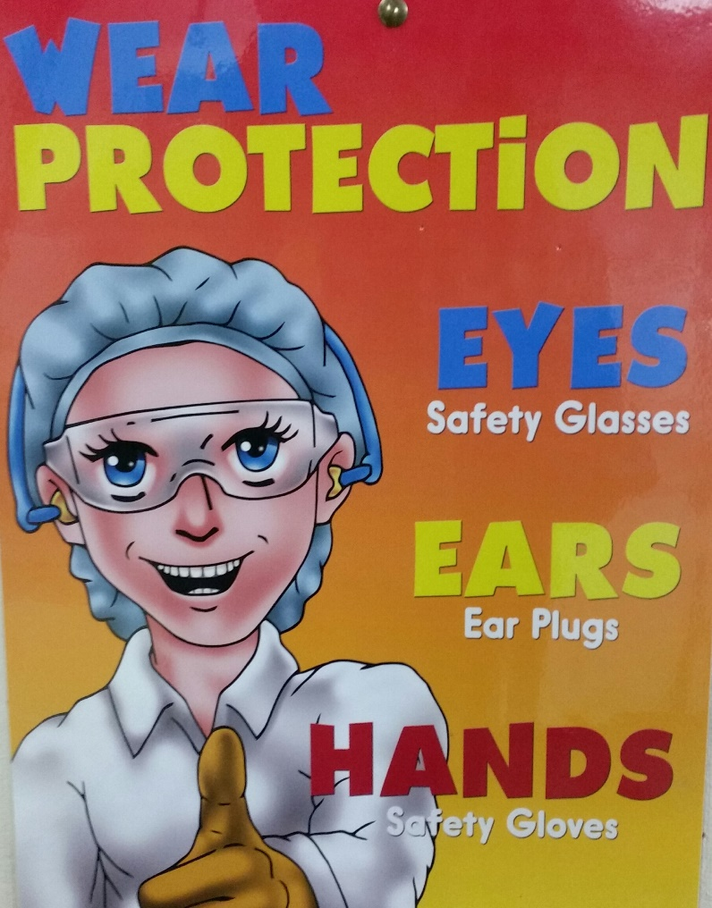  Remember guys Safety first. It only takes a minute to put you safety gear on and it will save you a lot of anguish and heart ache.  As long as you feel pain, you are still alive.  As long as you make mistakes, you are still human.  And as long as you keep trying, there is still hope.  PERSONAL MEMBER PROFILE  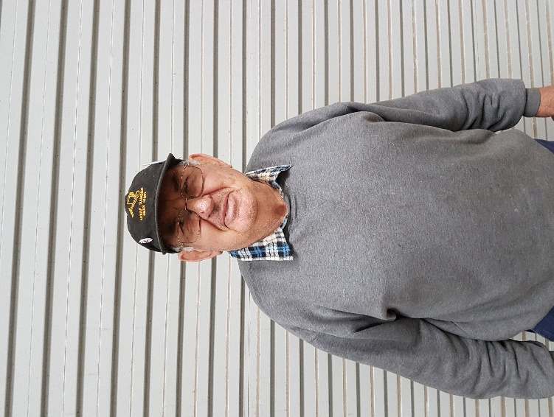  NAME:- Paul Caines  WHERE YOU HAVE WORKED:- Built Sheds and ran own business. Was a semi driver for 5 years. Then back to building sheds under contract.  SOMETHING ABOUT YOU OTHER MEMBERS MAY NOT KNOW:- When Paul first arived at Mount Gambier he was employed as a Police Officer.  WHAT YOU WISH TO DO IN THE SHED:- Help out others where possible and enjoy other members company.  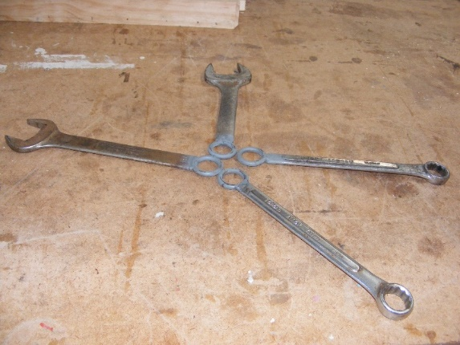  Sometimes they just do not make the right spanner for the machine so thanks Dave for the effort.  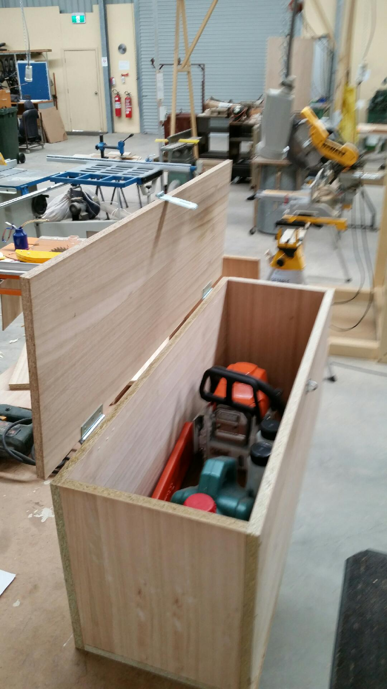  Peter Halleday made this chainsaw utility box for a gentleman who approached us. Job well done.  JUST FOR A LAUGH: Monthly Joke  ABBOTT AND COSTELLO "GET IT" Believe it or not, this gives you one of the best explanations of our current unemployment and that it is still relevant TODAY just goes to show, "History teaches us that history teaches us nothing" COSTELLO: I want to talk about the unemployment rate in America. ABBOTT: Good Subject. Terrible Times. It's 7.8%. COSTELLO: That many people are out of work? ABBOTT: No, that's 14.7%. COSTELLO: You just said 7.8%. ABBOTT: 7.8% unemployed. COSTELLO: Right 7.8% out of work. ABBOTT: No, that's 14.7%. COSTELLO: Okay, so it's 14.7% unemployed. ABBOTT: No, that's 7.8%. COSTELLO: WAIT A MINUTE. Is it 7.8% or 14.7%? ABBOTT: 7.8% are unemployed. 14.7% are out of work. COSTELLO: If you are out of work you are unemployed. ABBOTT: No, Parliament said you can't count the "Out of Work" as the unemployed. You have to look for work to be unemployed. COSTELLO: BUT THEY ARE OUT OF WORK!!! ABBOTT: No, you miss his point. COSTELLO: What point? ABBOTT: Someone who doesn't look for work can't be counted with those who look for work. It wouldn't be fair. COSTELLO: To whom? ABBOTT: The unemployed. COSTELLO: But ALL of them are out of work. ABBOTT: No, the unemployed are actively looking for work. Those who are out of work gave up looking and if you give up, you are no longer in the ranks of the unemployed. COSTELLO: So if you're off the unemployment roles that would count as less unemployment? ABBOTT: Unemployment would go down. Absolutely! COSTELLO: The unemployment just goes down because you don't look for work? | NEW BUSINESS:  - RAA grant money submission for retraining and training in First Aid applied for by Graham Carter.  - Metal top table on casters donated to Port MacDonnell Mens Shed  - Guillotine located in Mt Gambier Mens Shed on share basis with Port MacDonnell Mens Shed  - Metal Folder located at Port MacDonnell Mens Shed for sharing with Mt Gambier Mens Shed  - Mt Gambier Mens Shed signage to be investigated – Peter Halleday ongoing  - NW corner of the car park  - above the front roller door  - A pottery kiln has been delivered from Brett Henke – Sandy Waterhole on the Glenelg  - Biggest Morning Tea – Cancer Council raised $94.45 a few weeks ago.  - Bendigo Bank Defibrillator Sign  15th June Mens shed cluster at Portland shed.  Week 12-18 June 2017 Men’s Health week. Just a friendly reminder to all our men when was the last time you had a check-up at the doctor.  July 6th 10.30am Thursday SAPOL Road Safety for Seniors (date may change) – session booked District get together at our shed. To be announced:  15th August Tuesday Probus Club visit  15th August 12.30 Tuesday  South Aussie Hotel – memorial lunch ‘Barry Memorial Day’ – for members who have passed on or are deceased. Partners of those no longer with us and shedders and partners are invited  17th May 6.30 Wednesday  Dinner to be announced.  16th November 10.00 Thursday COTA SA ‘Moving Right Along’ - safe driving  HEALTH AND WELLBEING  Support and contact as you are able and as Shedders wish  Those with longer term/serious physical issues – Trevor T, Terry R, Peter S, Rob B, Arthur S, Philip V, Peter Halleday, Peter Heness and others recuperating; also partners of Shedders – Glen B.  REMINDERS  - ALL BORROWINGS must be authorised by a member of the Management Committee  and entered in the book by the ‘sign in’ book  - DAMAGED MACHINES – let someone know  - NAME BADGES – please wear  - TOOLS AFTER USE – please return to correct storage  - CAPS for sale $17  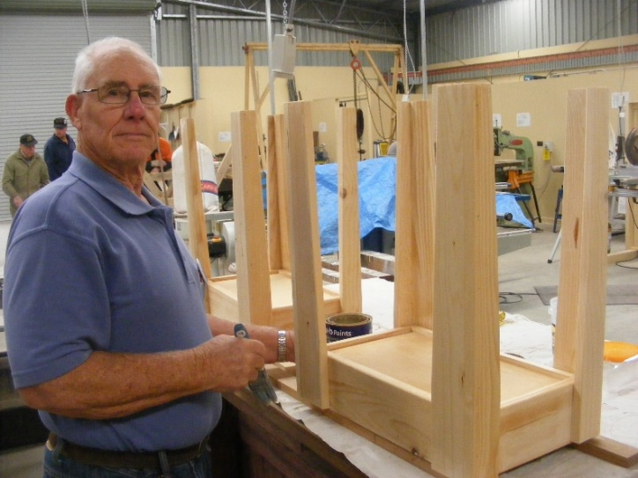  Tim Clarke painting the bowling boxes.  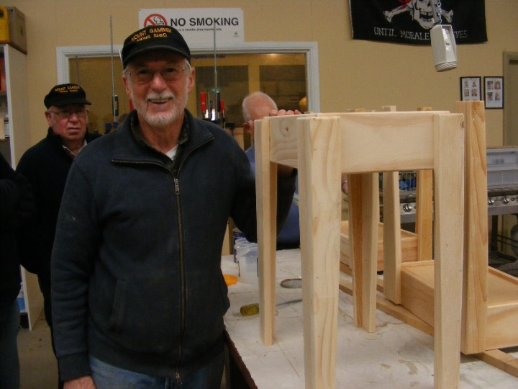  Fantastic job done by Don and his team on these bowling boxes.  Fee Free Workshop on  How to Manage your Money  TAFE SA is offering a FEE FREE 5 hour workshop on "How to Manage your Money" at 36 regional locations for eligible residents in June 2017.  Are you struggling to pay bills, reduce credit card debt, unable to save for that dream holiday or to buy a home? This one day workshop has been designed to provide you with the ability to better manage your money to achieve your goals. Prerequisites: None Workshop Participants: This workshop is designed for regional community business owners, partners, employees and residents of regional communities. Workshop Contents: The workshop provides participants with skills and knowledge for saving money, managing debts and mortgages, budgeting for expenses, determining insurance needs and utilising banking services. Workshop Delivery: This workshop will be conducted by Financial Services training professionals with extensive experience in financial products and services in a classroom environment. Participants money management skills and knowledge will be developed through the application of practical examples and day to day scenarios. Workshop Locations: The workshop will be offered at Bordertown, Coonalpyn, Keith, Kingston SE, Mannum, Millicent, Mount Gambier, Murray Bridge, Naracoorte, Robe, Tailem Bend. Workshop Timetable: Two session times are available (Morning 9am-2pm / Evening 4pm-9pm Training Materials: All necessary training materials are provided. Fee Free Eligibility: This workshop is fee free for eligible residents of regional communities in South Australia. Fee Free Eligibility conditions are as follows: Student must reside in a Regional Community in Regional South Australia from an eligible location. Please go to the SRC and RD Locations to check location eligibility. - Student must be an Australian Citizen or Permanent Resident - Students cannot be enrolled under any other funded program for the same service -Training must be either On Campus, or a mix of On and Off Campus  For further information contact: FJP.online@tafesa.edu.au / (08) 7210 3841  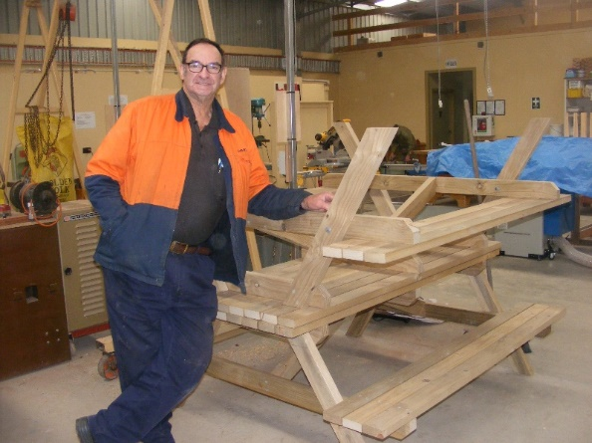  Dave standing by the tables for AC Care that he and Peter built.  ABBOTT: Absolutely it goes down. That's how it gets to 7.8%. Otherwise it would be 14.7%. COSTELLO: Wait, I got a question for you. That means there are two ways to bring down the unemployment number? ABBOTT: Two ways is correct. COSTELLO: Unemployment can go down if someone gets a job? ABBOTT: Correct. COSTELLO: And unemployment can also go down if you stop looking for a job? ABBOTT: Bingo. COSTELLO: So there are two ways to bring unemployment down, and the easier of the two is to have people stop looking for work. ABBOTT: Now you're thinking like an Economist. COSTELLO: I don't even know what the hell I just said! ABBOTT: Now you're thinking like a Politician.  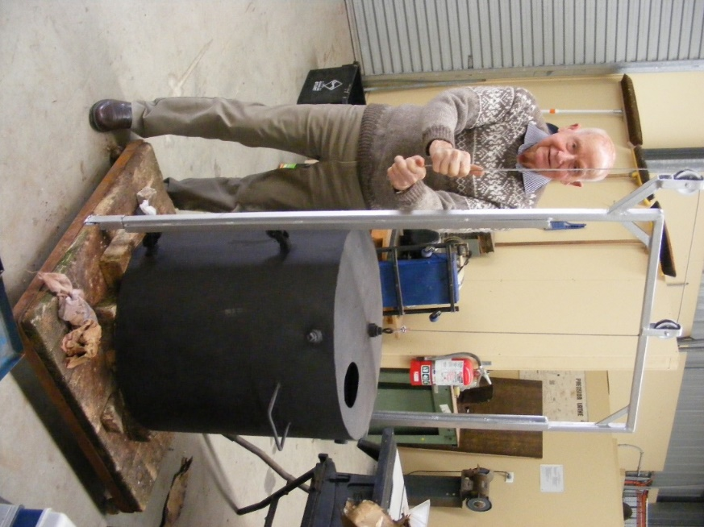  Kelvins’ kiln is slowly coming together.

