OFFICE BEARERS FOR 2017  PRESIDENT : Peter Halleday 0439500699  VICE PRESIDENT : Ansi Nitz  TREASURER : John Plunket  SECRETARY : Paul Edgeworth 0497386846  COMMITTEE : Dave Lawson  Glen Bowmer  Don Clements  Arthur Smith  Graham Carter  APPOINTMENT OF LEADERS for 2017 –  Work Health Safety Rob Burford/Graham Carter – joint management  Senior First Aiders Peter Halleday/Ansi Nitz – joint management  Building Fitout /Maintenance Peter Halleday/ Don Clements – joint management  Projects Don Clements  Social Organiser Dave Lawson  Webmaster Dave Lawson  Fund Raising Ansi Nitz  (Race Gates Brian Short)  Grant monies submission writer Graham Carter  Publicity Officer/ News Editor Peter Heness  Historian Graham Carter  Membership Support Brian Short  Kitchen Management Norman Collins  UPCOMING / ONGOING PROJECTS  - Historic local CHINESE HAND FRUIT CART repair – consultations happening  Peter Ha  - CHRISTMAS PARADE FLOATS - Mt Gambier City Council, waiting for CC to get back to us – Peter Ha  - AEROPLANE restoration – Grant District Council - handed back with suggestions  - Mt Gambier City Band – MUSICAL INSTRUMENT TROLLIES – Don C  - Reassemble the SHED FLOAT for the Christmas Parade –Peter Heness ------  - ROUTING SOME TIMBER LENGTHS for a Mt Gambier History Group public display - Don C  - Boandik Dementia unit – 2 raised garden beds –Dave and crew  THANKS to  - Dave Lawson for represent the Shed at the Portland District gathering  - Wayne Earle for supporting Australian Hearings 50th birthday celebration, representing the Shed  - ABC live radio and 5SE taped District Mens Sheds’ reports and NEWSLETTER - Peter Heness  - PRIVATE SHED CLEARANCE 15th June – Arthur S, Paul C, Graham Carter, Don Clements, Peter Halleday, Paul Edgeworth, Ian Bond, Dave Lawson, Geoff Hart  Final clearance 29th June – Paul E, Don C, Brian S, Paul C  - All the sorters with the mammoth task  - 29th June – Don C, Paul C, Paul E, Brain S  - Don C for rebuilt a footstool for the donor  - Bunnings Sausage day 2nd July - Arthur S, Terry G, Ian B, Linden M, Geoff H, Phil V, Graeme R, Paul C, Don C, Dave L  - Don C and Peter Ha for supporting the Boandik Lodge Mens group visit  - Graham C and Peter Ha for preparing and submitting a request for grant monies through Round 15 AMSA for First Aid Training and a Band Saw  - Scones – Norman C, Arthur S, Terry R and Terry G  - Wall shelves – Don C construction with Tim C painting  - Kelvin S for mounting the high temperature kiln on wheels  - Dave L and crew for constructing the next raised garden bed  - Dave L for organising tea at Belgiorno’s - 10 attended  - Rob B for ongoing monthly electrical asset testing and tagging  Welcome to SAFETY:  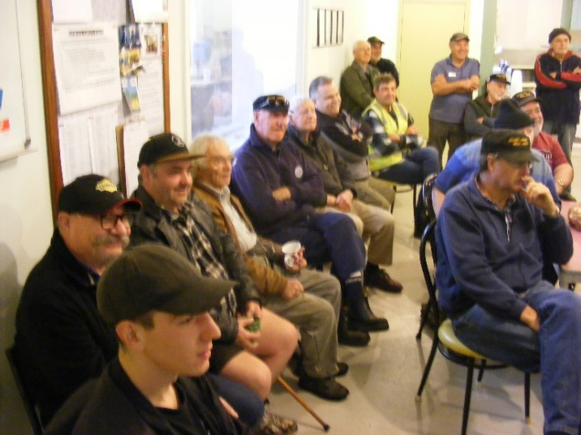  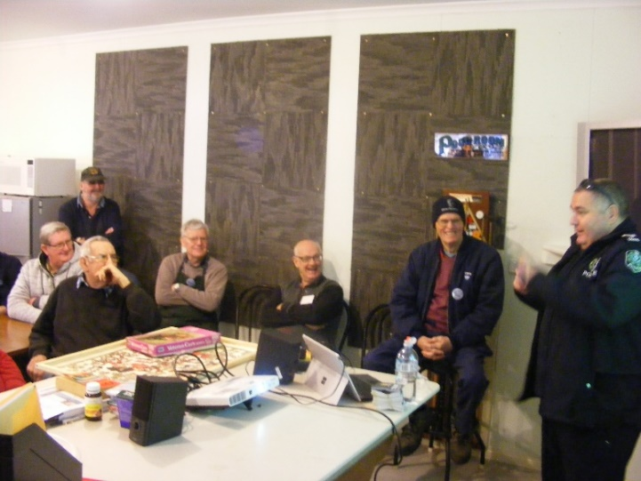  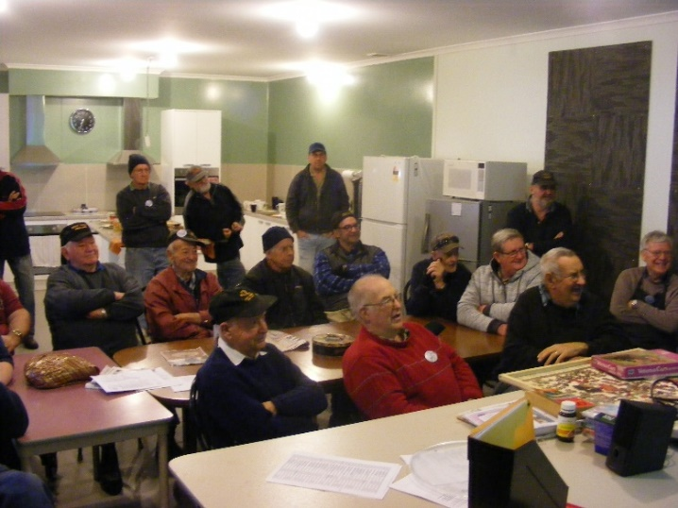  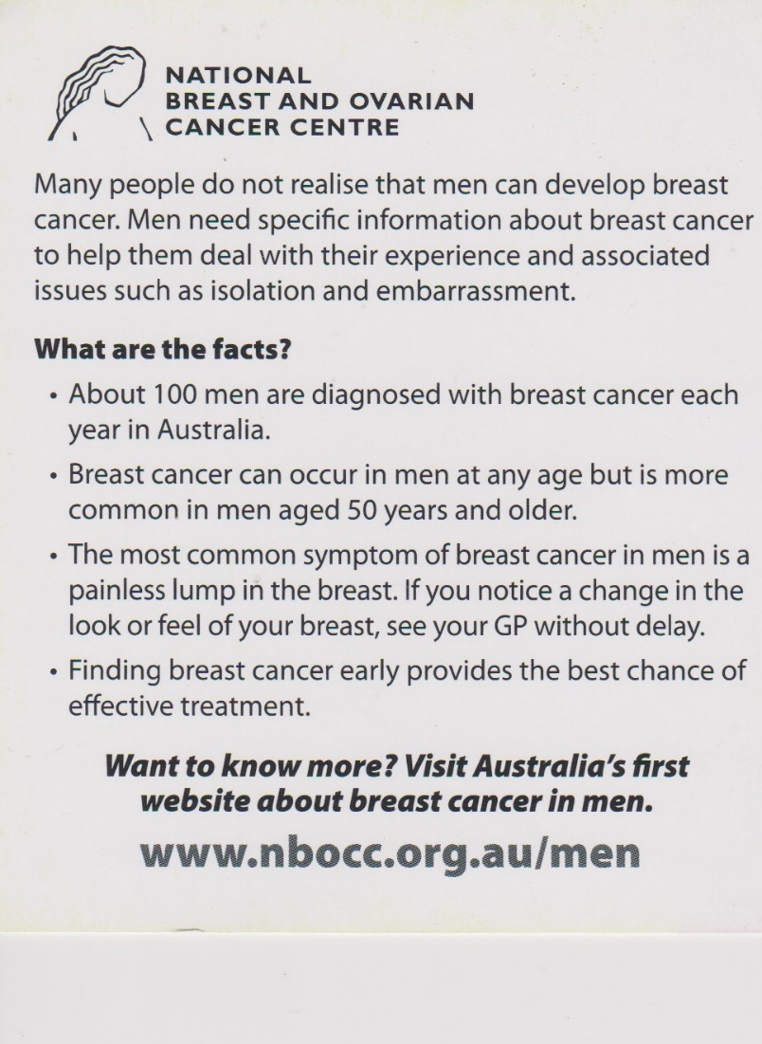    The day following the Heywood Mens Health day we have booked a representative of the MOTR (Men on the Run - a Motor Cycles club based in Warrnambool - a volunteer organisation) for a 10.00 session at our Shed - Thursday 24th August.  JUST FOR A LAUGH: Monthly Joke  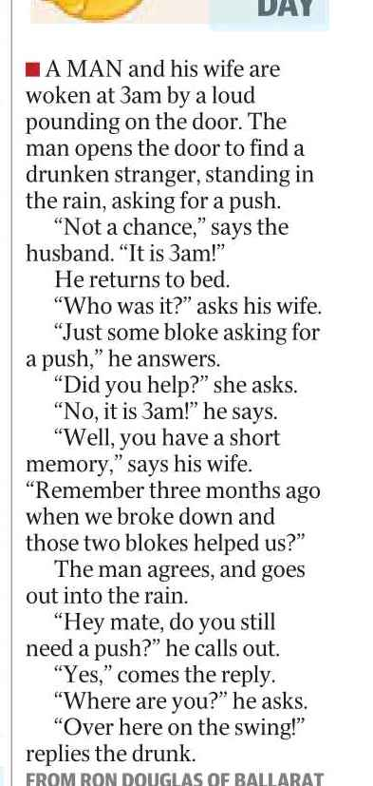  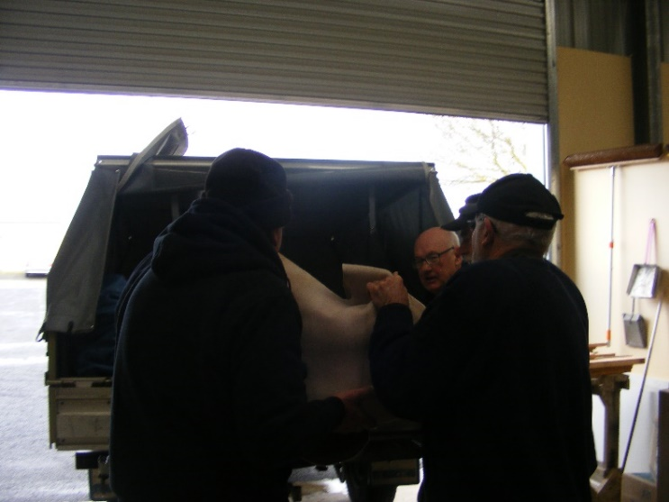  Doug N , Ansi N and John P loading carpet.  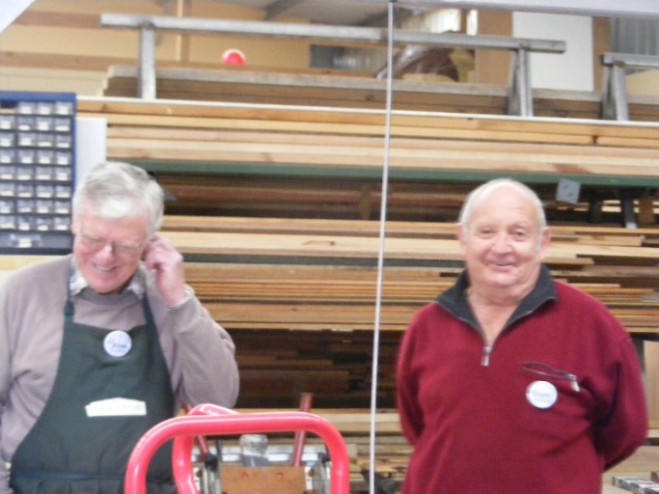  Jim T- What is that you are listening to, not Graeme R  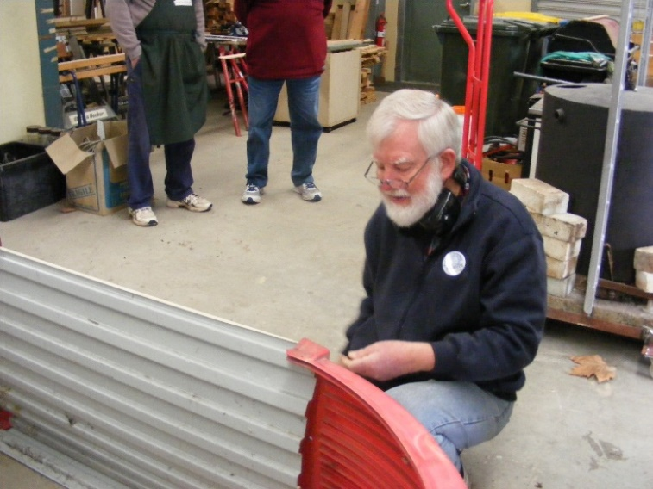  Neville D working on the Boandik project  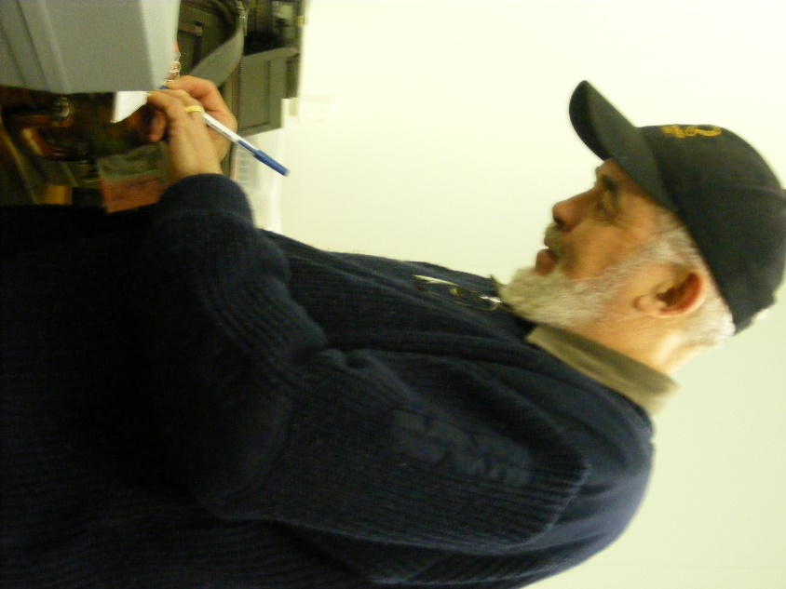  John P now who did this cash belong to not me so I better put it in the shed.  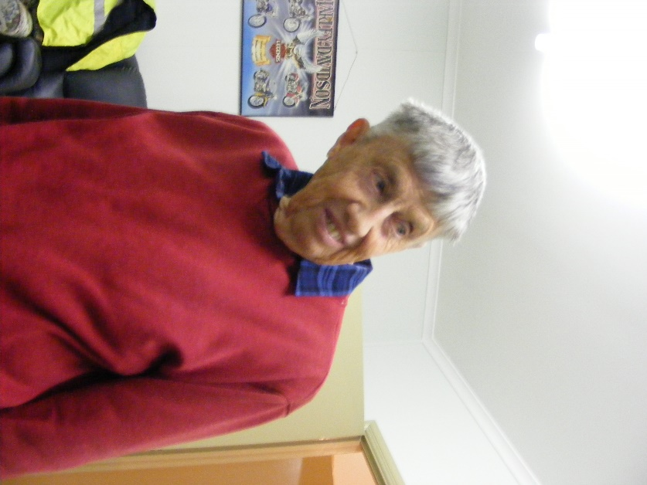  Trevor J Joined us again. | - TOY MAKING for Mayors Christmas Appeal - Ian B and Peter Heness  Mitre 10 has agreed to assist with paint  - SMALL PLANTER BOXES – Laurie T  NEW BUSINESS:  15th August Tuesday  Probus Club visit  NOTE CHANGE to Memorial Day and time  17th August 12.30 Tuesday  South Aussie Hotel –lunch ‘Barry Memorial Day’ for remembering members who have passed on. Partners of those no longer with us and shedders and partners are invited.  12th September Tuesday 11.10  Australian Hearing talk – Phil Mann 13th September Wednesday District Sheds get together at Hamilton 13th September Tea at Gourmet India (99 Commercial St East) 16th November 10.00 Thursday COTA SA ‘Moving Right Along’ - safe driving  - Date to be advised – negotiating with Tony Pasin  a chat with Shedders  - visit to /from Millicent Mens Shed to be advised  - Heywood Mens Shed are organising the annual Good Health afternoon – date to be advised  HEALTH AND WELLBEING  Support and contact as you are able and as Shedders wish  Those with longer term/serious physical issues –Terry R, Peter S, Norman C, Frank H, Rob B, Arthur S, Philip V, recuperating; also partners of Shedders – Glen B.  Good to have Don L, Ansi, Ray and Shorty back on board from their illnesses.  WELCOME to new members:  Lyndon Manser, Myles Geraghty, Allan Compton  Birthday’s this month  David Burt 4th  Don Clements 5th  Paul Edgeworth 7th  Gary Vandepeer 13th  Don Latty 14th  Rob Burford 23rd  Frank Hill 26th  REMINDERS  - ALL BORROWINGS must be authorised by a member of the Management Committee  and entered in the book by the ‘sign in’ book  - DAMAGED MACHINES – let someone know  - NAME BADGES – please wear  - TOOLS AFTER USE – please return to correct storage  - CAPS for sale $17  PERSONAL MEMBER PROFILE  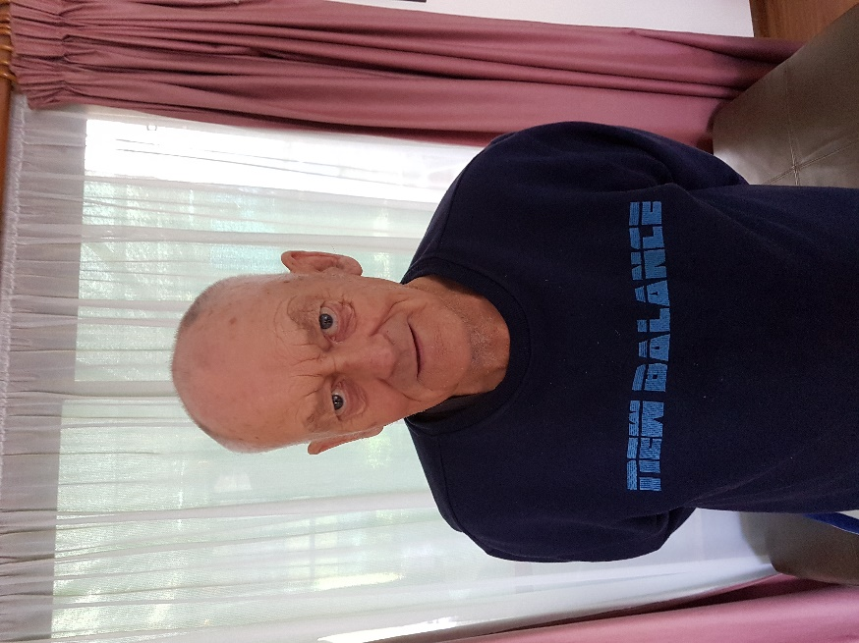  NAME:- Brian Short ( SHORTY )  WHERE YOU HAVE WORKED Numerous amount and Various jobs.  SOMETHING ABOUT YOU OTHER MEMBERS MAY NOT Was a fair haired little bugger when he was young. Loved getting into trouble. He helped build the Melbourne Underground rail system, drove the cement trucks that supplied the cement.  KNOW:- WHAT YOU WISH TO DO IN THE SHED:- Be able to participate and help where possible with others and enjoy their commeradery.  ROAD SAFETY FOR SENIORS and younger  Twelve months ago our Mens Shed invited Senior Constable Nigel Allen from the SA Police Safety Division to speak with us.  It was found in that session many gaps or misinterpretations of the road rules and safe driving, were common amongst Shedders.  As our membership has increased significantly over the last year and there was a perceived need for visiting this information frequently, Senior Constable Nigel was invited again. This year’s session had the biggest attendance of Shedders for a single event ever.  If you got something right you might have gotten a police car squeeze ‘ball’. If not – a pocket edition of the Road Rules was airmailed. Fortunately more squeeze balls were handed out than the other and we did much better than last year.  This year’s session firstly focused on the many situations where Give Way is required, whether signed or not. This does not mean though that you demand to be given way to. Always choose safe driving practices.  It appeared the most misunderstood rule was when two lanes merge into one.  When there is no dotted line at the end of the two lanes- the car behind Gives Way to the one in front (even if it is just in front – as Nigel said, even by a bumper bar width).  When there is an ongoing dotted line which is marking your left lane and your left lane ends – you give way to all vehicles in the right lane, even if it means you having to stop.  Mush discussion was had about simplifying these rules for consistency – but that is as it stands now.  There was a bit about cycle lanes – keep your vehicle a metre (roughly a door open width) away from a cyclist when in an under 60 kph zone and 1.5 m away when in an over 60kph zone.  Remember the joke about telling if the cyclist was under or over 60!  Alcohol  Senior Constable Nigel spent time in demonstrating (not by drinking) how the level of drinks in the various ‘glasses’ can affect how much alcohol has really been drunk.  Then the aging stuff  – how our eye sight changes around 60 years of age and how less distinct things become around 75 ( a brilliant set of photos)  - usually we drive better as we are more experienced and slower for the road and weather conditions but our reaction time often is longer. Some have neck problems and can’t turn easily to check to the side and behind – a chiropractor may assist.  And there was so much more.  We plan to have these sessions regularly.  To brush up on your understanding there are more Pocket Rule booklets at the Shed or go online – mylicence.sa.gov.au / road rules  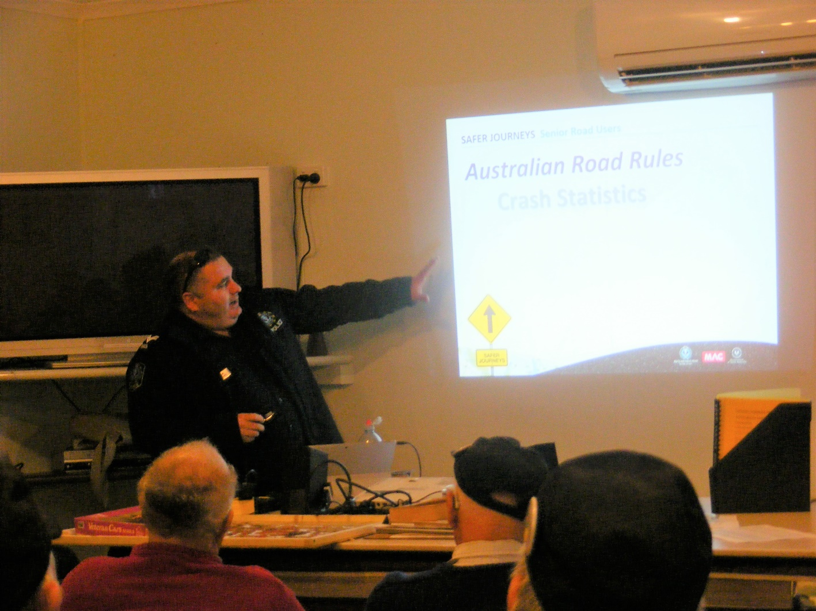  John Walker (yes, he was born in the Scottish town where the whiskey was made) and his partner Maureen will come across from Heywood.  John was originally a tradie but moved into a counselling role in Scotland, Canada and now volunteers here in Australia. He has worked with a number of Police Forces, many Mens Sheds and a host of other organisations.  He is a story teller but has a message of 'assisting men to build resilience to cope with the pressures of modern life'.  The Cat in the Hat on Aging  I cannot see  I cannot pee  I cannot chew  I cannot screw  Oh, my God, what can I do?  My memory shrinks  My hearing stinks  No sense of smell  I look like hell  My mood is bad - - can you tell?  My body’s drooping  Have trouble pooping  The Golden Years have come at last  The Golden Years can kiss my ----------.  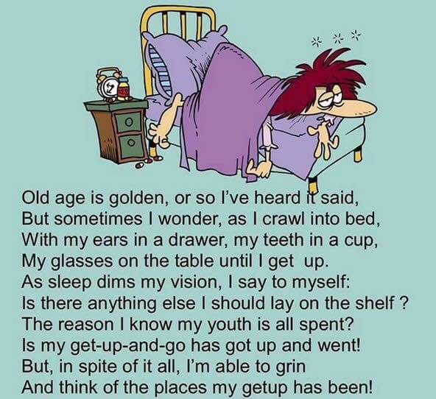  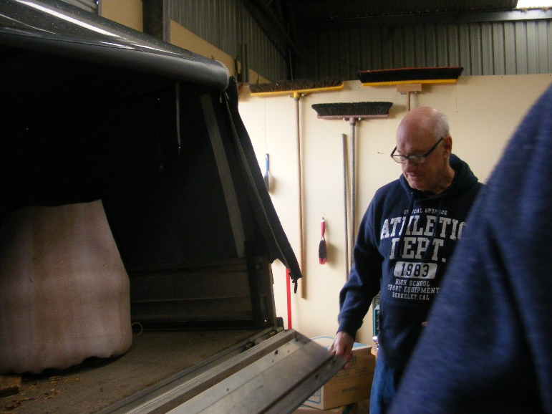  Doug R contemplating the loaded carpet.  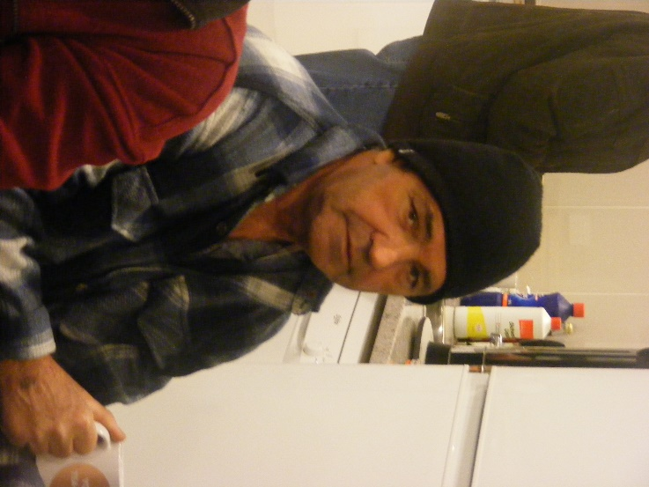  Joe P enjoying a cuppa  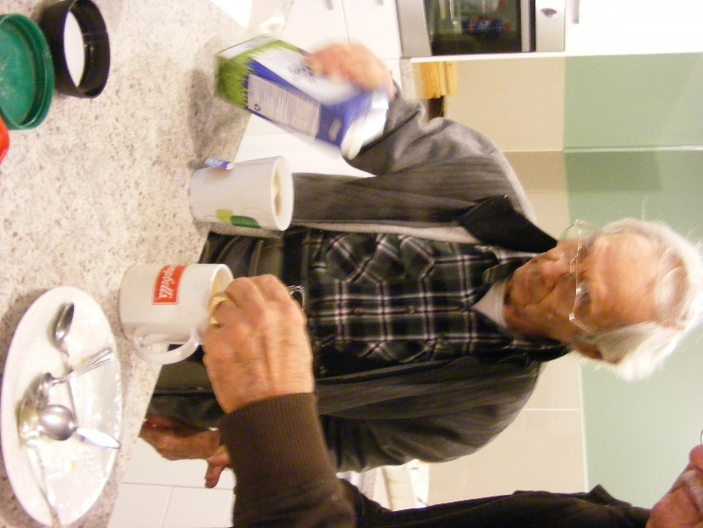  Steady Frank H is ready for his cuppa and scone.  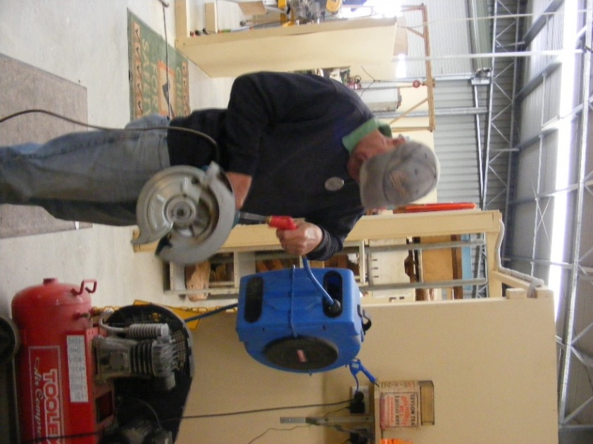  Who is that doing all the blowing.

