OFFICE BEARERS FOR 2017  PRESIDENT : Peter Halleday 0439500699  VICE PRESIDENT : Ansi Nitz  TREASURER : John Plunket  SECRETARY : Paul Edgeworth 0497386846  COMMITTEE : Dave Lawson  Glen Bowmer  Don Clements  Arthur Smith  Graham Carter  APPOINTMENT OF LEADERS for 2017 –  Work Health Safety Rob Burford/Graham Carter – joint management  Senior First Aiders Peter Halleday/Ansi Nitz – joint management  Building Fitout /Maintenance Peter Halleday/ Don Clements – joint management  Projects Don Clements  Social Organiser Dave Lawson  Webmaster Dave Lawson  Fund Raising Ansi Nitz  (Race Gates Brian Short)  Grant monies submission writer Graham Carter  Publicity Officer/ News Editor Peter Heness  Historian Graham Carter  Membership Support Brian Short  Kitchen Management Norman Collins  UPCOMING / ONGOING PROJECTS  - Folding garden table  - Raised garden beds  - Mike Kasparian for metal welding in 2017  - ‘Buddy Bench’  - AC CARE Park 2 Benches  - Hallmont Bowling high rise ball holding tables  - ‘Fruit Boxes’ – a dozen + constructed by Peter Halleday and team and donated to the Royal Society for the Blind as display boxes.  - Rolling Pins Request  PERSONAL MEMBER PROFILE  NAME:- Glen Bowmer: 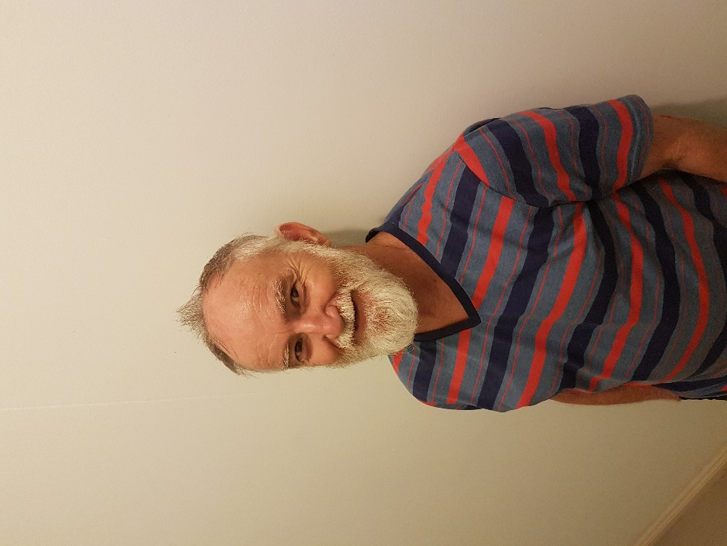  WHERE YOU HAVE WORKED:- before retireing worked at the Australian Post Office.  Starting in telegrams, then moving to a postage, onto a sorter and finally ending up as the supervisor.  SOMETHING ABOUT YOU OTHER MEMBERS MAY NOT KNOW:- Glen has a nickname even though he has never ridden a horse of JOCKEY. He was also in the Coast Guard and once received an award for a rescue.  WHAT YOU WISH TO DO IN THE SHED:-Learn as much as possible meet new friends and learn how to use a wood lathe.  Notes :  - If the cancer has not escaped to elsewhere in the body there is a 93% likely hood of 5 to 10 more years.  - Many men die with Prostate Cancer not because of it. They die of other things.  - More men are diagnosed with Prostate Cancer than women with Breast Cancer.  - By age 75, 1 in 7 and by age 80, 1 in 4 will be diagnosed.  - Warrnambool currently has the best services and equipment with the new Royal Adelaide matching the equipment.  - The Shed was given a range of booklets and information sheets (see the boxes in the office).  - There are also DVD’s of ‘Pelvic Floor Exercises for Men’  - An enlarged prostate is totally different – this is where the urine tube is squeezed shut. This is fixed with a rebore. It is usually not cancerous.  - Secondary cancers like bone and brain are still prostate cancer.  An invitation was given to attend meetings – see the brochure. Thanks Richard and Malcolm  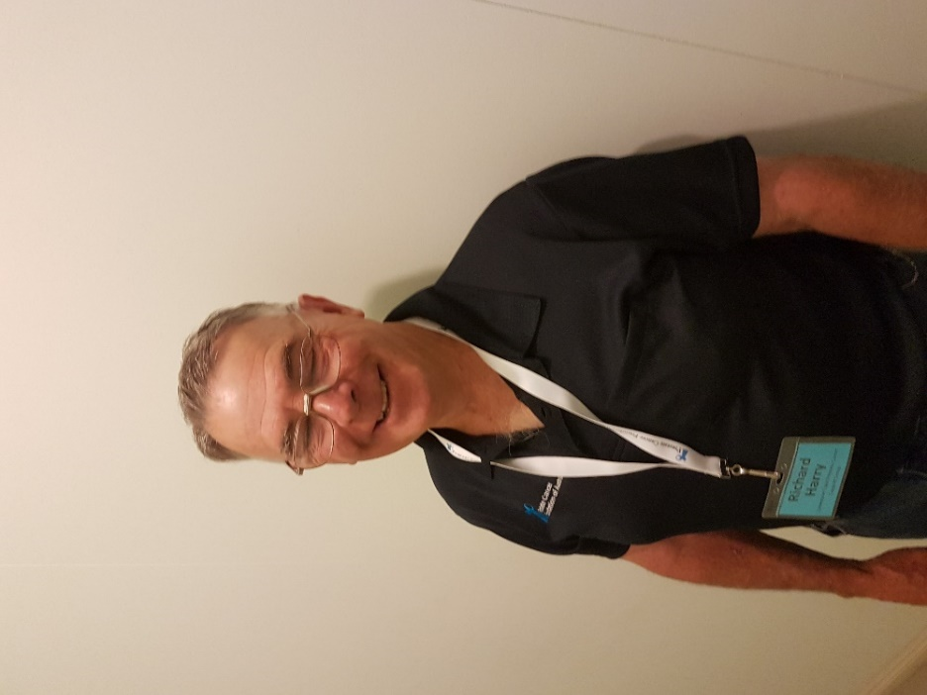  Richard Harry presenter  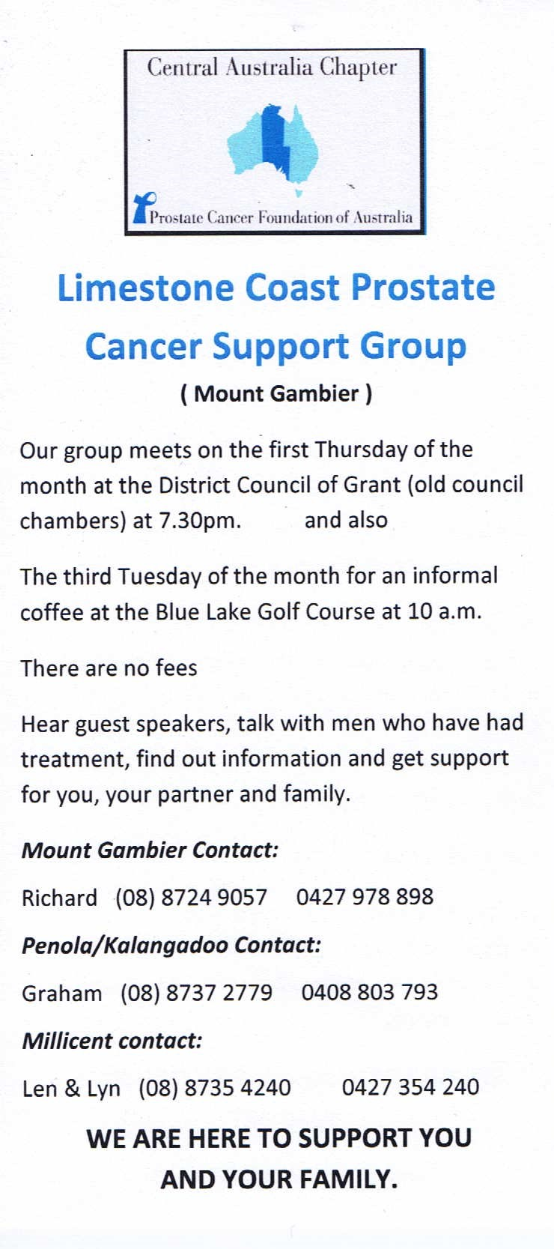  Finished and ready for installing.  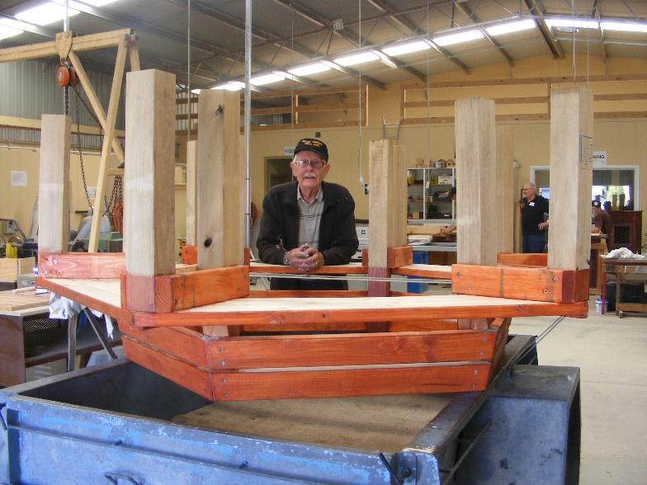  Ray checking out some of his and dave’s handy work. | March 8th 6.30pm Wednesday Tea get together – FACT April 1st Saturday Bunnings sausage sizzle. April 7th Friday Race Gates ticket selling Glenburnie May 11th Thursday Race Gates ticket selling Glenburnie May 12th Friday Race Gates ticket selling Glenburnie July 6th 10.30am Thursday SAPOL Road Safety for Seniors (date may change) – session booked To be announced: District get together at our shed. SAPOL Road Safety.  REMINDERS  - all borrowings must be authorised by a member of the Management Committee  - and entered in the book by the ‘sign in’ book  Welcome to SAFETY: This is still the same as It is very important.  Only a short safety this month and my saying is always, and I mean always, remember that it takes a split second to do some major damage to yourself so. So if and where possible wear gloves and make sure, if you have a guard you use it. And if you see that there should be a guard then report it as soon as possible. WE DO NOT NEED OR WANT ANYONE OF OUR FRIENDS HURT OR INJURED.  PROSTATE CANCER AWARENESS  LIMESTONE COAST PROSTATE CANCER SUPPORT GROUP  In February, our Shedders were given personal insights into Prostate Cancer by two local chaps, Richard Harry and Malcolm Porter – both with very different experiences of diagnosis and treatment.  Over 40’s - get yourself checked annually through a blood test which gives a PSA reading.  You watch for either a gradual change in level or a spike – and ask your doctor to compare levels each year -don’t leave it just to your doctor.  The first reading sets the level for comparing each test that follows.  An initial reading near 0 or even much higher (for say a bike rider who irritates the groin area) may be quite normal. It is the upward change that needs further checking by a urologist.  Richard had a first PSA test reading of 5 in 2006. His doctor suggested it was a bit high for his age and left it at that. Richard didn’t realise he should have asked for more information. This was a big mistake because 4 years later it had risen to 15 and within a fortnight of the second test it had rocketed to 20. His option then was radical surgery.  If detected earlier there could have been other treatments.  Malcolm was fortunate to have a ‘fill-in’ doctor who noticed a change in his PSA readings from 4 to 8 through a 6 month check. More tests were ordered with a urologist surgeon. 8 out of the 12 biopsies (bits removed from the prostate) showed cancer cells. He was advised to have radical surgical removal of the prostate.  Through a chance meeting with members of the local support group he found there were alternative treatments including Brachytherapy - the injection of radio-active seeds that kill the cancers. He is a survivor of this treatment. His PSA is currently 0.03 (negligible) and is he is alive.  Malcolm Porter - Richards helper  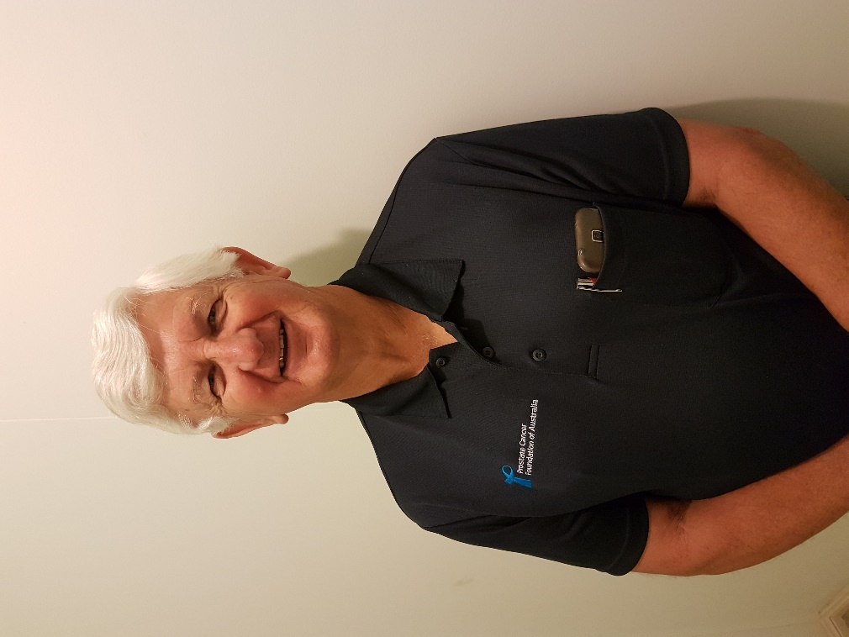  Richard and Malcolm have also asked if any other sheds in the area would like them to talk to their members then please do not hesitate to give them a call.  JUST FOR A LAUGH: Monthly Jokes  A man stuck his hand out the window to see if it was raining.  As he reached out, a glass eye fell into his hand.  Looking up, he saw a gorgeous young woman looking down from the apartment above.  “Is this yours?” he asked.  “Oh, thank you!” she replied. “Can you bring it up?”  Upstairs, she offered him a drink, which he eagerly accepted, then invited him to stay for dinner.  “Wow,” the man responded. “Do you act this way with every man you meet?”  “Of course not,” the women said. “But you caught my eye.”  “Buddy Chair”  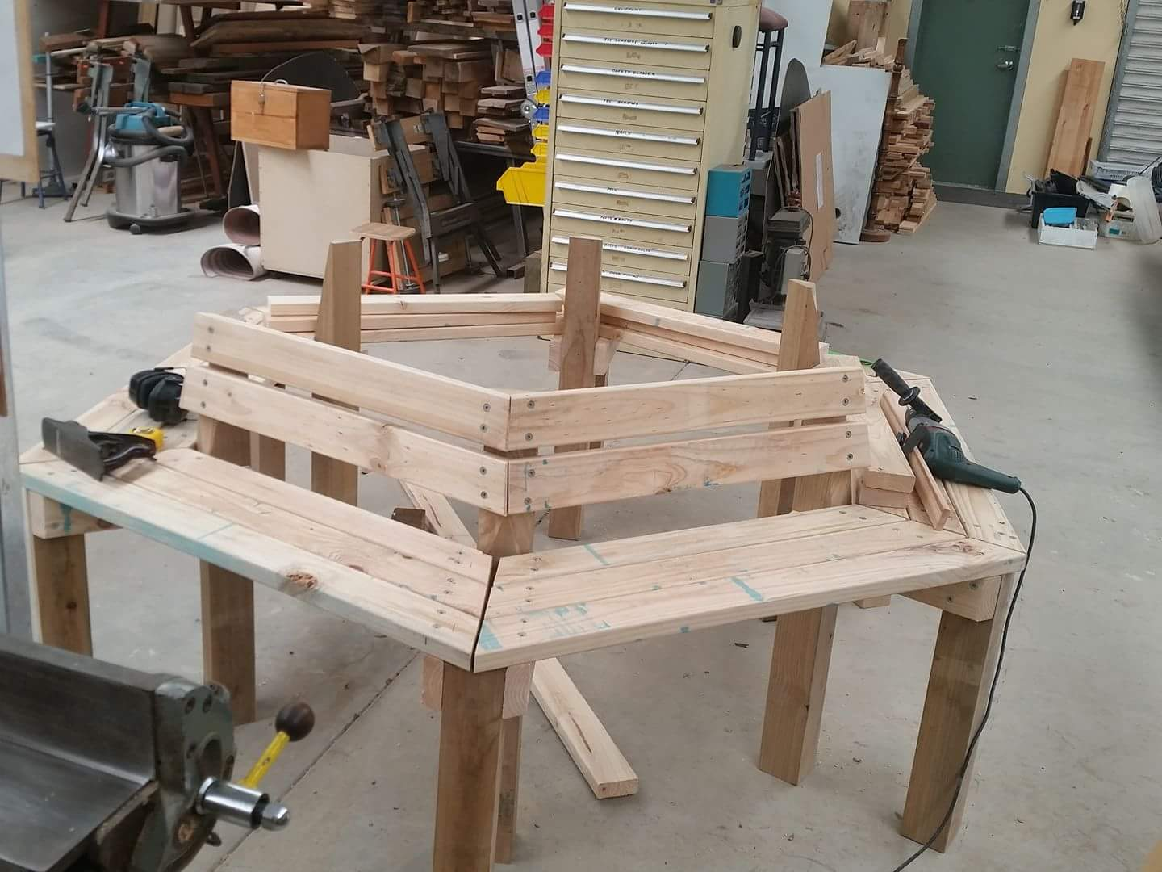  Dave and Ray with it nearly finished.  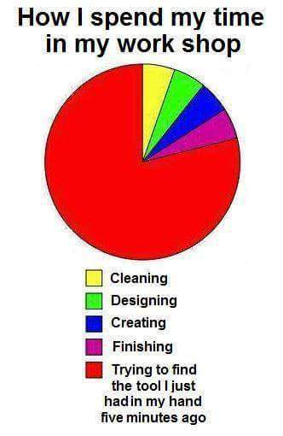  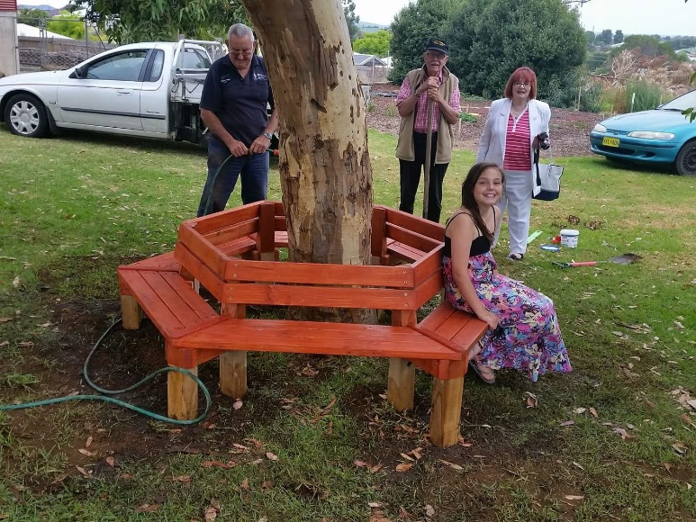  Paul, Ray and Vicki and seat tester, and finally the Buddy Chair is installed.

