OFFICE BEARERS FOR 2017  PRESIDENT : Peter Halleday 0439500699  VICE PRESIDENT : Ansi Nitz  TREASURER : John Plunket  SECRETARY : Paul Edgeworth 0497386846  COMMITTEE : Dave Lawson  Glen Bowmer  Don Clements  Arthur Smith  Graham Carter  APPOINTMENT OF LEADERS for 2017 –  Work Health Safety Rob Burford/Graham Carter joint management  Senior First Aiders Peter Halleday/Ansi Nitz – joint management  Building Fitout /Maintenance Peter Halleday/ Don Clements – joint management  Projects Don Clements  Social Organiser Dave Lawson  Webmaster Dave Lawson  Fund Raising Ansi Nitz  (Race Gates Brian Short)  Grant monies submission writer Graham Carter  Publicity Officer/ News Editor Peter Heness  Historian Graham Carter  Membership Support Brian Short  Kitchen Management Norman Collins  UPCOMING / ONGOING PROJECTS  - Mt Gambier City Band – MUSICAL INSTRUMENT TROLLIES – Don C  - TOY MAKING Foodbank plastic bag dispenser – Peter Halleday  - Sound Box Acoustic design for Rotary generator Ray L  - PICNIC SETTING for Stephen Sylvester’s family memorial near Penola  - NATURE GLENELG TRUST Eagle Hawk Swamp shearers hut – bird boxes, kitchen sink bench top, insect display box (2- 3months time) –Dave Lawson  - ST MARTINS SCHOOL playground equipment and seating  - PLANTER BOX AND SEAT – Wayne E (for George R)  - PICKET FENCE - (for Vicki Lazenby)  - RAISED GARDEN BEDS – another made, more to come  Just a laugh  This is a story about a couple who had been happily married for years, the only friction in their marriage was the husband’s habit of farting loudly every morning when he awoke the noise would wake his wife and the smell would make her eyes water and make her gasp for air. Every morning she would plead with him to stop ripping them off because it was making her sick. He told her he couldn't stop it and that it was perfectly natural. She told him to see a doctor, she was concerned that one day he would blow his guts out. The years went by and he continued to rip them out. Then one Christmas day morning, as she was preparing the turkey for dinner and he was upstairs sound asleep, she looked at the innards, neck, gizzard, liver and all the spare parts, and a malicious thought came to her. She took the bowl and went upstairs where her husband was sound asleep and, gently pulling the bed covers back, she pulled back the elastic waistband of his underpants and emptied the bowl of turkey guts into his shorts. Sometime later she heard her husband waken with his usual trumpeting which was followed by a blood curdling scream and the sound of frantic footsteps as he ran into the bath room. The wife could hardly control herself as she rolled on the floor laughing, tears in her eyes! After years of torture she reckoned she had got him back pretty good. About twenty minutes later, her husband came downstairs in his blood stained underpants with a look of horror on his face. She bit her lip as she asked him what was the matter. He said, “Honey you were right… all these years you have warned me and I didn't listen to you.” “What do you mean?” asked his wife. “Well, you always told me that one day I would end up farting my guts out, and today it finally happened, but by the grace of god, some Vaseline and two fingers. I think I got most of them back in…  Thanks to the Mallala Mens Shed newsletter for this joke.  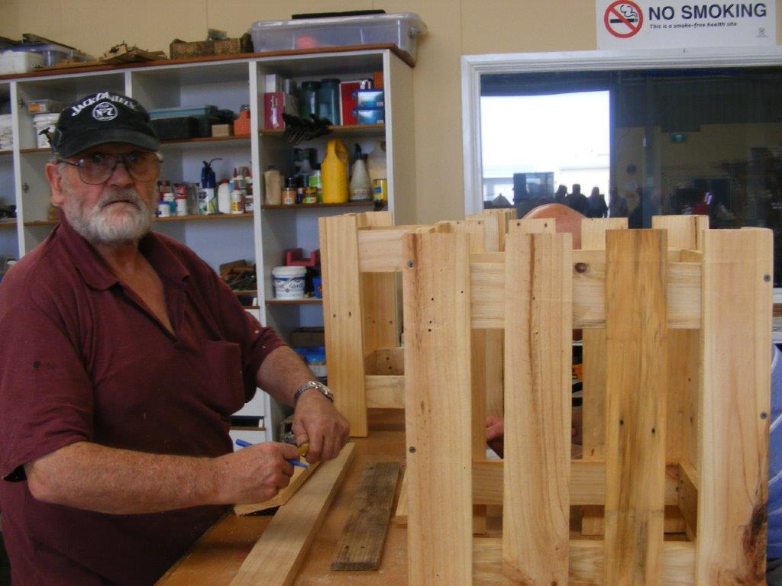  Wayne E taking the planter box suround seriously  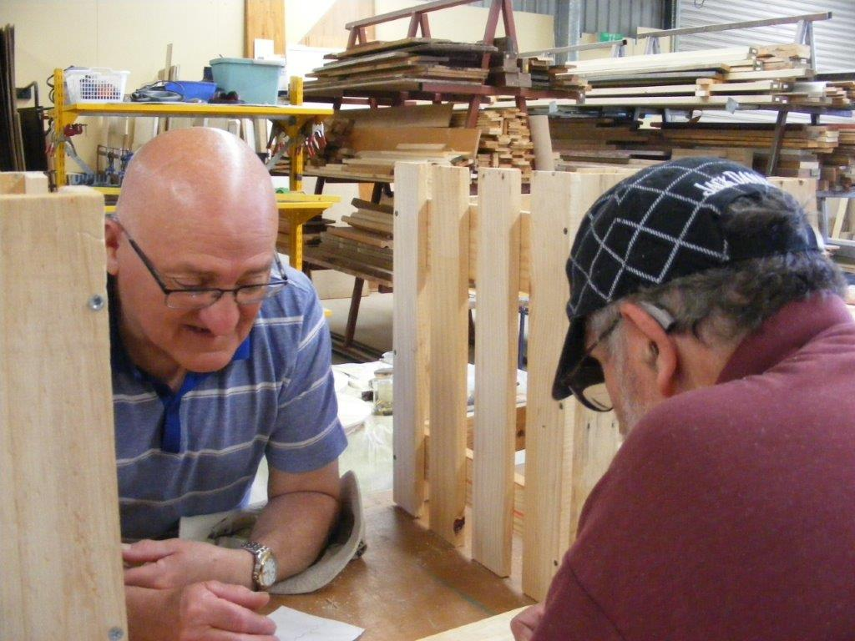  Wayne E and George R consulting each other on the way to build their planter boxes  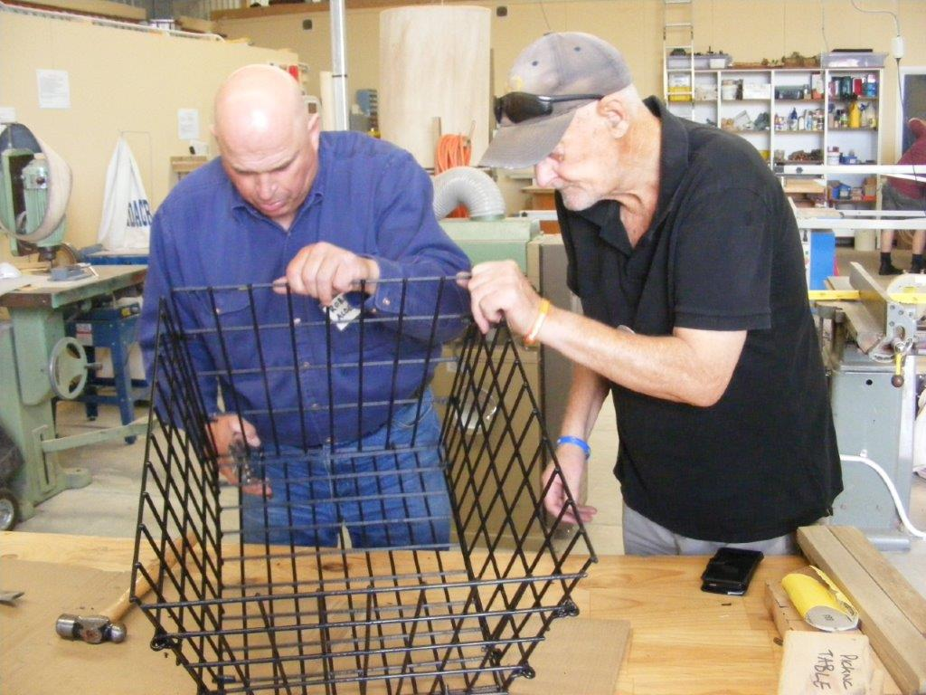  Robert A and Brian S working on the trike basket  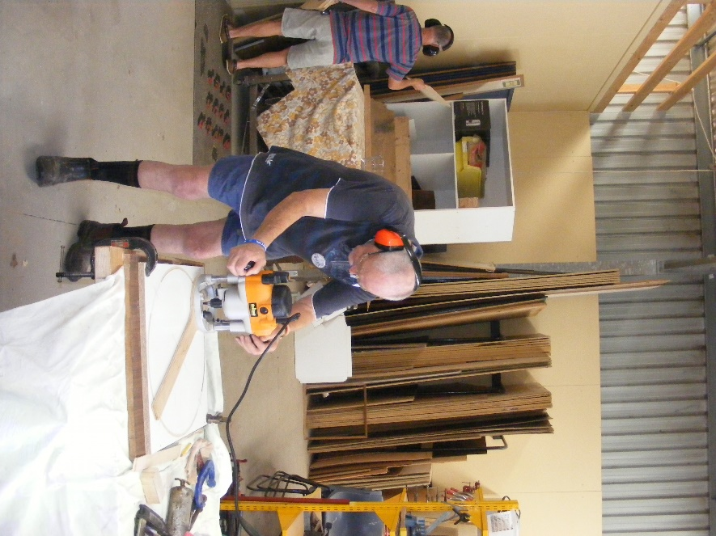  Brian S making sure that his circle work is perfect look at the concentration.  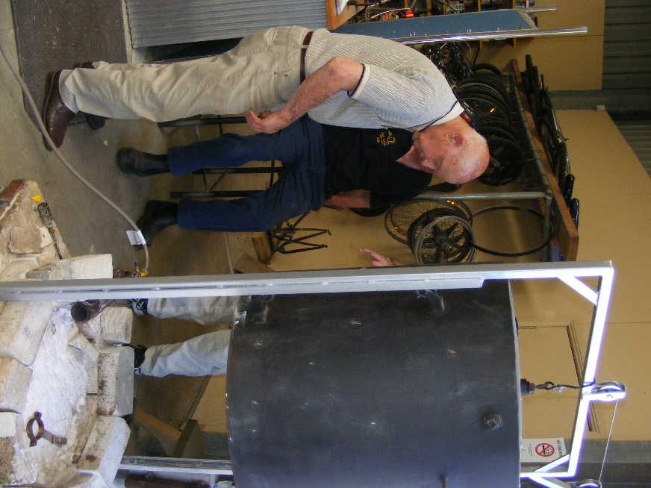Kelvin S checking the gas suply ready for when the pottery starts | THANKS to  ABC live radio and 5SE taped District Mens Sheds’ reports and NEWSLETTER - Peter Heness  Scones – Norman C, Arthur S, Terry R & Terry G  Dates to remember 6th January - Saturday 2018 – 8.30 am names - Dave L, Don C, Peter Ha, Geoff H  12.00pm till 3.30/4.00 -Peter He, Paul E, Phil V, Brian S, Ian B 11th January Thursday 10.00 Shed Members Meeting 18th January Thursday 10.00 Re Use meeting with Aaron Izzard City Council 25th January Thursday 10.00 ‘CPR 30 minute’ training with Joe Renko  HEALTH AND WELLBEING - Support and contact as you are able, and as Shedders wish. Those with longer term/serious physical issues –Peter S, Ces Jones, Trevor Twilley  Keith Reichelt (daughter – going well now), Terry Radford’s son and others recuperating;  Also partners and families of Shedders Those with critical or ongoing psychological and brain issues – Don L Laurie Tricker is back with us. Trevor Twilley and Trina are still in need of your thoughts Remember too; Peter Schutz, Those with critical or ongoing psychological and mental issues Other REMINDERS ALL BORROWINGS must be authorised by a member of the Management Committee and entered in the book by the ‘sign in’ book DAMAGED MACHINES – let someone know NAME BADGES – please wear TOOLS AFTER USE – please return to correct storage CAPS for sale $17  SAFETY  A Timely reminder at the start of the year. Our Safety Officer asked me to put this in the newsletter to reinforce the point he constantly makes about the need to use our Ear and Eye Protection Equipment (PPE’s) at all times. Please take heed.  Birthday’s this month  Timothy Clarke 17th Jan  Phillip Vine 31st Jan  And some we may have missed  Paul Caines 26th Dec  Terry Galway 27th Dec  WELCOME BACK TO THE SHED FOR ANOTHER YEAR OF FUN FOOD WORK AND FRIENDSHIP.  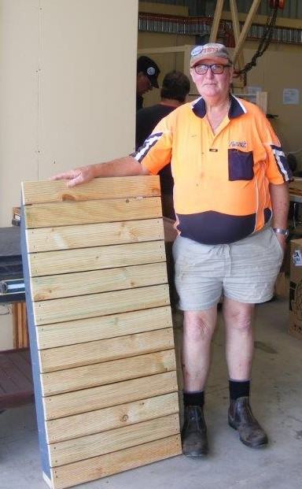  Alan C displaying one of two ramps.  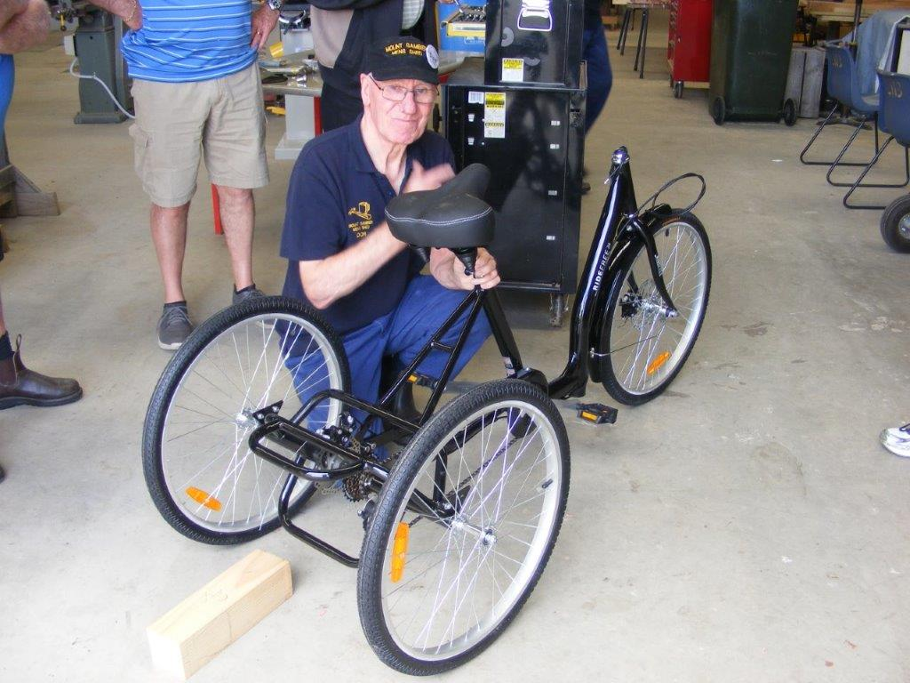  Don L working on the last of the trike  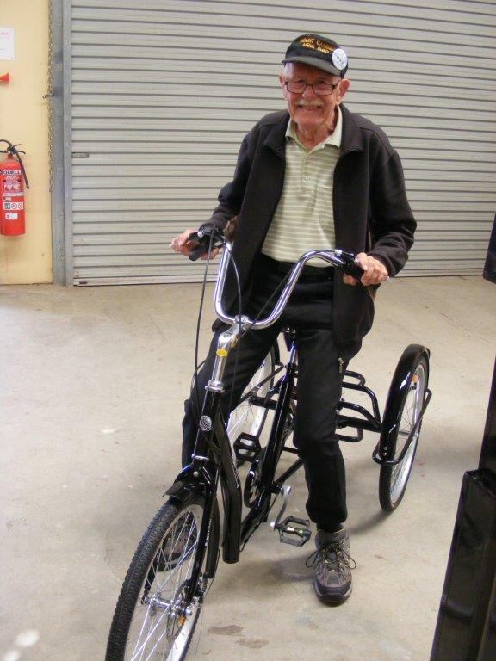  In every shed there has to be a biiiiig kid and Ray L had to test out the trike and its brakes.  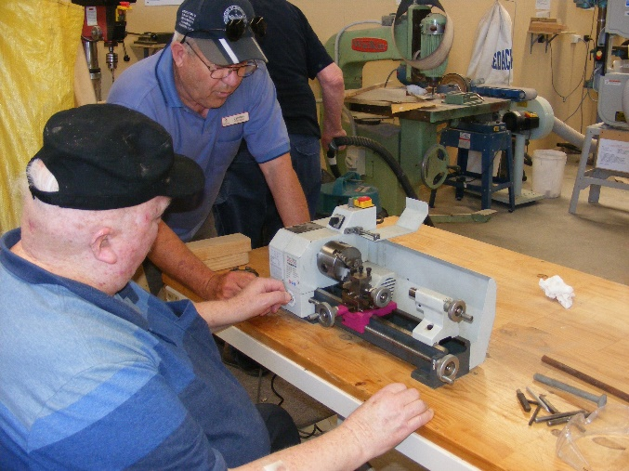  Myles G and Lindon M checking out the little lathe  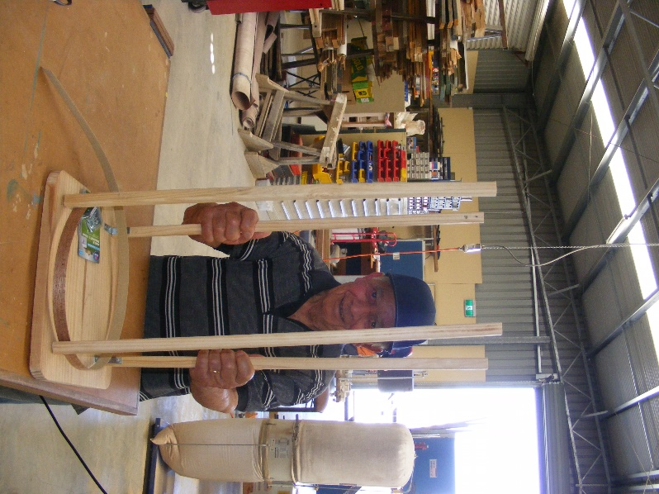  Joe C doing what he does best checking out them legs and mighty fine they are too

