OFFICE BEARERS FOR 2017  PRESIDENT : Peter Halleday 0439500699  VICE PRESIDENT : Ansi Nitz  TREASURER : John Plunket  SECRETARY : Paul Edgeworth 0497386846  COMMITTEE : Dave Lawson  Glen Bowmer  Don Clements  Arthur Smith  Graham Carter  APPOINTMENT OF LEADERS for 2017 –  Work Health Safety Rob Burford/Graham Carter – joint management  Senior First Aiders Peter Halleday/Ansi Nitz – joint management  Building Fitout /Maintenance Peter Halleday/ Don Clements – joint management  Projects Don Clements  Social Organiser Dave Lawson  Webmaster Dave Lawson  Fund Raising Ansi Nitz  (Race Gates Brian Short)  Grant monies submission writer Graham Carter  Publicity Officer/ News Editor Peter Heness  Historian Graham Carter  Membership Support Brian Short  Kitchen Management Norman Collins  UPCOMING / ONGOING PROJECTS  - Folding garden table  - Raised garden beds  - Jason Sims for metal welding in 2017  - AC CARE Park 2 Benches  - Hallmont Bowling high rise ball holding tables  - ‘Fruit Boxes’ – a dozen + constructed by Peter Halleday and team and donated to the Royal Society for the Blind as display boxes.  - Rolling Pins Request  THANKS to  - Peter Heness for ABC live radio reports and newsletters  - Graham Carter for transporting the pottery goods  - Race Gate volunteers - 15th March – Brian S, Phil V, Paul C, Glen B, Laurie T  - Race Gate volunteers – 7th April – Brian S, Phil V, Paul C, Laurie T, Rod L  - Dave Lawson for installing Office 2016  - Vicki Lazenby for the special dietary biscuits and ‘regular’ biscuits  - Brian S, Terry R, Arthur S, Norman C and others for scone making  - Bunnings sausages 1st April –Brian S, Phillip v, Paul E, Peter H, Ansi N, Dave L, Peter He., Arthur S (onions and shopping) about 450 sausages and over $981 net  - Those who constructed and filled the box for East Timor – Glen B, Brian S, Paul C  - Australia Post (Stephen McLeod Mt G) for decommissioned mail delivery boxes – about 100 so far – (last order today)  Welcome to SAFETY: 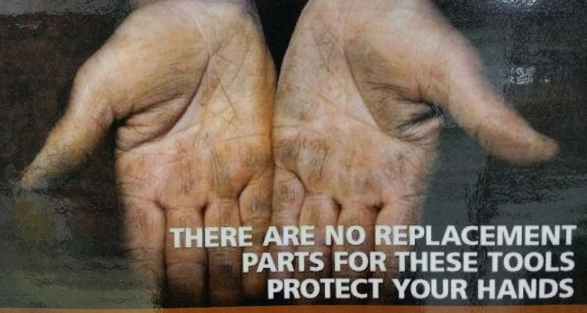  These don’t look like much as we all have them but if you abuse them or use a machine the wrong way then you could maim yourself or even worse lose them. So please be aware and protect them, even a pair of gloves can help.  PERSONAL MEMBER PROFILE  I thought as I am the editor it was about time I did my own profile.  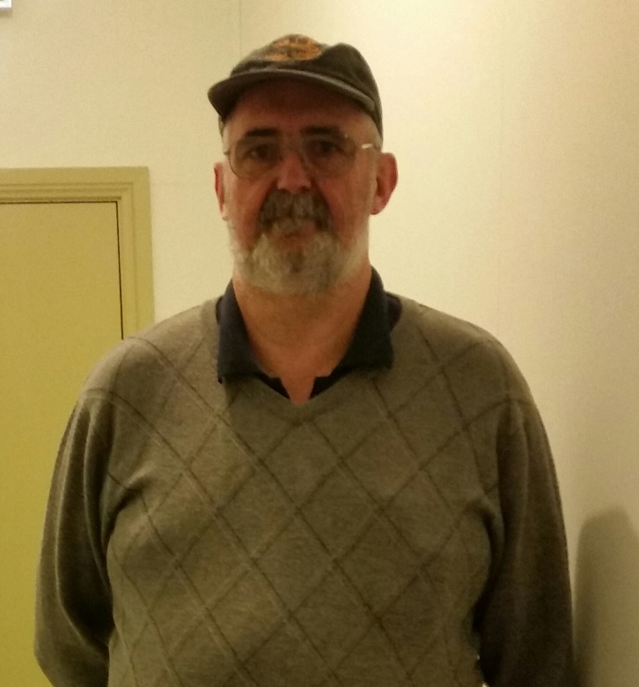  NAME:- Peter Heness  WHERE YOU HAVE WORKED:- Did 6mths of carpentery when I left school and since then have been in the particalboard industry for the past 42 years.  SOMETHING ABOUT YOU OTHER MEMBERS MAY NOT KNOW:- I had and trained trotting horses, winning at Moonee Valley and all over Victoria.  WHAT YOU WISH TO DO IN THE SHED:- Like all young ones, as I am the baby of the shed at the moment, I want to cause as much mayhem as possible (Ha Ha). But seriously would like to learn lathe work, both metal and wood, also welding, but most of all want to learn as much as possible from the older members of the shed.  JUST FOR A LAUGH: Monthly Joke  Received this one through from Dave. Thanks for this one, I hope you all enjoy.  1. The Grim Reaper came for me last night and I beat him off with a vacuum cleaner. Talk about Dyson with death.  2. A mate of mine recently admitted to being addicted to brake fluid. When I quizzed him on it he reckoned he could stop any time....  3. I went to the cemetery yesterday to lay some flowers on a grave. As I was standing there I noticed 4 grave diggers walking about with a coffin - 3 hours later and they're still walking about with it. I thought to myself, they've lost the plot!!  4. My daughter asked me for a pet spider for her birthday so I went to our local pet shop and they were $70!!!  Blow this, I thought, I can get one cheaper off the web.  5. I was at an ATM yesterday when a little old lady asked if I could check her balance, so I pushed her over.  6. I start a new job in Seoul next week. I thought it was a good Korea move.  7. I was driving this morning when I saw an RAA van parked up. The driver was sobbing uncontrollably and looked very miserable. I thought to myself that guy's heading for a breakdown.  8. Statistically 6 out of 7 dwarfs are not Happy.  9. My neighbour knocked on my door at 2:30 am this morning, can you believe that, 2:30 am?! Luckily for him I was still up playing my Bagpipes.  10. Paddy says "Mick, I'm thinking of buying a Labrador. "Blow that" says Mick "have you seen how many of their owners go blind?"  11. My girlfriend thinks that I'm a stalker. Well, she's not exactly my girlfriend yet.  12. I woke up last night to find the ghost of Gloria Gaynor standing at the foot of my bed. At first I was afraid.......then I was petrified.  13. Two Muslims have crashed a speedboat into the Thames barrier in London. Police think it might be the start of Ram-a-dam.  14. The wife was counting all the 1c's and 2c's out on the kitchen table when she suddenly got very angry and started shouting and crying for no reason. I thought to myself, "She's going through the change." | - Ryder Cheshire and Rotary have organised with us to construct a second pallet box for goods to go to East Timor – under construction by Glen  NEW BUSINESS:  - Microsoft Office 2016 purchased and installed – Management Committee decision  - Vicki Lazenby has offered to bake biscuits occasionally to assist with special dietary needs – already started  - RAA grant money submission for retraining and training in First Aid applied for by Graham Carter.  - Invitation from Pt MacDonnell Mens Shed for 3 guests to attend their Shed opening -3rd May  - Metal top table on casters donated to Port MacDonnell Mens Shed  - Guillotine located in Mt Gambier Mens Shed on share basis with Port MacDonnell Mens Shed  - Metal Folder located at Port MacDonnell Mens Shed for sharing with Mt Gambier Mens Shed  May 3rd Wednesday Pt MacDonnell Shed opening (3 guests)  May 11th Thursday Race Gates selling entry ticket Glenburnie  May 12th Friday  Race Gates selling entry ticket Glenburnie  May 17th Wednesday Dinner 6.30 at venue to be advised  July 6th 10.30am Thursday SAPOL Road Safety for Seniors (date may change) – session booked District get together at our shed. To be announced:  Men’s Health Week 12-18 June 2017. Just a friendly reminder to all our men when was the last time you had a check-up at the doctor.  REMINDERS  all borrowings must be authorised by a member of the Management Committee  and entered in the book by the ‘sign in’ book  EASY RECIPE :- As we are getting close to winter thought it was time to look at soup and how to make it.  Pumpkin Soup:-  Ingredients:-  500 grams Pumpkin, 250 grams Potato, 1 onion chopped,  1/3 cup margarine, 2 ½ cups milk, 2 ½ cups chicken stock,  ½ cup cream, salt and pepper.  Method:-  Peel and dice up pumpkin and potato and onion, put into a saucepan with milk, margarine, salt and pepper, and bring to the boil (watch it does not boil over). Simmer for 40 mins until soft.  Blend all together to a puree and put back into the pot, add stock and cream and reheat. Then enjoy.  Items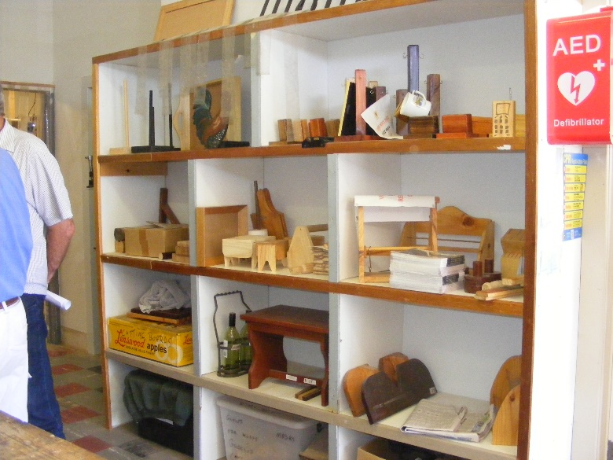  Some of the items for sale at the Goroke men’s shed as viewed while some of the men went to the district get together.  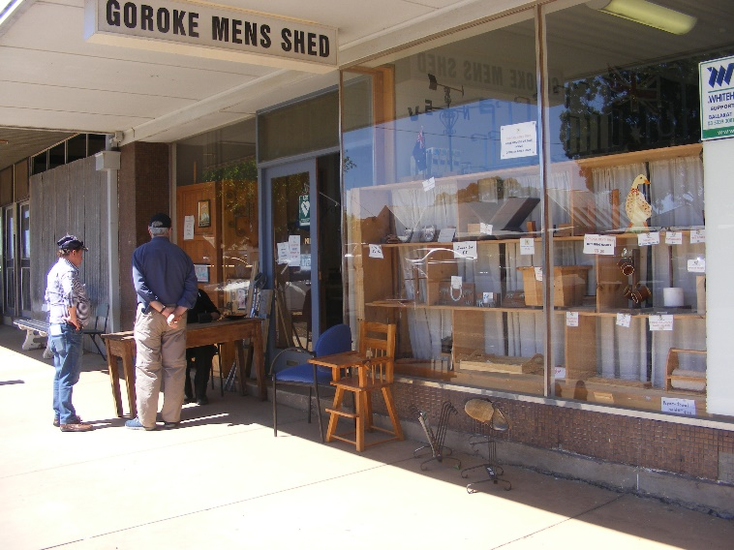  The front of Goroke shed which opens onto the main street.  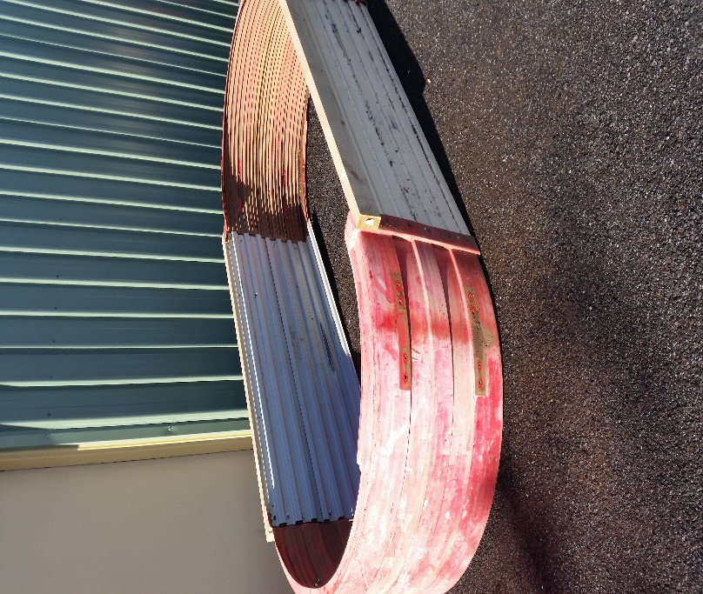  Raised Vegetable garden for sale at the shed.  15. Local Police hunting the 'knitting needle nutter', who has stabbed six people on the bottom in the last 48 hours, believe the attacker could be following some kind of pattern.  16. Bought some 'rocket salad' yesterday but it went off before I could eat it!  17. Murphy says to Paddy "What ya talkin to an envelope for?" "I'm sending a voicemail ya thick idiot!"  18. Just got back from my mate's funeral. He died after being hit on the head with a tennis ball. It was a lovely service.  19. 19 paddies go to the cinema, the ticket lady asks "Why so many of you?” Mick replies "The film said 18 or over."  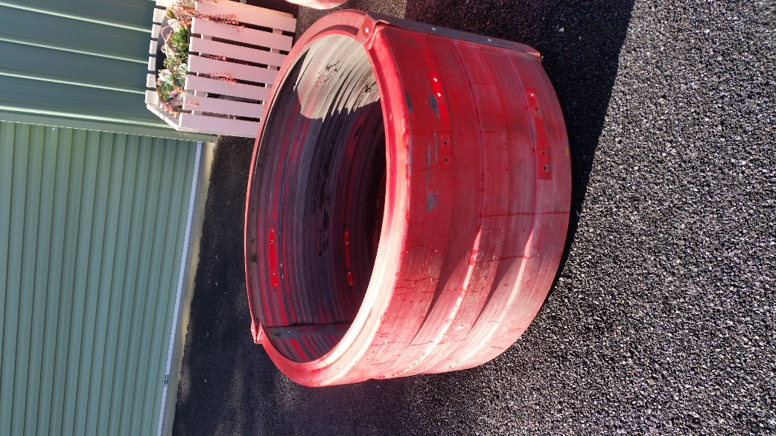  One of the vegetable raised beds for sale at the shed.

