OFFICE BEARERS FOR 2017  PRESIDENT : Peter Halleday 0439500699  VICE PRESIDENT : Ansi Nitz  TREASURER : John Plunket  SECRETARY : Paul Edgeworth 0497386846  COMMITTEE : Dave Lawson  Glen Bowmer  Don Clements  Arthur Smith  Graham Carter  APPOINTMENT OF LEADERS for 2017 –  Work Health Safety Rob Burford/Graham Carter joint management  Senior First Aiders Peter Halleday/Ansi Nitz – joint management  Building Fitout /Maintenance Peter Halleday/ Don Clements – joint management  Projects Don Clements  Social Organiser Dave Lawson  Webmaster Dave Lawson  Fund Raising Ansi Nitz  (Race Gates Brian Short)  Grant monies submission writer Graham Carter  Publicity Officer/ News Editor Peter Heness  Historian Graham Carter  Membership Support Brian Short  Kitchen Management Norman Collins  UPCOMING / ONGOING PROJECTS  - CHRISTMAS PARADE FLOATS - Mt Gambier City Council, waiting for CC to get back to us – Peter Ha  - Mt Gambier City Band – MUSICAL INSTRUMENT TROLLIES – Don C  - The area for pottery has been set up near the bikes Geoff Hart is building shelving for it.  - TOY MAKING Foodbank plastic bag dispenser – Peter Halleday  - Sound Box Acoustic design for Rotary generator Ray L  WELCOME to new members.  Clem Hutchesson, Peter Martin, George Renzi, Stephen Sylvester and Robert Aldersey  Birthday’s this month  Graham C 22/12/1941  Paul C 26/12/1945  Terry G 27/12/1946  PERSONAL MEMBER PROFILE  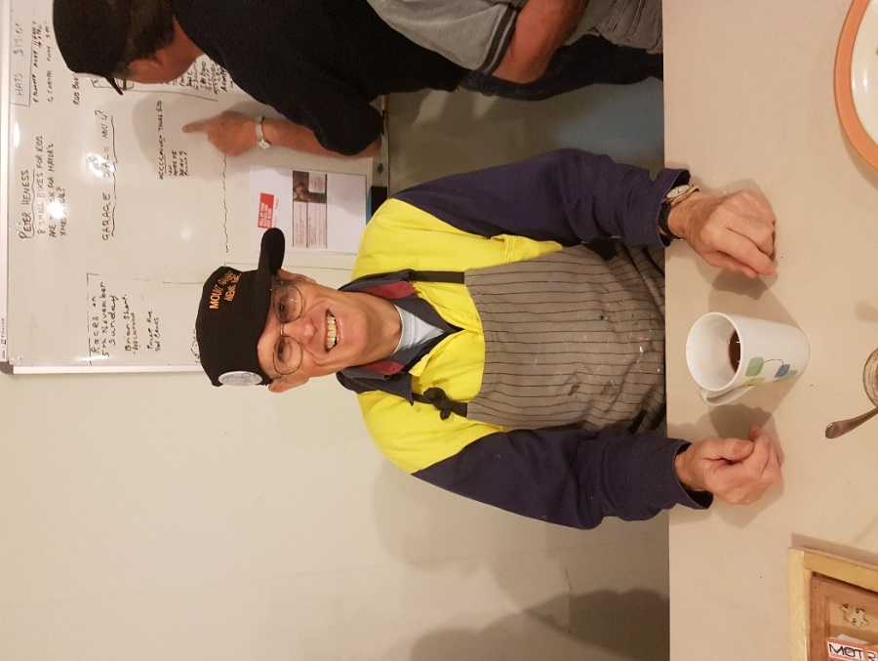  Name:- Bond Alan Bond  Where Have You Worked:- 45 years with S.A. Water as a maintenance fitter.  Something about you other members may not know:- I am a Polio Surviver. Also a Rotary member for 25 years. As President for 5 years in Adelaide.  What do you wish to achieve in the shed:- Anything that comes along especially to help out others.  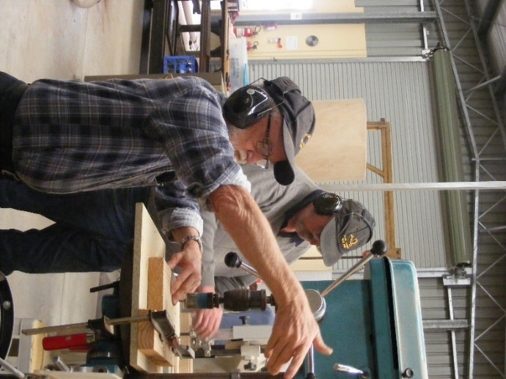  Couple of shifty hard workers not sure what they are up to might mean trouble.  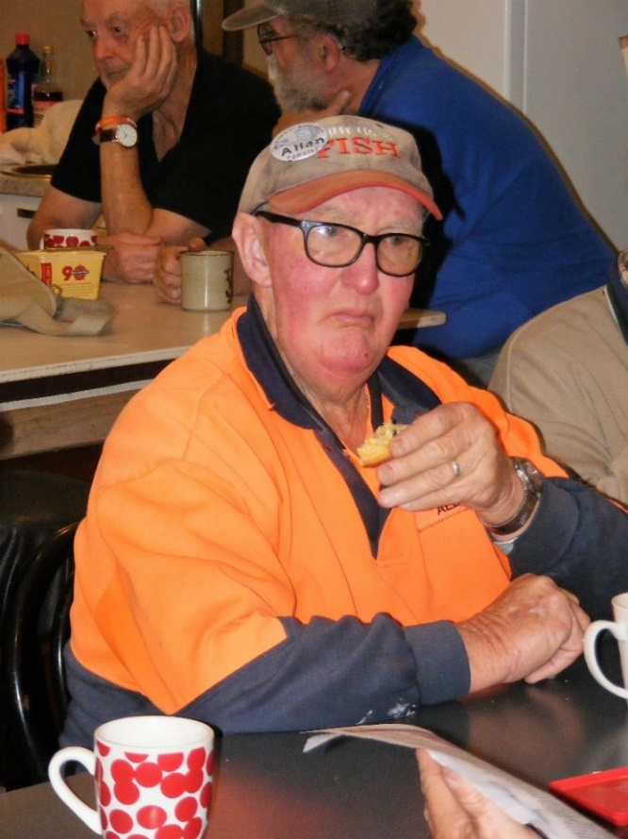  Allen as usual enjoying his scones.  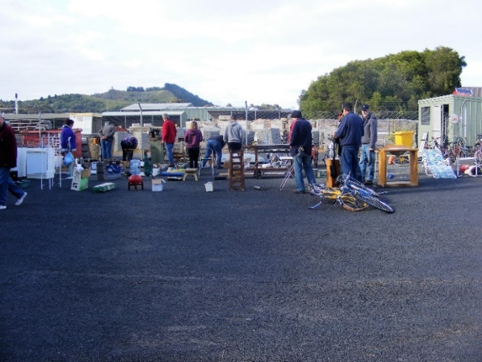  Garage Sale day all is in readiness.  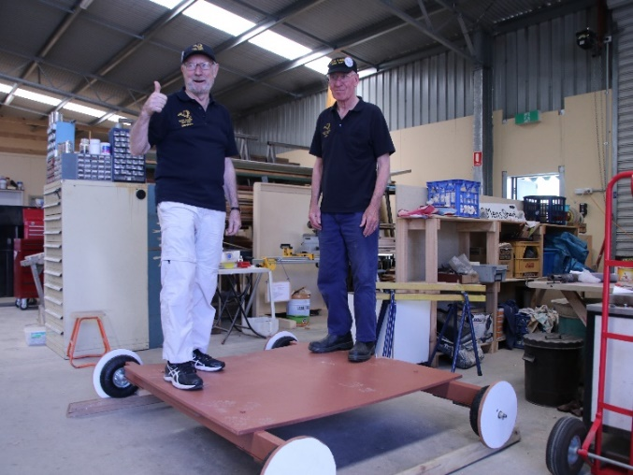  Graham and Don checking out the the Camera dolly made for Whistle Post Winery at Coonawarra.  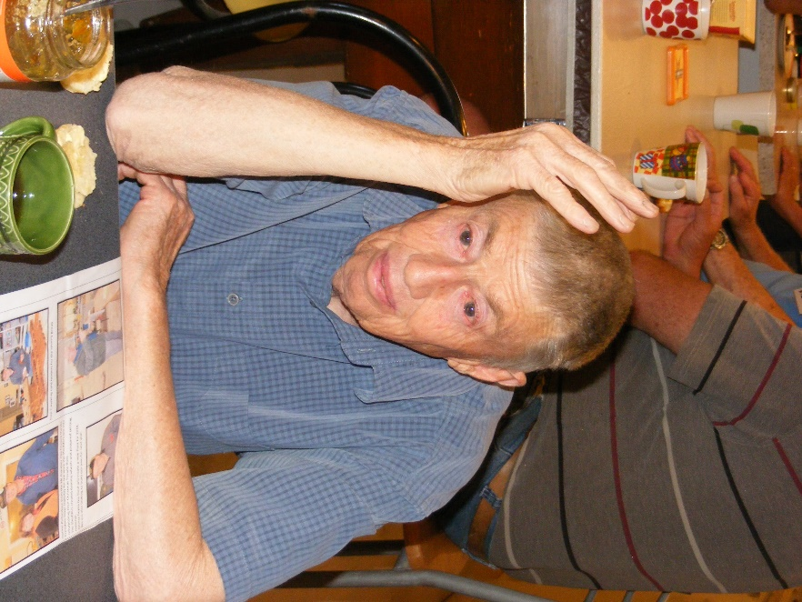  Trevor enjoying a cuppa and reading last months Newsletter.  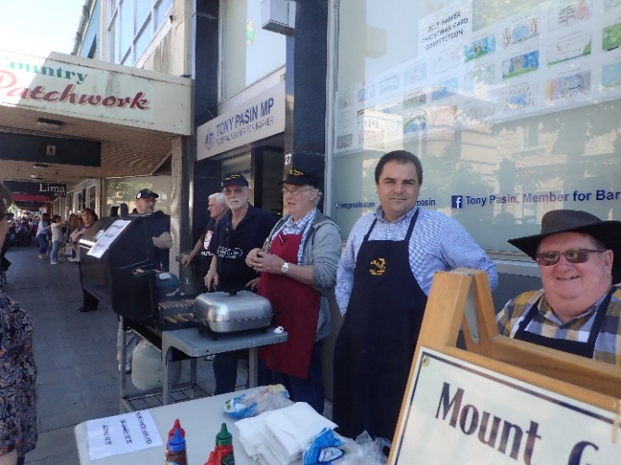  The team hard at work on Christmas Parade day. Graham, Kelvin, Don, Rod, Tony and Phil.  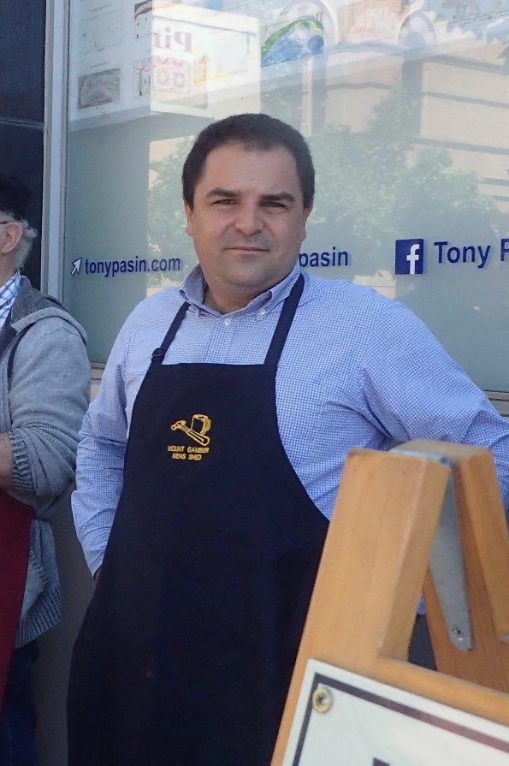  Tony Pasin at the Christmas parade sausage sizzle helping out. Thanks Tony and others.  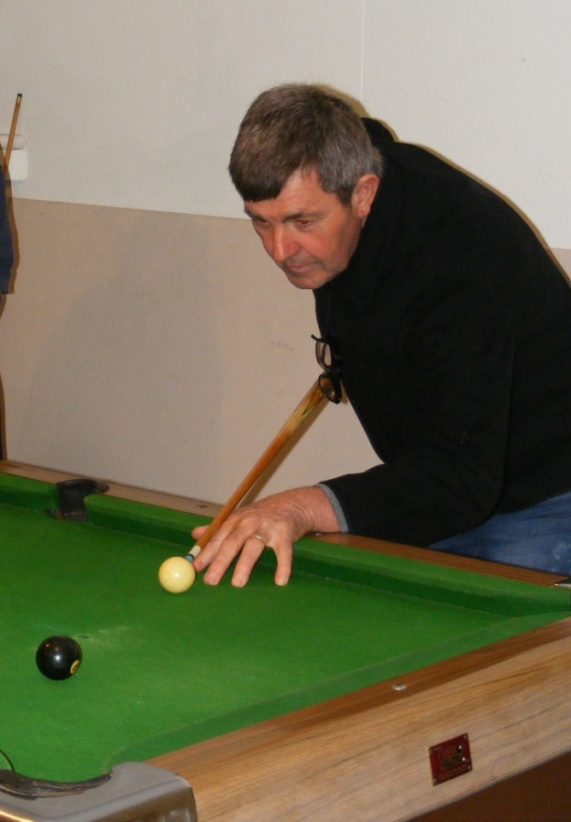  As Joe will testify it is not all work at the shed.  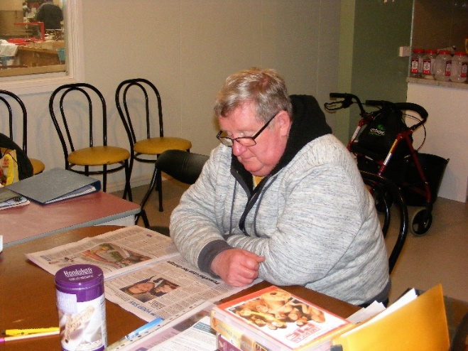  Phil enjoying his own company while reading the local paper.  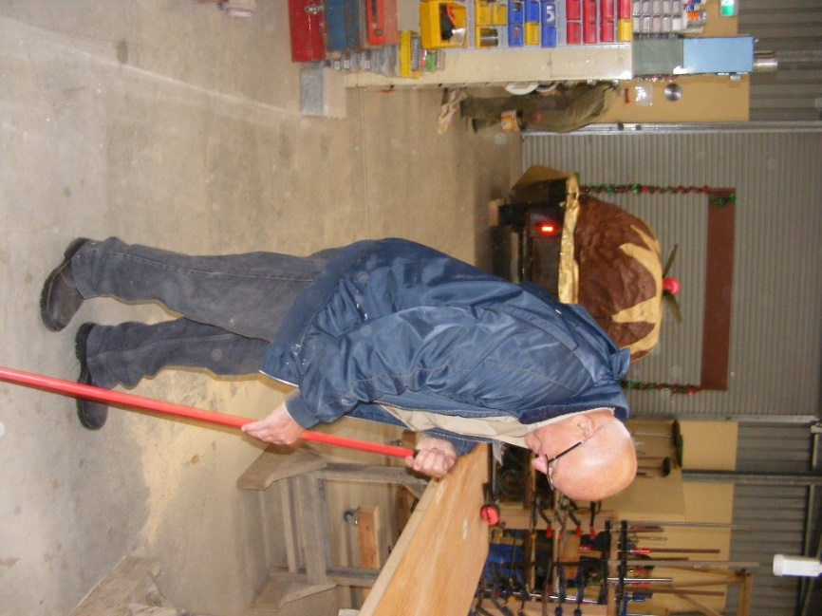  New member George doing a bit of house cleaning.  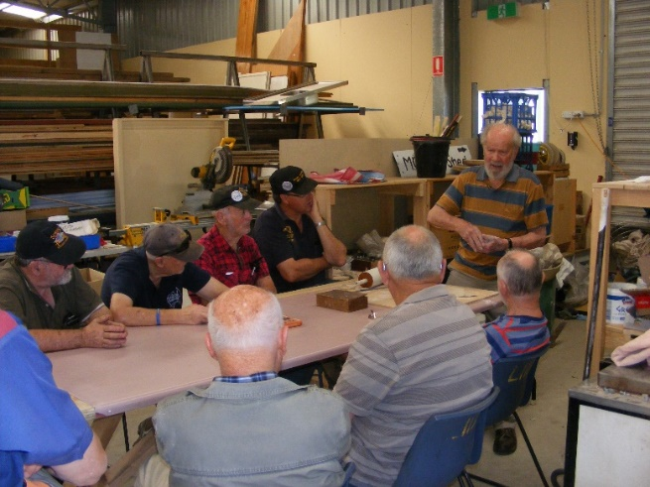  First lesson with pottery, held by Kingsley Marks.  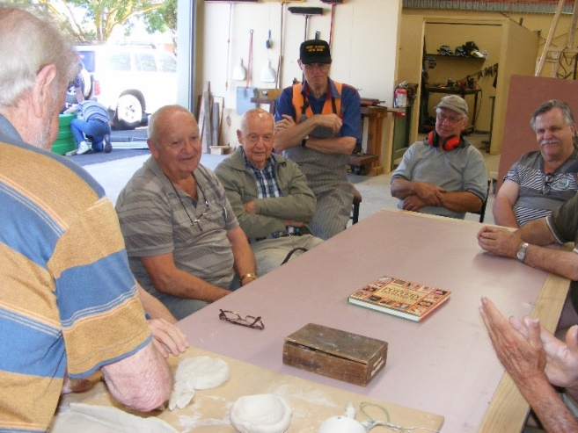  COTA – ‘moving right along’ – SAFETY FOR OLDER DRIVERS  This SA Government sponsored program was presented by COTA’s Julienne Feast to Shedders in November.  Over 65 year olds represent 17% of the driving population and are equally at risk with young drivers 17% (16 -25) for the most significant injuries and deaths.  For we older drivers anxiety is raised when our freedom and independence is curtailed or taken away. We also have to consider risk to ourselves and others and the factors that continue to make our driving safer.  Mental capacity – have an ability to plan, have good reaction times, be able to stay focused and awake  Physical capacities  - be able to reach the pedals  - have strength to use the pedals (hand controls) and steering wheel  - have the ability to get in and out of the car and be in a ‘comfortable driving’ position  - be able to rotate your head and body for rearward safety  - have eye sight that is adaptable for evening, night and hazardous driving conditions  Medicare has free optometric tests yearly for over 65’s – under 65’s have to wait a bit longer in between  - have a medical exam yearly particularly to review medications particularly– whether they are still necessary and their interaction with each other for safe driving  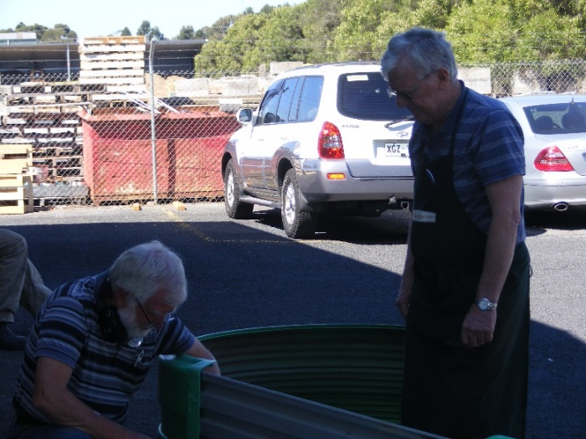  Neville and Jim making another garden bed.  REINDEER'S STORY  According to the Department of Fish and Game in Alaska, both male and female reindeer grow antlers in the summer each year. Only male reindeer drop their antlers at the beginning of winter, usually late November to mid-December.  Female reindeer retain their antlers till after they give birth in the spring. Therefore, according to EVERY historical rendition depicting Santa's reindeer, EVERY single one of them, from Rudolph to Blitzen, had to be a girl.  We should have known...  ONLY women would be able to drag a fat man in a red velvet suit all around the world in one night and not get lost.   | THANKS to  ABC live radio and 5SE taped District Mens Sheds’ reports and NEWSLETTER - Peter Heness  Scones – Norman C, Arthur S, Terry R & Terry G Norm Collins spoke at Probus meeting recently  We made $355 at the Christmas Parade Sausage Sizzle –thanks all Dates to remember 1st December - RACE GATES (a big twilight meeting) Brian S, Peter Ha, Geoff H, Paul E, Arthur S, Graeme R, Kevin W, Laurie T 9th December – 9.30 MT GAMBIER TRUCK SHOW at the Show Ground, volunteers – Brian S, Ian B, Rod L, Dave L (gold coin entry) 13th December - SHED TEA at the Western Tavern – Shedders and Partners (put your name on the white board with 1 or 2 coming 14th December - Shed Members Meeting - (need a minutes secretary) 16th December – BWS OPENING (Coles car park) selling sausages 9.00am till 1.00pm Names 6th January - BUNNINGS SAUSAGE sale day Saturday names - HEALTH AND WELLBEING - Support and contact as you are able, and as Shedders wish. Laurie Tricker is back with us. Cec Jones has been around also. Rob Burford is hard at it doing electrical testing Trevor Twilley and Trina are still in need of your thoughts Remember too; Keith Reichelt, Peter Schutz, Terry Radford, Don Latty and Arthur Smith Those with critical or ongoing psychological and mental issues Other REMINDERS ALL BORROWINGS must be authorised by a member of the Management Committee and entered in the book by the ‘sign in’ book DAMAGED MACHINES – let someone know NAME BADGES – please wear TOOLS AFTER USE – please return to correct storage CAPS for sale $17  Toy making, launch for Mayors Christmas Appeal – Peter Heness spoke with ‘backup’ by Ian Bond (positive public feedback about how Peter Heness spoke and a good show case for the Shed)- toy makers who attended: Ian B, Peter Heness, Brian Short, Phil Vine, Ray Lazenby – reported in the Border Watch and Lifestyle. These toys have now been handed over to the various charities for distribution. A big hearty thanks to all who helped in any way towards this new venture we have taken on.  Peter He  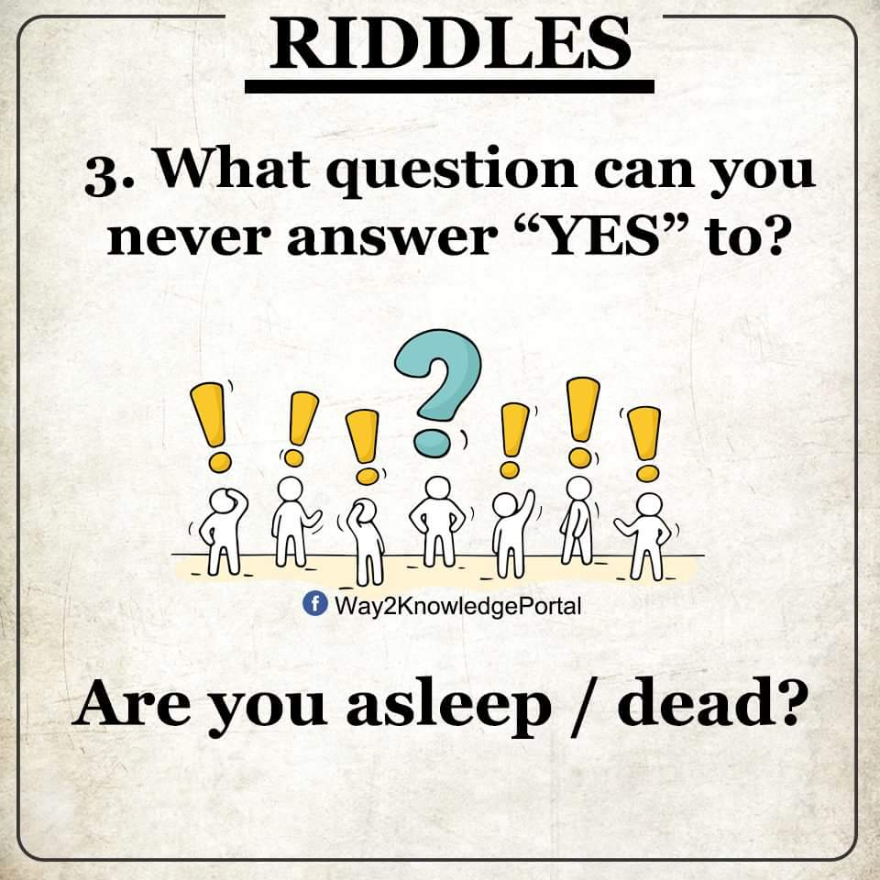  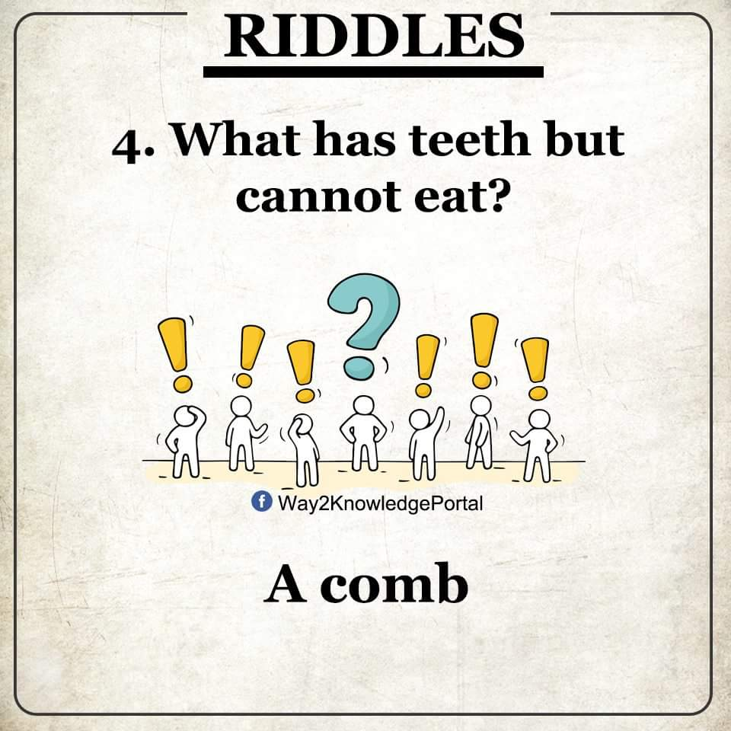  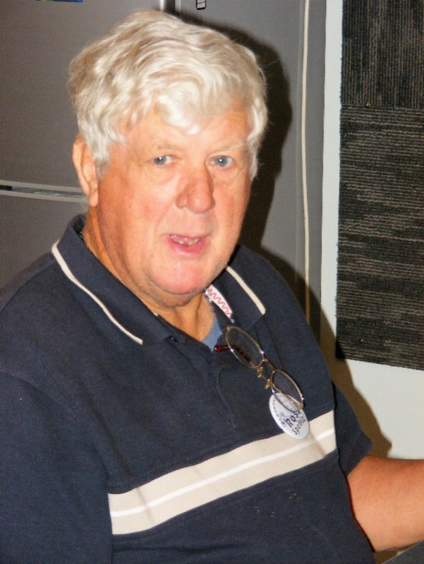  Ross being Ross.  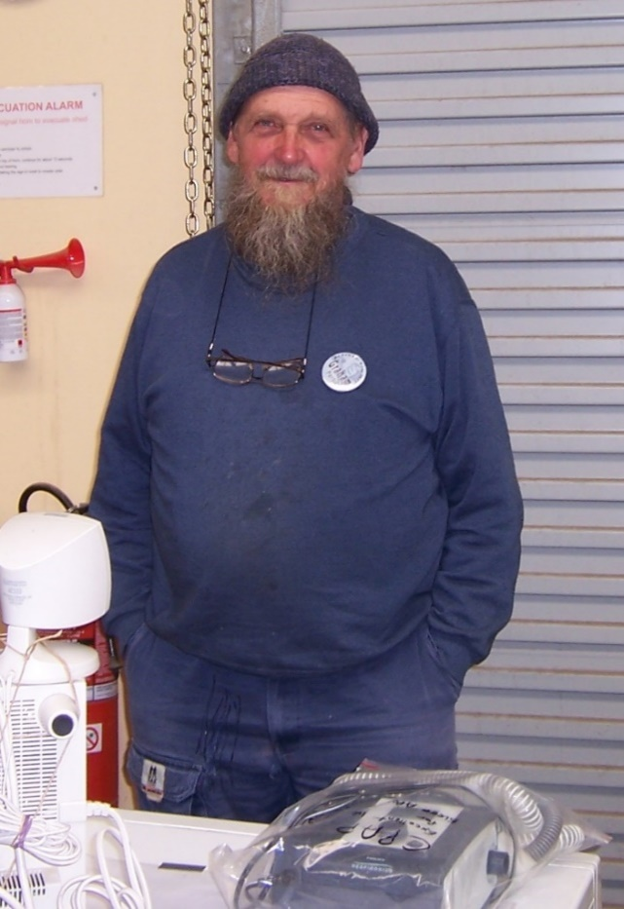  One off our newer members Graham trying to work out what he will do next.  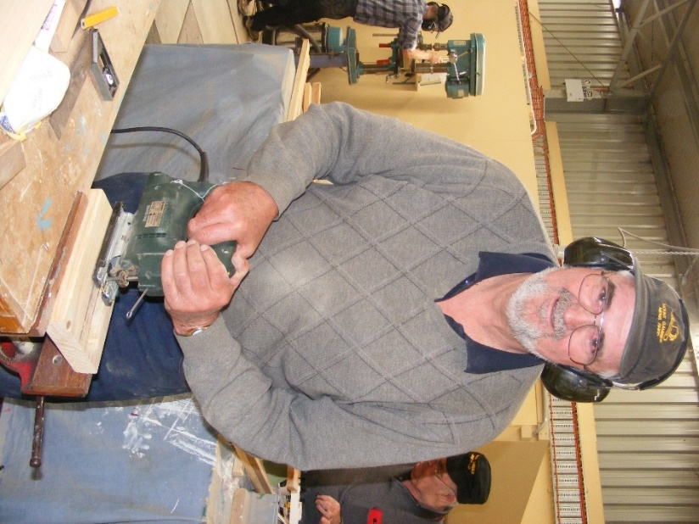  Peter- Sometime I just have to put my own photo in to prove I do work every now and then.  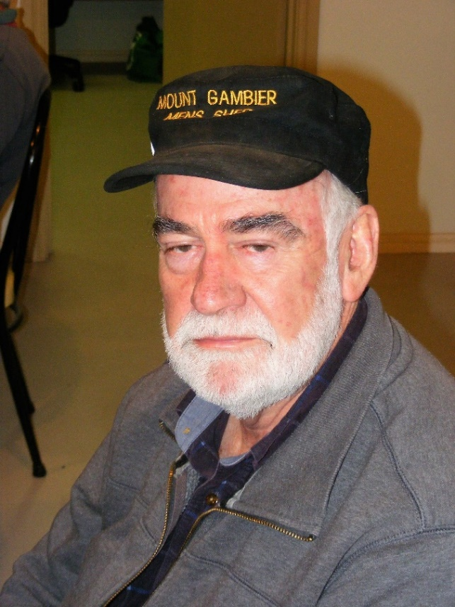  Good to see Rob back with us even though he does not look happy to be here.  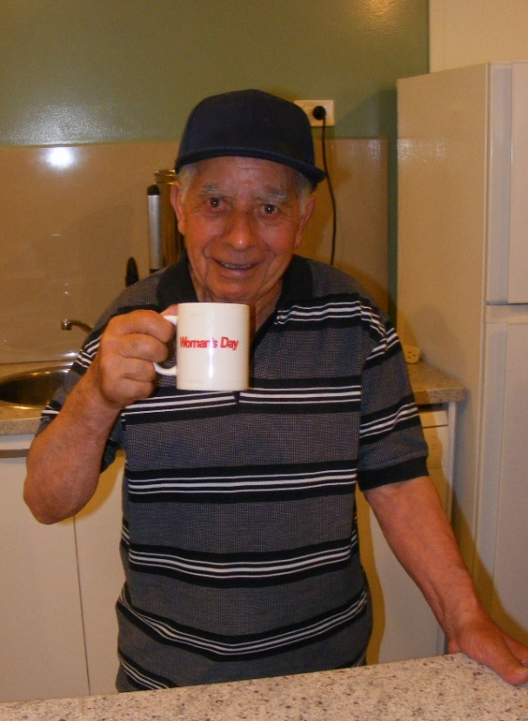  Joe enjoying a cuppa.  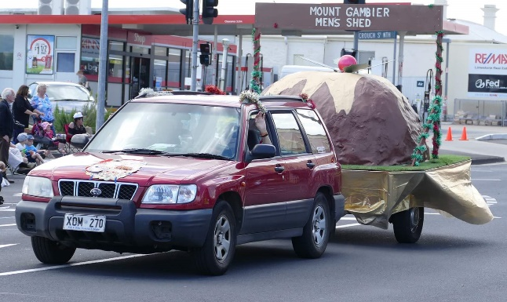  Dave and shorty towing our Christmas float.  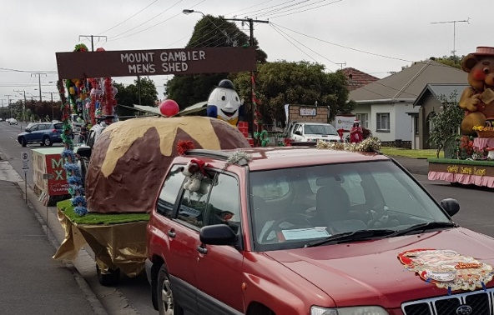  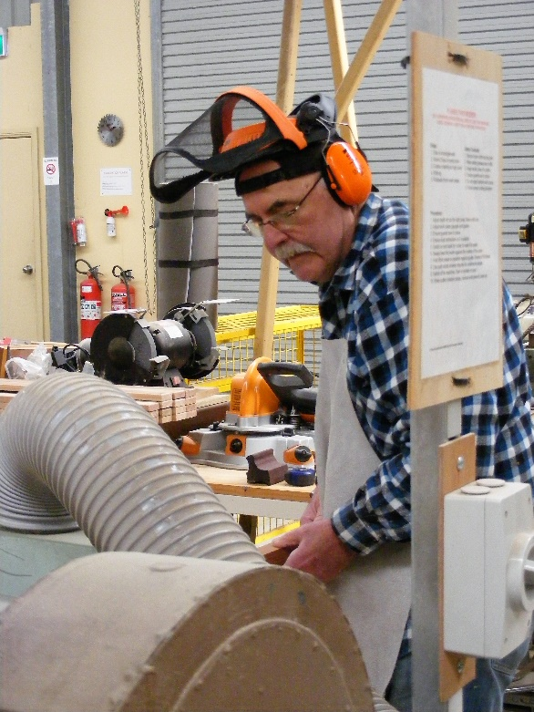  Ansi - Hard at it as per usual  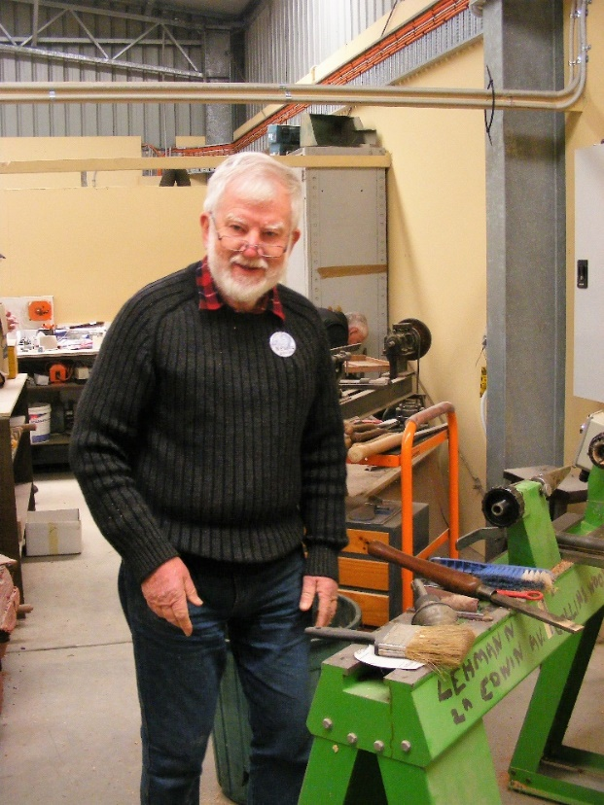  Neville about to start working on the lathe.  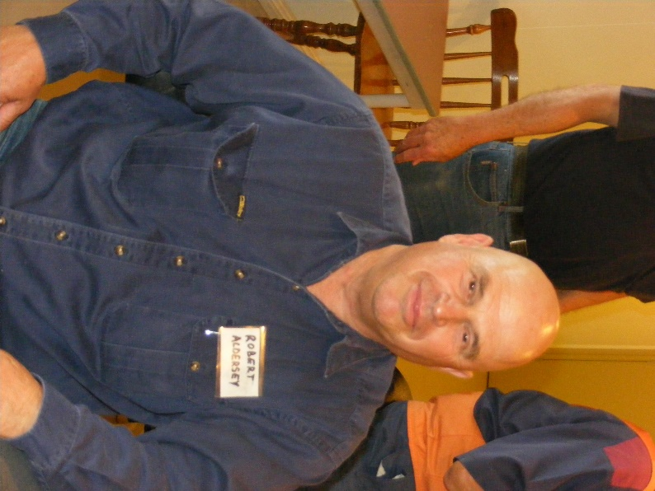  Our newest member Robert.  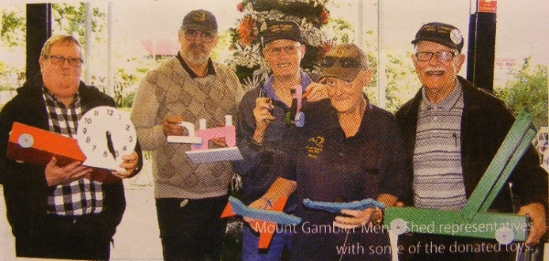  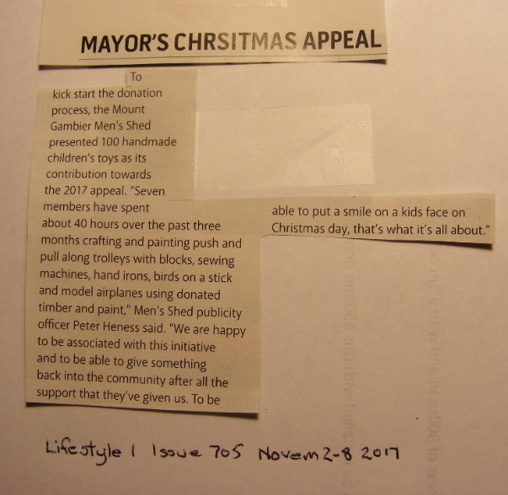  - have a free hearing check every few years – Australian Hearing are not out to sell hearing aids –they do a free screen for anyone over 18  - have NO alcohol as our aging ‘systems’ are slower to process it and it also acts as a depressant (of course no illegal drugs either)  - keep hydrated (with water) before and during driving  South Australian Drivers Handbook – look at the Shed’s latest copy or buy your own for $10 at Services SA  Look at the RAA magazine for explanations and diagrams of lots of the rules and new ones.  Go out with a Driving Instructor ever couple of years to check your driving habits and rules knowledge. Go out with someone learning to drive like a grandchild and sit in the back. Most instructors are happy with this particularly if you are assisting with building up practice hours.  Paul Edgeworth  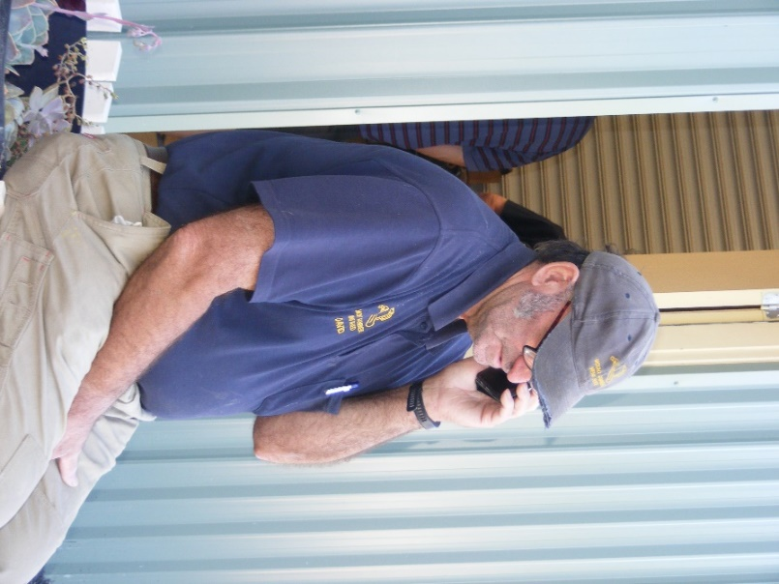  Dave doing what he is good at. Talking on the phone.    MERRY CHRISTMAS AND A HAPPY NEW YEAR TO ALL & REMEMBER THE SHED IS CLOSED FOR A BREAK FROM DEC 22ND UNTIL JAN 2ND

