OFFICE BEARERS FOR 2017  PRESIDENT : Peter Halleday 0439500699  VICE PRESIDENT : Ansi Nitz  TREASURER : John Plunket  SECRETARY : Paul Edgeworth 0497386846  COMMITTEE : Dave Lawson  Glen Bowmer  Don Clements  Arthur Smith  Graham Carter  APPOINTMENT OF LEADERS for 2017 –  Work Health Safety Rob Burford/Graham Carter – joint management  Senior First Aiders Peter Halleday/Ansi Nitz – joint management  Building Fitout /Maintenance Peter Halleday/ Don Clements – joint management  Projects Don Clements  Social Organiser Dave Lawson  Webmaster Dave Lawson  Fund Raising Ansi Nitz  (Race Gates Brian Short)  Grant monies submission writer Graham Carter  Publicity Officer/ News Editor Peter Heness  Historian Graham Carter  Membership Support Brian Short  Kitchen Management Norman Collins  UPCOMING / ONGOING PROJECTS  - CHRISTMAS PARADE FLOATS - Mt Gambier City Council, waiting for CC to get back to us – Peter Ha  - Mt Gambier City Band – MUSICAL INSTRUMENT TROLLIES – Don C  - Reassemble the SHED FLOAT for the Christmas Parade –Peter Heness ------  - The area for pottery has been set up near the bikes Geoff Hart is building shelving for it.  WELCOME to new members.  Clem Hutchesson, Peter Martin.  THANKS to  - ABC live radio and 5SE taped District Mens Sheds’ reports and NEWSLETTER - Peter Heness  - Scones – Norman C, Arthur S, Terry R & Terry G  - Bunnings for clear finish donation for Mayor’s Christmas Appeal toys.  MOUNT GAMBIER MENS SHED  NON - COMPLIANCE POLICY & PROCEDURES  A grievance may also be brought by the Management Committee to the notice of a Shed member(s) where that member appears to be acting in a manner contrary to Mt Gambier Mens Shed constitution, policies and procedures and /or the constitution, policies, procedures and aims of the Australian Mens Shed Association.  In the above matters and in particular where health and safety of the member or towards another Shed member(s) are concerned the following will be adopted:  1. A verbal request to desist from the action and/or comply with Shed rules by any appropriate Shed member 2. A verbal request to desist or comply by a Management Committee representative accompanied by a witness from the Management Committee.  The Management Committee representative will make known the consequences of another non-compliance of the same or similar event repeated within a reasonable time frame.  The non-compliance will be documented.  3. In the event of a further non-compliance following Step 2, the Shed member will incur a period of exclusion (or other determination) from the Shed’s workshop or Shed premises depending on the relevance of the non- compliance.  The period and type of exclusion will depend on the level of non- compliance and will be a Management Committee’s decision.  A Management Committee representative accompanied by a witness from the Management Committee will provide the member with the Management Committee’s determination with accompanying documentation.  4. Following the member’s return, or whatever other determination was made by the Management Committee, should the non- compliance persist, a further period of exclusion may follow or ultimately result in membership termination.  5 The member may appeal to the President at any stage.  6. With full documentation, the member may appeal to the SA Mens Shed Association should there be no resolution at the local Shed level.  9th October 2017  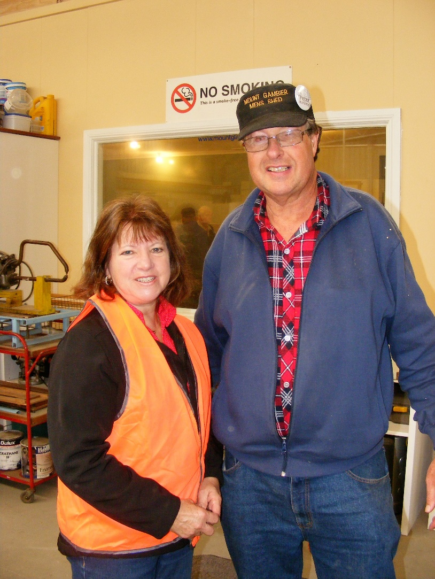  Denise Richardson from the Mt Gambier City Council thanks President Peter Halleday for the work the Shedders put into refurbishing their Christmas Parade float.  The Shedders created dummy wheels and prepared skirting material.  Denise hopes the Shed will create a new float for 2018.  We are also looking to build our own for next year.  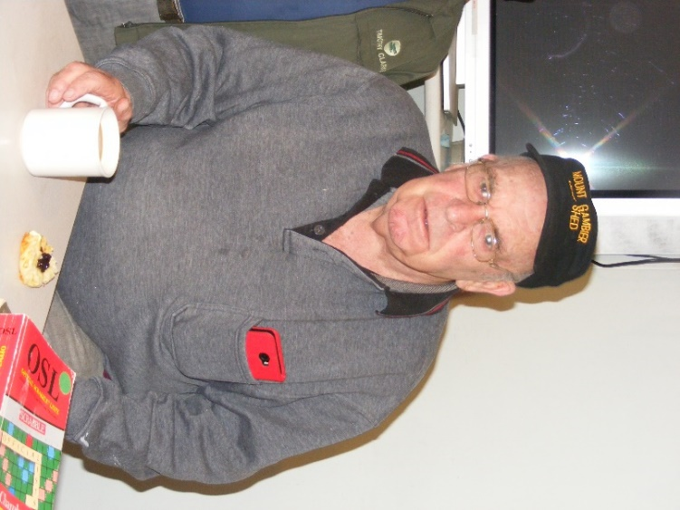  Jim enjoying a cuppa.  PERSONAL MEMBER PROFILE  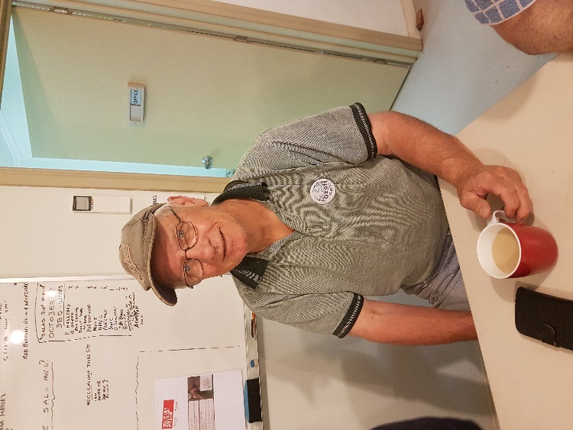  Our profile is a little different this time as Geoff sent me his whole history and does not mind it being passed on.  NAME:- Geoffrey Hart - AKA Gerimah, Godfrey, Rsole and a few more which won't be mentioned here.  Born at Clare in November 1948  Raised in Strathalbyn following my father's transfer with ETSA in 1953, where I did all of my schooling.  In my earlier years I played (or should I say tried to - more often than not, left right out) Aussie rules footy for Strath, Langhorne Creek, West Gambier (1967/68 senior colts) and later Woomera Village Sporting Club.  My working career commenced at Strathalbyn in 1964 with the former PMG and later Australia Post as a Telegram Boy.  In April 1967 was transferred to Mt Gambier as a Postman/Mail Officer (no choice - either go or resign as was the case in those days). I worked in the old PO on Bay Road until approx. 1972 when I was fortunate enough to obtain a transfer to Woomera. (Oh boy was I glad to get away from the cold weather). After spending a couple of years in Woomera, I was offered a promotion and transferred to Adelaide metro area working in the Northern Suburbs and later in the GPO and state administration. Prior to my resignation as a corporate employee I held the position of Delivery Manager at the former Unley Delivery Centre where I had a staff of 62.  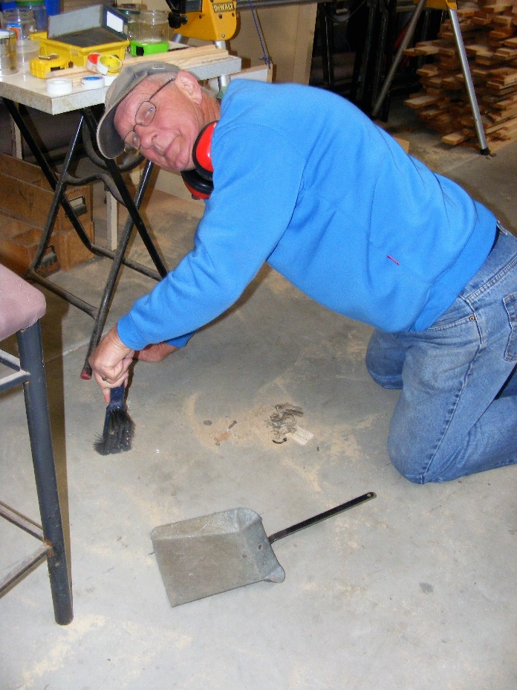  Geoff, well there’s nothing like starting at the bottom.  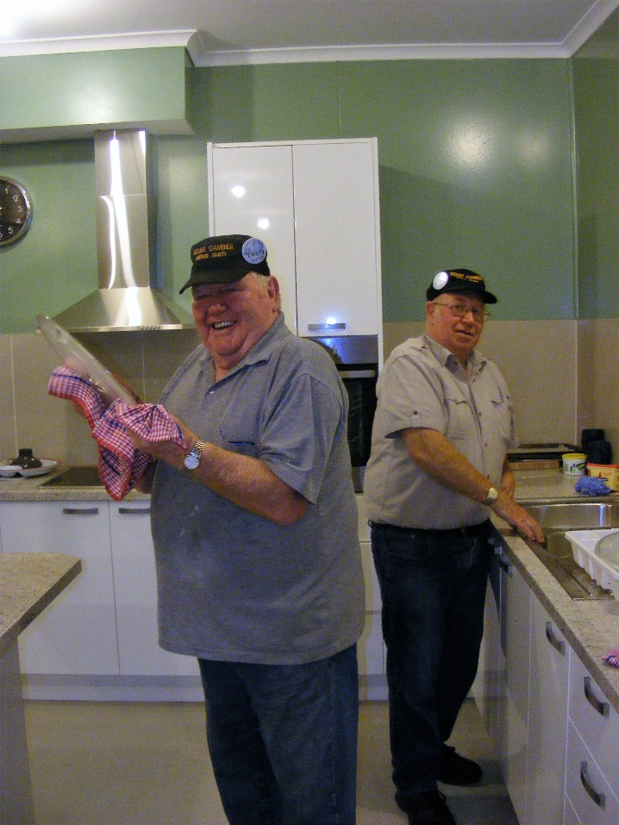  Terry and Terry. Someone has to do the dishes. Well done guys.  MENS CONTINENCE - HEALTHY BLADDER AND BOWLS  This is a summary of a presentation by Lisa Lawton representing the Continence Foundation of Australia (CFA).  For the FREE NATIONAL telephone advisory service, staffed by Continence Nurse Advisors, Monday to Friday 8.00am – 8pm (AEST), funded by the Australian Government - call 1800 33 00 66 – Webpage: continence.org.au  The Continence Resource Centre is a linked (CFA) SOUTH AUSTRALIAN Organisation that provides information and advice with displays – call 1300 885 886 and ask to be connected.  Webpage: www.sa.gov.au/disability/crc Email: continence@sa.gov.au  Incontinence is the involuntary passing of urine and faeces – not making it to the toilet, rushing to get there, not able to hold, not controlling farting, leaking, straining and difficulty in passing urine.  1 in 4 people in Australia experience problems with their bladder and bowel – that is 4.8 million with 80% being women. Many of us men are affected through prostate procedures.  It is NOT a natural part of aging; it is not normal at any age.  Your bladder should hold at least one cup. It is normal to urinate about 6 times a day with no more than once a night. Bowel emptying can be three times a day to three times a week.  WHAT TO DO  Tone Pelvic Floor Muscles - yes we men have them! They should be regularly exercised to give control over our bladder and bowel: ten x ten second exercises each day – there are DVD’s at the Shed to borrow.  Drink (and fluid is included in most foods – custard, jellies, fruit) 1.5 – 2.0 L per day – limit caffeine, alcohol and sugar drinks as they can be irritants.  Eat 30gm of fibre- fruit, vegetables, cereals, breads. Exercise daily. Sit on the toilet with knees up and your back leaning forward.  If you still need assistance go to the top of this article.  (There is funding support for some continence products for some people – ask if you are eligible.) | - TOY MAKING for Mayors Christmas Appeal - Ian B and Peter Heness  Mitre 10 has agreed to assist with paint.  Big thanks to those who attended the town hall for the launch of the Mayors Christmas appeal  - City Council Christmas Float work – Geoff H, Dave L, Brian S, Ray L, Paul C, Martin K  - Foodbank plastic bag dispenser – Peter Halleday  - Onion peeling – Rod L, Arthur S  - Sound Box Acoustic design for Rotary generator Ray L  Dates to remember 4th November Saturday Shed Garage Sale any commission selling at 20%; all goods not sold to be taken back by donors. 5th November Sunday Race gates 8th November Wednesday 6.30 pm tea – Mac’s Hotel Special meal deal $13 16th November 10.00 Thursday COTA SA ‘Moving Right Along’ - safe driving. 1hr presentation. 18th November Saturday Christmas Parade Float & Sausage table 1st December Friday Race gates 6th January 2018 Saturday Bunnings sausage sizzle Visit to /from Millicent Mens Shed to be advised Heywood Mens Shed are organising the annual Good Health afternoon – date to be advised  HEALTH AND WELLBEING  Support and contact as you are able, and as Shedders wish.  - Those with longer term/serious physical issues –Peter S, Rob Burford, Cec Jones and others recuperating;  also partners of Shedders  - Those with critical or ongoing psychological and mental issues  Birthday’s this month  Geoff Hart 19/ 11 /1948  Arthur Smith 24/11/1936  Graham Carter 22/12/1941  Paul Caines 26/12/1945  Terry Galway 27/12/1946  Other news Pony Pasin MP has given the Shed a $3500 grant from the Federal Government for a band saw and safety equipment – Don Clements and Graham Carter made the application  Bunnings donated a trailer load of bits and pieces this week  REMINDERS  - ALL BORROWINGS must be authorised by a member of the Management Committee  and entered in the book by the ‘sign in’ book  - DAMAGED MACHINES – let someone know  - NAME BADGES – please wear  - TOOLS AFTER USE – please return to correct storage  - CAPS for sale $17  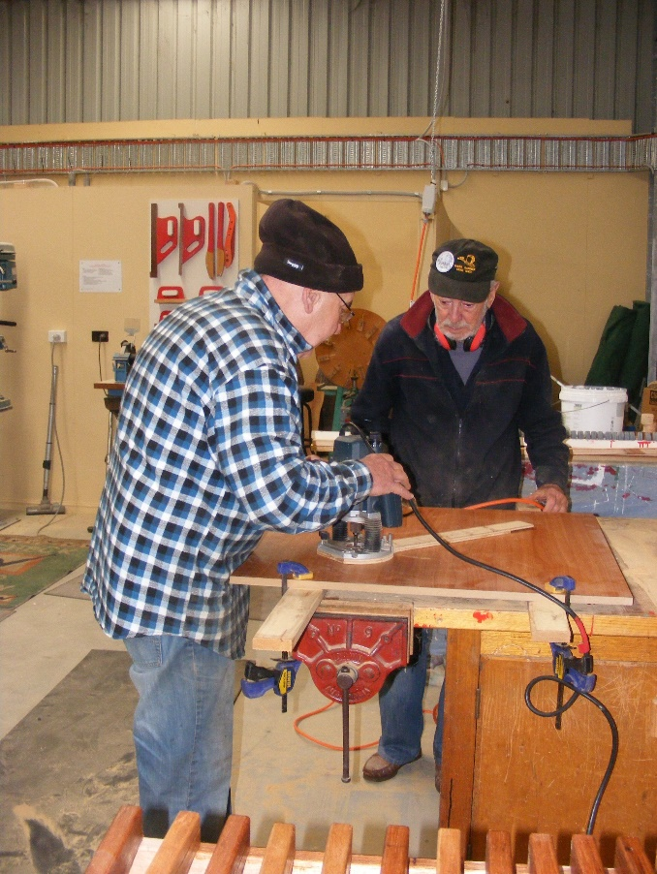  Ansi and Arthur starting to make a table top.  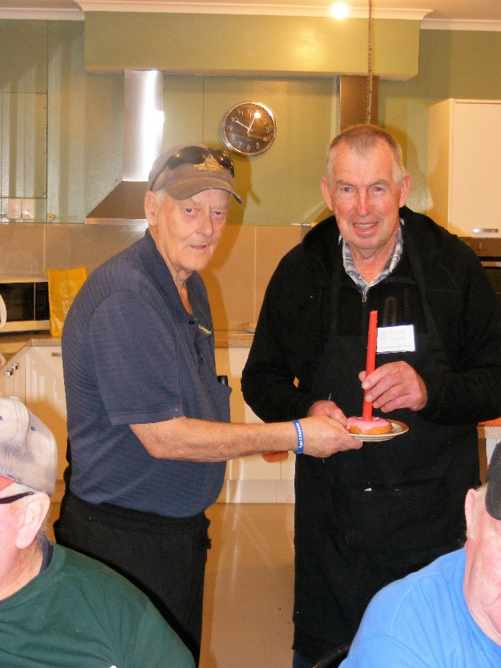  Brian and Trevor share a birthday  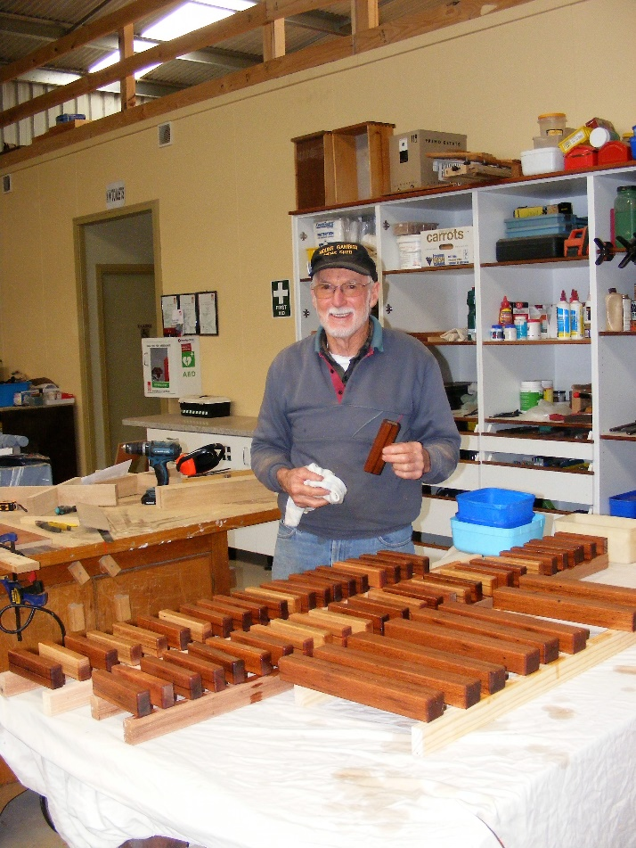  Don making card holders for the History group  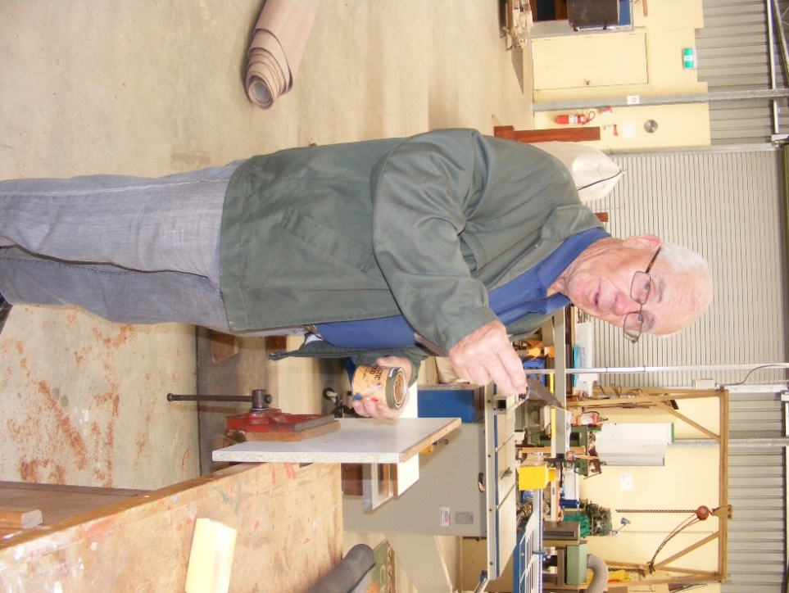  Bit of a shock for Tim he was not expecting his photo to be taken while doing some edging.  In March 2000 I resigned from Post (after 36.10.16 - 36 years 10 month and 16 days) and bought a grazing property at Strathalbyn and went back to Post as a Contractor which gave me the freedom to run the farm and earn an off farm income.  In 2011 my marriage broke down, but was very fortunate to meet a darling woman (Elaine) in March 2013 and were married the same year.  Upon my retirement in June 2014 we resided in Strathalbyn but ventured to the Mount every 6-8 weeks to visit Elaine's kids and siblings (she was a former Mount girl).  In 2015/16 we decided to extend our house, but the renovations were going to cost more than the price to build a new house, so we opted to move elsewhere and finished up the Mount in June 2016.  Following the move we spent the first year making the new house our home. By May/June 2017 the majority of tasks were completed and we had time on our hands - bored, so we looked for outside interests away from home, where we could meet others and make new friends/acquaintances. I chose the Men's Shed as I had intentions of join the Strath branch, but never got around to it. In June of this year I became a member of MGMS and thoroughly enjoy the companionship/comradely and helping out the community with projects.  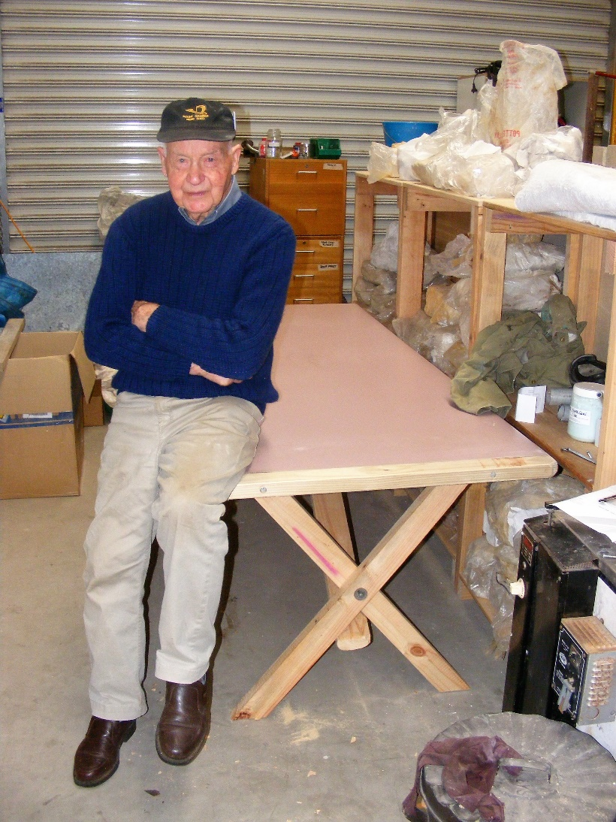  Kelvin at his pottery table  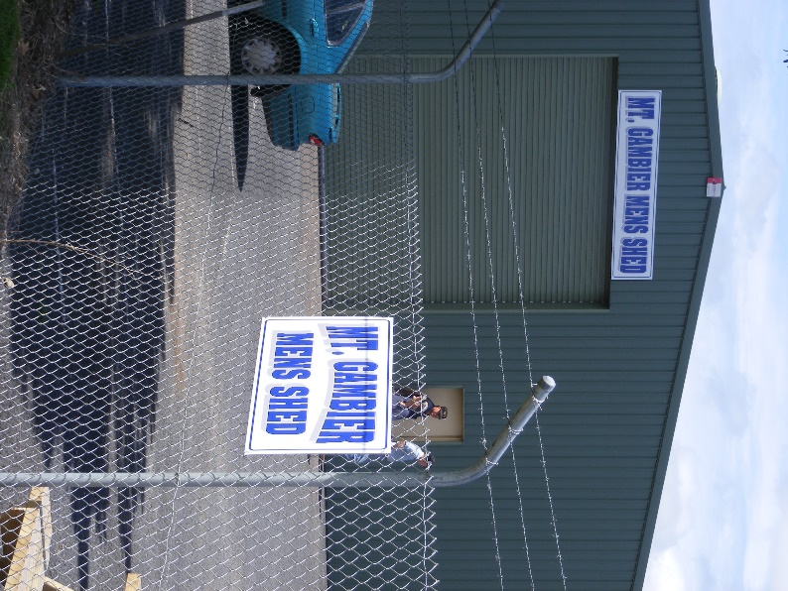  Shed Signage is now up. We know where we live now.  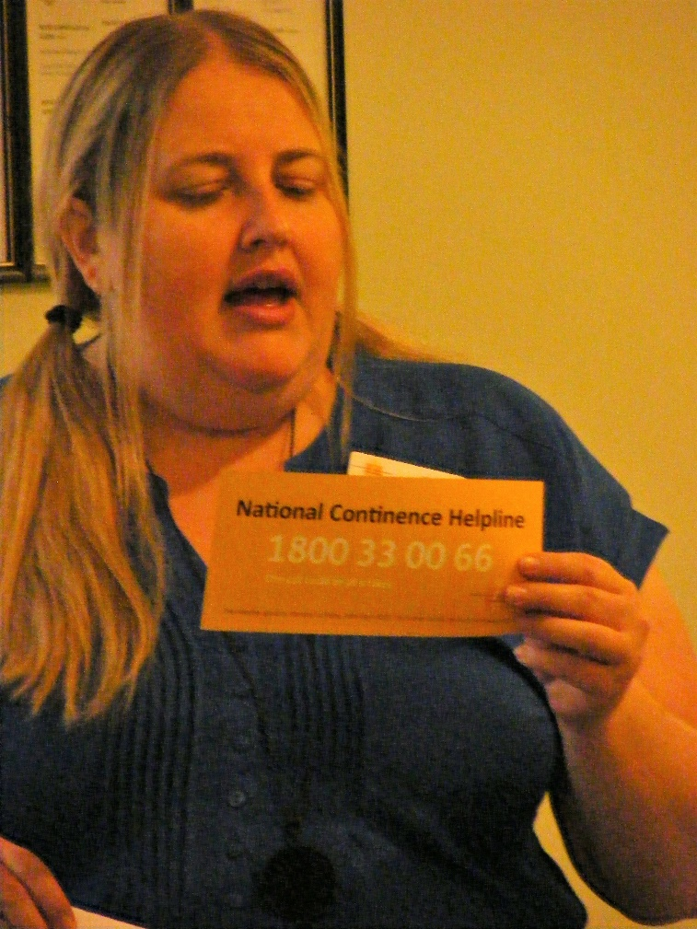  Lisa from continence resource centre  JUST FOR A LAUGH: Monthly Joke  