OFFICE BEARERS FOR 2017  PRESIDENT : Peter Halleday 0439500699  VICE PRESIDENT : Ansi Nitz  TREASURER : John Plunket  SECRETARY : Paul Edgeworth 0497386846  COMMITTEE : Dave Lawson  Glen Bowmer  Don Clements  Arthur Smith  Graham Carter  APPOINTMENT OF LEADERS for 2017 –  Work Health Safety Rob Burford/Graham Carter – joint management  Senior First Aiders Peter Halleday/Ansi Nitz – joint management  Building Fitout /Maintenance Peter Halleday/ Don Clements – joint management  Projects Don Clements  Social Organiser Dave Lawson  Webmaster Dave Lawson  Fund Raising Ansi Nitz  (Race Gates Brian Short)  Grant monies submission writer Graham Carter  Publicity Officer/ News Editor Peter Heness  Historian Graham Carter  Membership Support Brian Short  Kitchen Management Norman Collins  UPCOMING / ONGOING PROJECTS  - CHRISTMAS PARADE FLOATS - Mt Gambier City Council, waiting for CC to get back to us – Peter Ha  - Mt Gambier City Band – MUSICAL INSTRUMENT TROLLIES – Don C  - Reassemble the SHED FLOAT for the Christmas Parade –Peter Heness ------  - The area for pottery has been set up near the bikes Geoff Hart is building shelving for it  THANKS to  - Don C for making the cutting boards presented to Dave Lawson and Norman Collins for services to the Mens Shed  - Those who made the Boandik garden beds  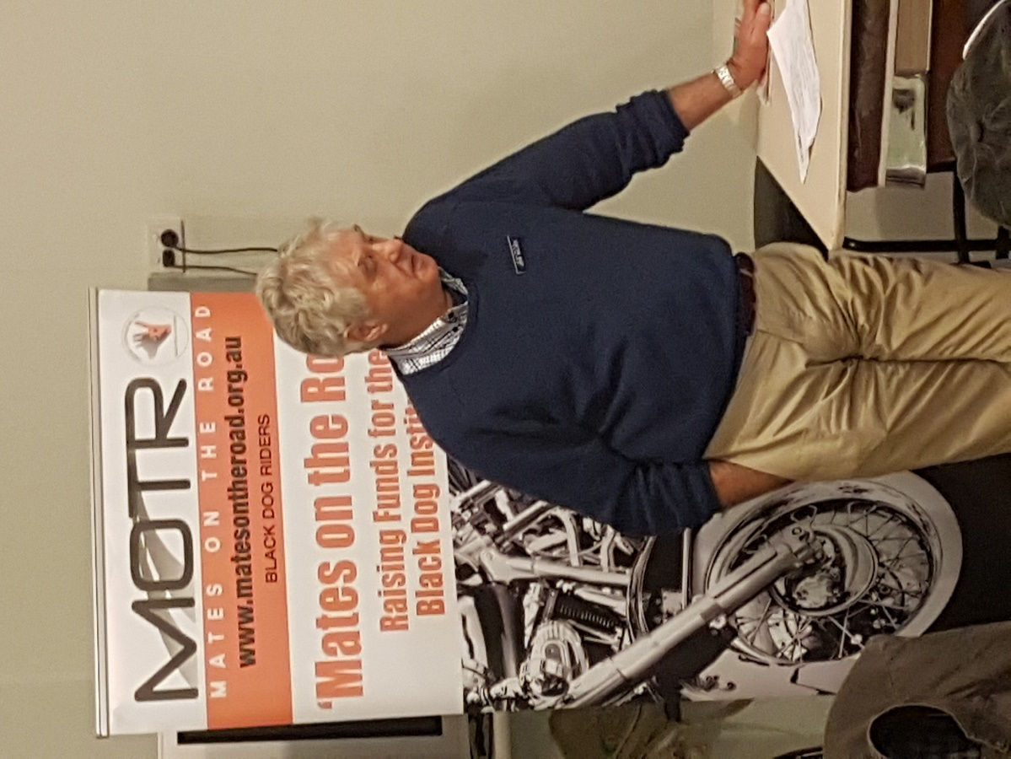  Mates on the Road MOTR arrangements to speak 24th August a great session on’ building resilience to cope with pressures of modern life’  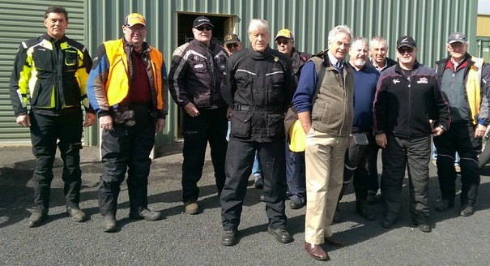  Mates on the Road visitors  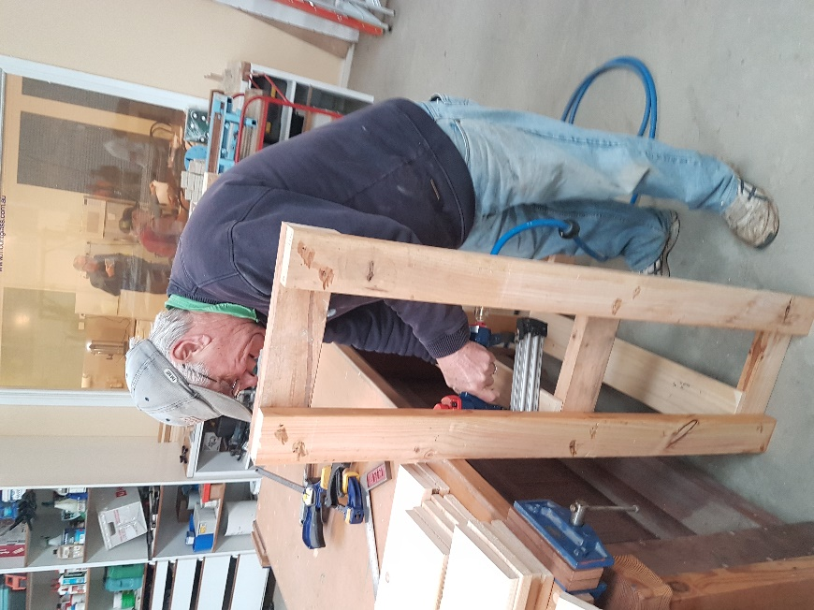  Geoff Hart is building shelving for the pottery area.  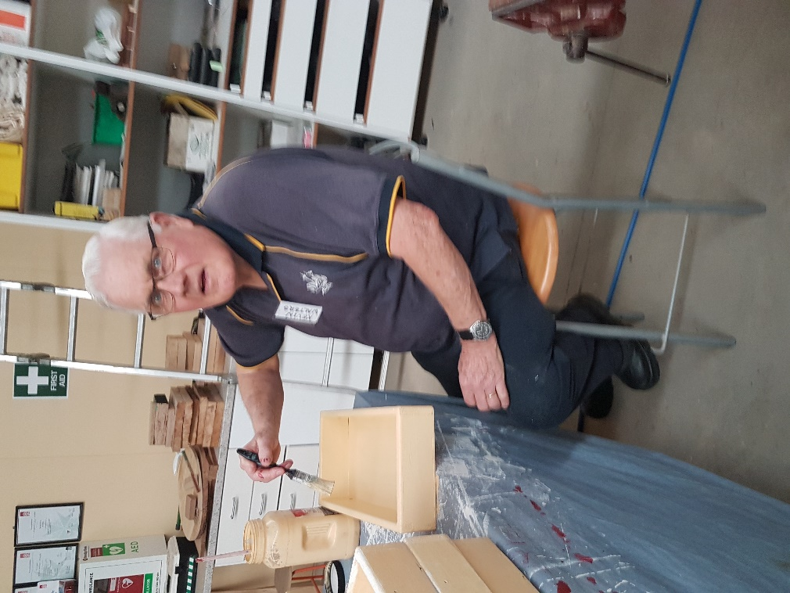  Sorry about the smile Kevin must have been working hard that day on the toys.  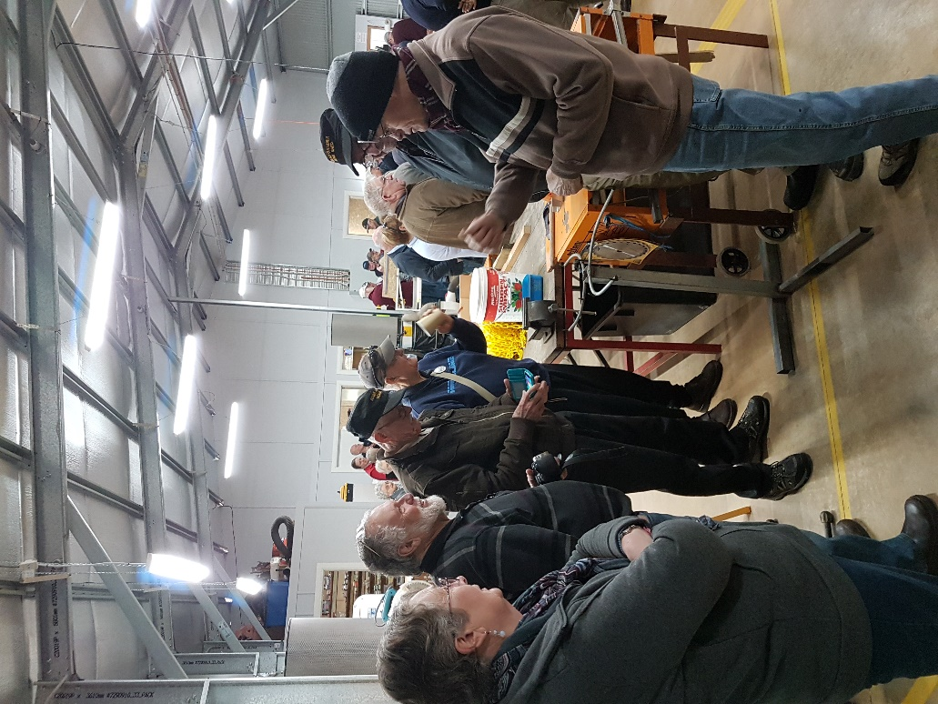  A great day was had by all at the Naracoorte Shed opening with many things on display.  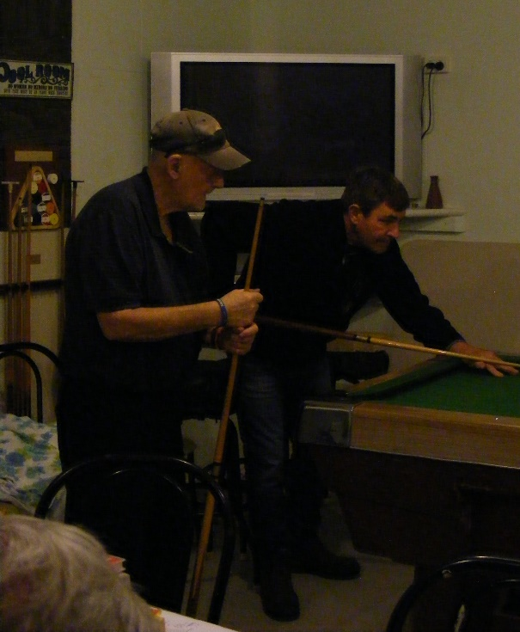  Not all work at the shed some can relax if need be  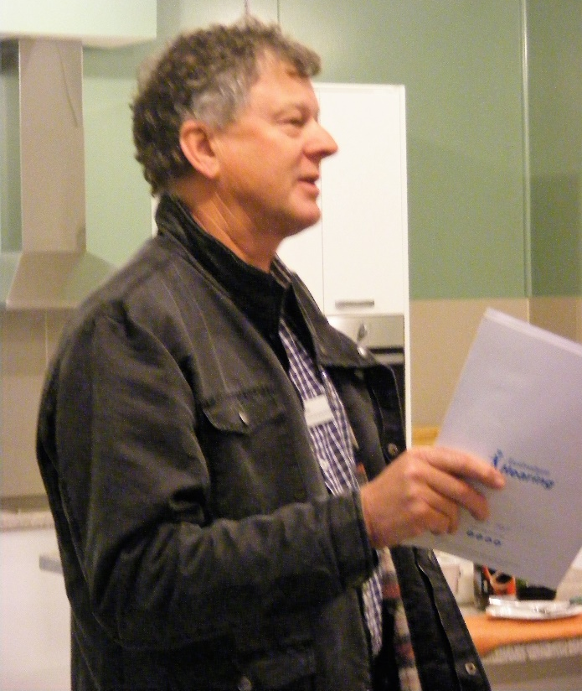  Phil Mann from Australian Hearing Mt Gambier  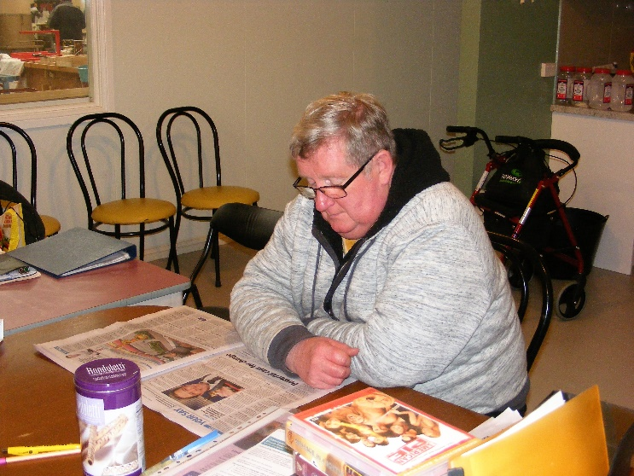  As mentioned before not all at the shed have work to do or need to work for that matter.  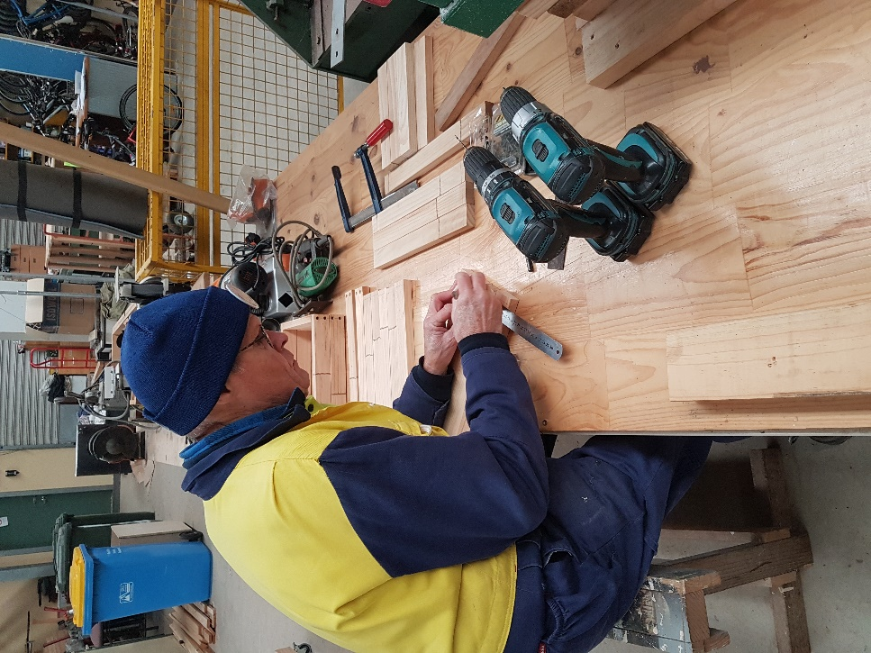  One of the Elves doing his thing working hard.  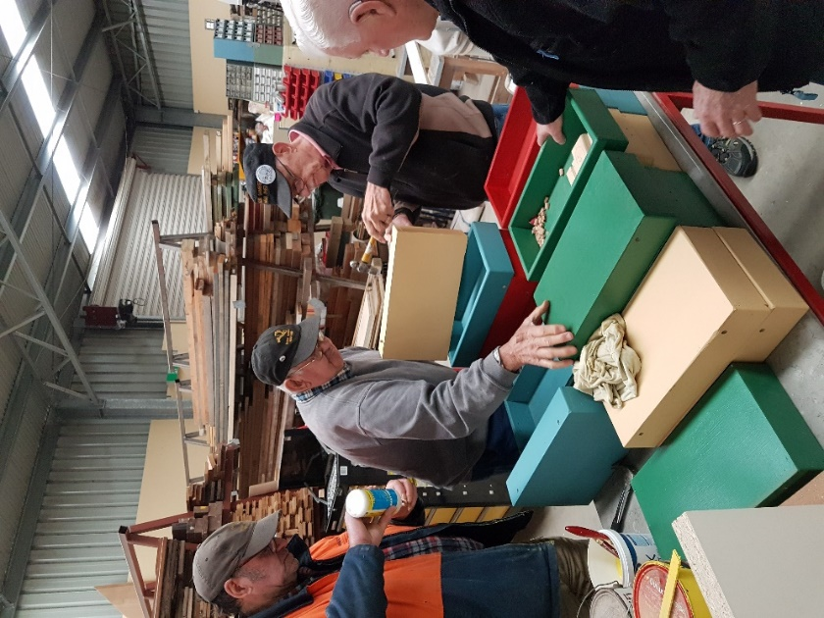  With lots of painting to be done it is great to see all hands on board.  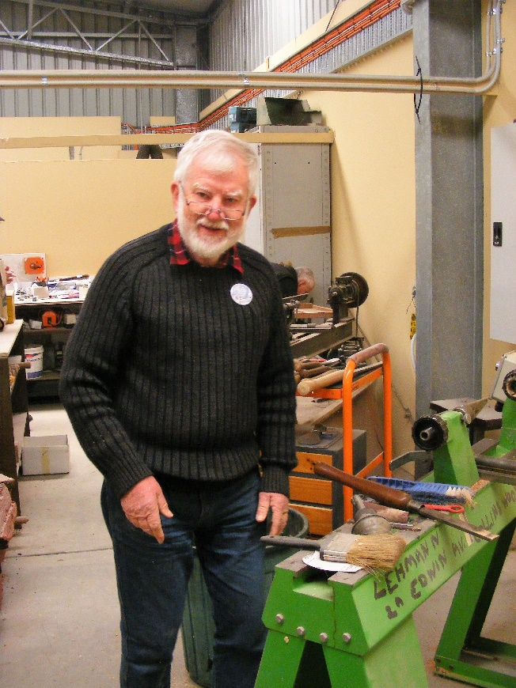  Neville D. Working on one of our wood lathes.  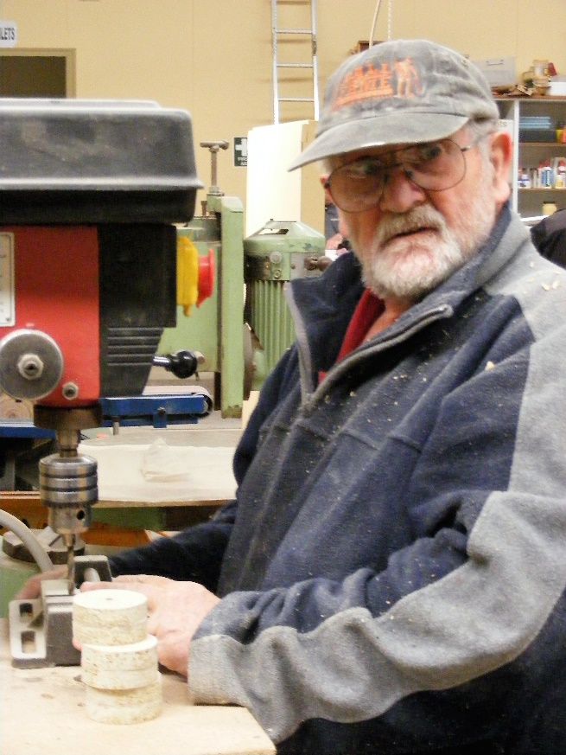  Wayne E Cutting wheels for the toys. | - ABC live radio and 5SE taped District Mens Sheds’ reports and NEWSLETTER - Peter Heness  - Scones – Norman C, Arthur S, Terry R and Terry G  - TOY MAKING for Mayors Christmas Appeal - Ian B and Peter Heness  Mitre 10 has agreed to assist with paint  - SMALL PLANTER BOXES – Laurie T  Dates to rember  19th October Thursday 10.00 Continence management  Lisa Lawton  8th November Wednesday 6.30 tea – Mac’s Hotel  Special meal deal  16th November 10.00 Thursday COTA SA ‘Moving Right  Along’ - safe driving  Date to be advised – negotiating with Tony Pasin  a chat with Shedders  Visit to /from Millicent Mens Shed to be advised  Heywood Mens Shed are organising the annual Good  Health afternoon – date to be advised  HEALTH AND WELLBEING  Support and contact as you are able and as Shedders wish  Those with longer term/serious physical issues –Terry R, Peter S, Norman C, Frank H, Rob B, Arthur S, Philip V, recuperating; also partners of Shedders – Glen B. Good to have Trevor Twilley, Brian Short, Ces Jones back on board from their illnesses.  WELCOME to new members:  Lyndon Manser, Myles Geraghty, Allan Compton  Birthday’s this month  Tony Pasin 1/10/1977  John Plunkett 2/10/1950  Peter Heness 14/10/1958  REMINDERS  - ALL BORROWINGS must be authorised by a member of the Management Committee  and entered in the book by the ‘sign in’ book  - DAMAGED MACHINES – let someone know  - NAME BADGES – please wear  - TOOLS AFTER USE – please return to correct storage  - CAPS for sale $17  Safety in the shed:-  - Safety of men in the workshop –  Being signed off as a competent, trained user of a machine requires the adherence to the Safe Operating Procedures (SOP’s) – displayed on each machine  A procedure is being developed should Shedders not adhere to the SOP conditions on multiple occasions  - Should Shedders be close to others operating noisy machines it is good practice to use ear protection also – (except Shedders walking past)  PERSONAL MEMBER PROFILE  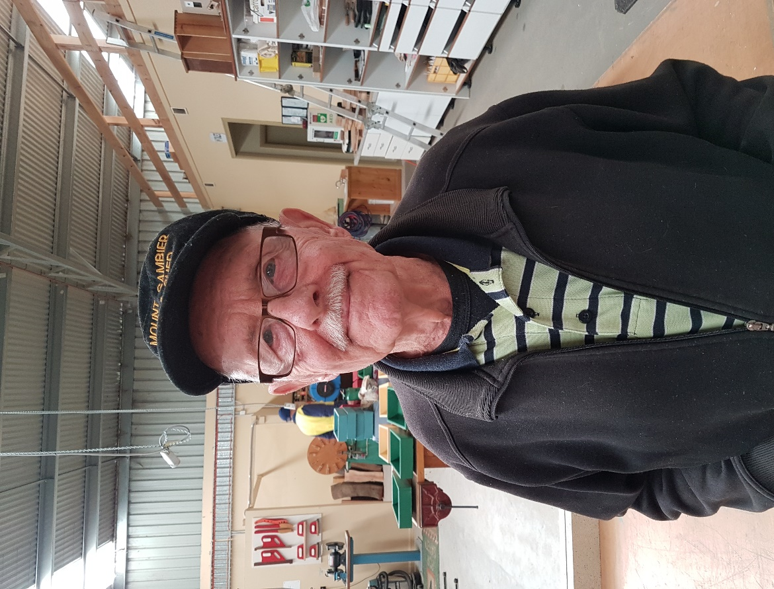  NAME:- Ray Lazenby  WHERE YOU HAVE WORKED 36 years with General Motors in Adelaide  SOMETHING ABOUT YOU OTHER MEMBERS MAY NOT Was a competitive sailor and won several Trophies as a crew.  KNOW:- WHAT YOU WISH TO DO IN THE SHED:- Have friendship and companionship and be able to assist others with their projects.  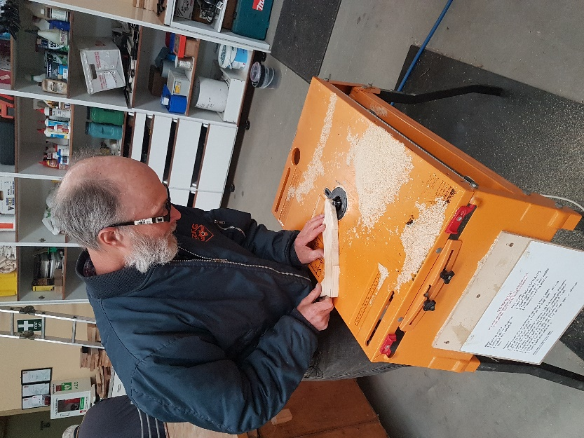  Using the router while making toys.  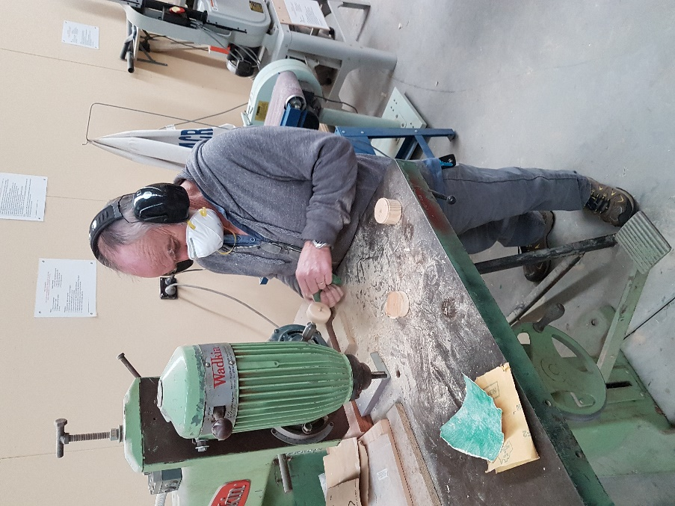  Another little elf hard at work sanding off wheels.  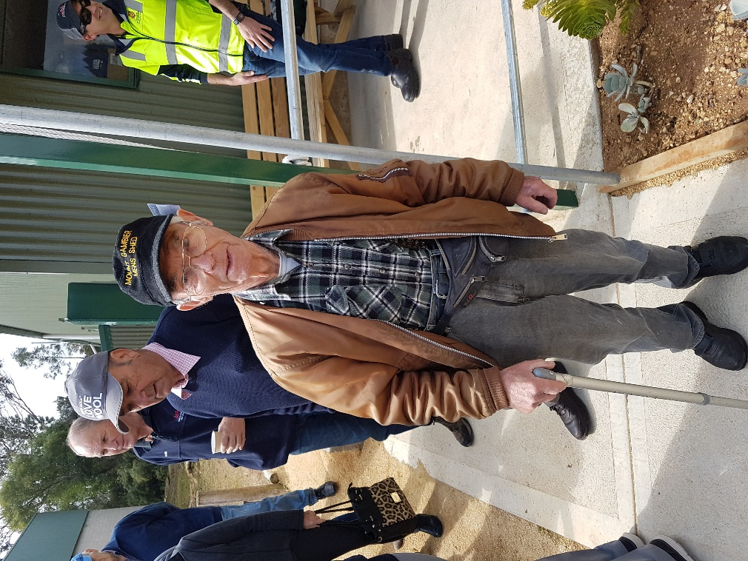  Frank H enjoying a day out at the Naracoorte open day.  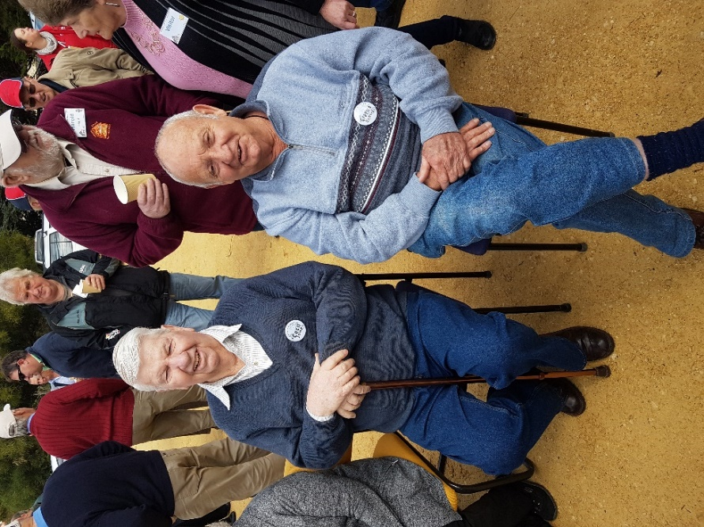  Other members at Naracoorte open day.  Australian Hearing  Phil Mann from Australian Hearing Mt Gambier occasionally drops into our Shed, we think, to sample the scones.  On a more official visit he spoke to our Shedders, 29 of us on the day, about hearing impairment, the recent ABC’s Checkout programme on hearing aid providers, the services that Australian Hearing have and he did hearing screening tests.  At Australian Hearing on the corner of Percy and Mitchell St - opposite Belgiorno’s and at the East end of the Centrelink building, they provide free hearing screenings for any adult. This is for anyone having their first hearing test, whether you go to any other hearing service provider and even if you have hearing aids.  If you ae a pensioner or a DVA card holder they are able to make appointments to see two new Australian speaking audiologists for more thorough testing and fitting of hearing aids (if needed).  They have a range of 7 levels of hearing devices. The first 3 levels are completely free (with a $45 annual fee for batteries and ongoing support). You may choose to have more ‘bells and whistles’ which you pay extra for.  One recent client found that his multi thousand $ hearing aids were nowhere near as good a free model.  Should you be with any other hearing service provider you are able to switch to any other (and back again) as you choose. All you have to do is go to the one of your choice – sign a form – and have all your records sent to your new choice. Should you want to go back to your previous service provider – all you do is go back to them or any other hearing service provider, sign another form and change again. DVA card holders do not need any permission from DVA to do this.  Australian Hearing, at their office, has a very large range of other assistive listening devices that they can demonstrate – things like TV listeners, personal communicators and alarm systems. They can be purchased. Note: some pensioners and DVA clients may access some of these free through other sources.  Thanks Phil for an enlightening session.  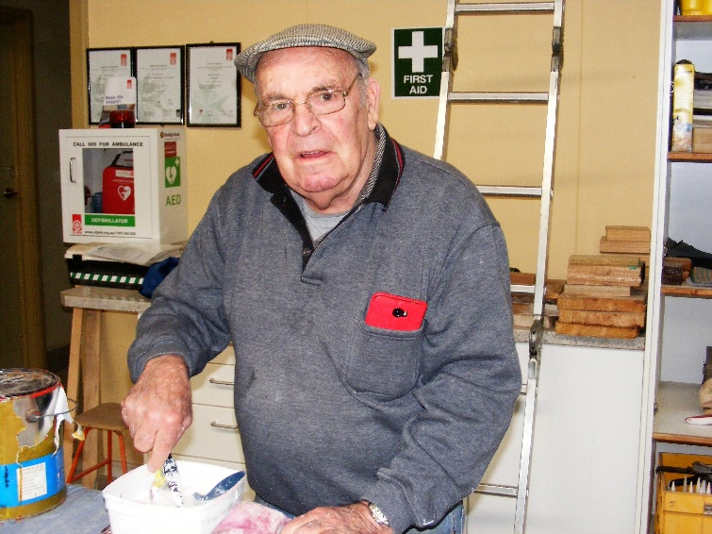  Another little elf working hard. Thanks for your help Jim M  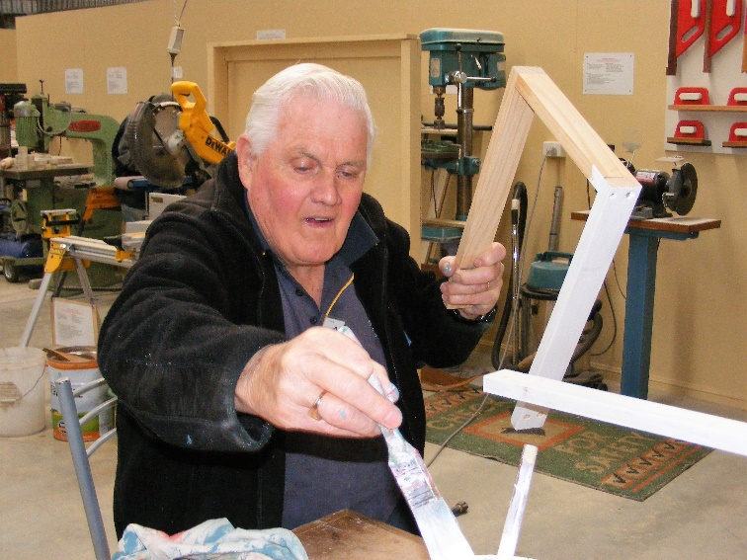  Thanks Kevin W for your help with the Kids toys.  JUST FOR A LAUGH: Monthly Joke  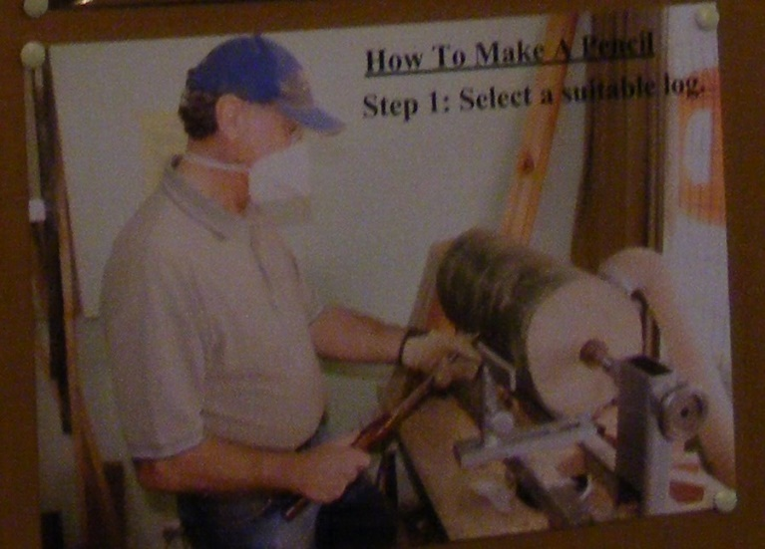  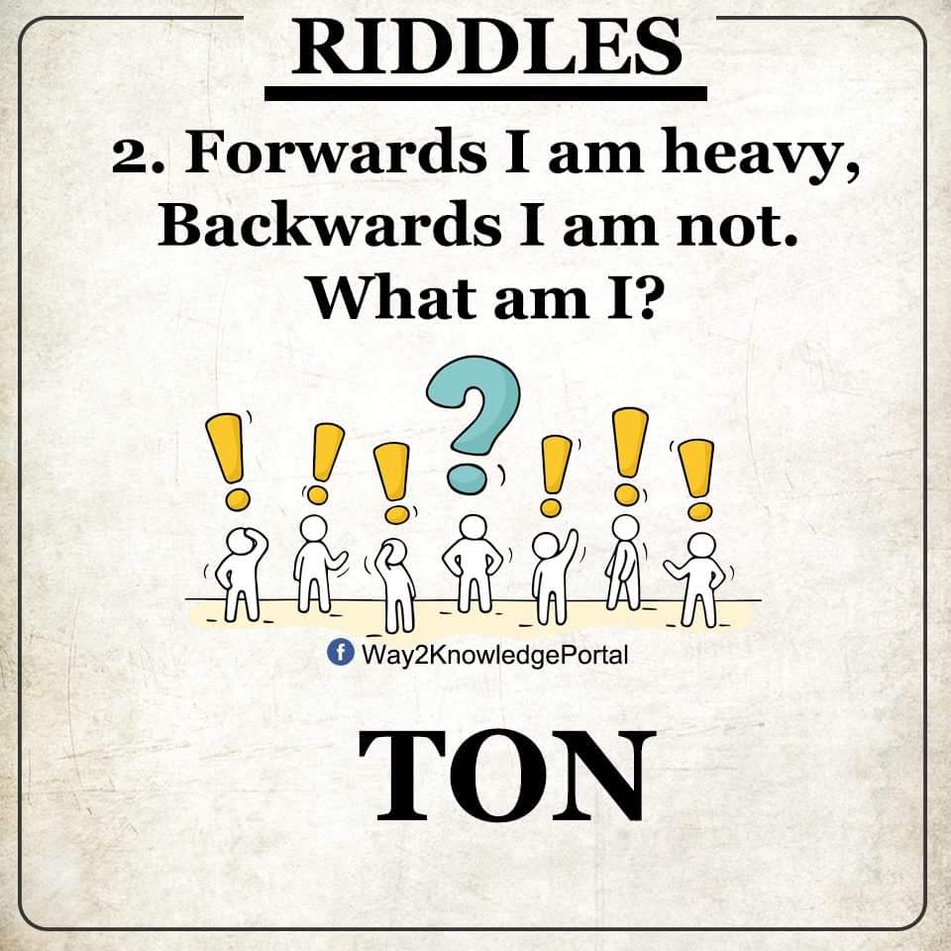  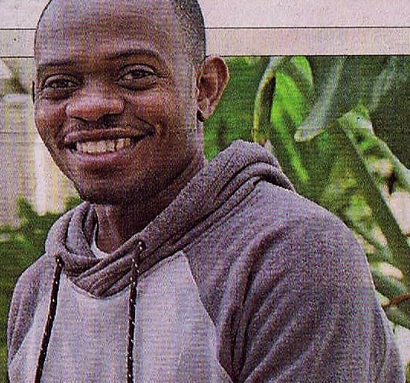  For those of you that know Sadiki May or may not know he was recently in the Borderwatch with Kevin S showing off some of the creative skills he has.

