OFFICE BEARERS FOR 2017  PRESIDENT : Peter Halleday 0439500699  VICE PRESIDENT : Ansi Nitz  TREASURER : John Plunket  SECRETARY : Paul Edgeworth 0497386846  COMMITTEE : Dave Lawson  Glen Bowmer  Don Clements  Arthur Smith  Graham Carter  APPOINTMENT OF LEADERS for 2017 –  Work Health Safety Rob Burford/Graham Carter – joint management  Senior First Aiders Peter Halleday/Ansi Nitz – joint management  Building Fitout /Maintenance Peter Halleday/ Don Clements – joint management  Projects Don Clements  Social Organiser Dave Lawson  Webmaster Dave Lawson  Fund Raising Ansi Nitz  (Race Gates Brian Short)  Grant monies submission writer Graham Carter  Publicity Officer/ News Editor Peter Heness  Historian Graham Carter  Membership Support Brian Short  Kitchen Management Norman Collins  UPCOMING / ONGOING PROJECTS  - Folding garden table  - Raised garden beds  - Jason Sims for metal welding in 2017  - AC CARE Park 2 Benches  - Hallmont Bowling high rise ball holding tables  - ‘Fruit Boxes’ – a dozen + constructed by Peter Halleday and team and donated to the Royal Society for the Blind as display boxes.  - Rolling Pins Request  PERSONAL MEMBER PROFILE  NAME:- Bernard Rogers: 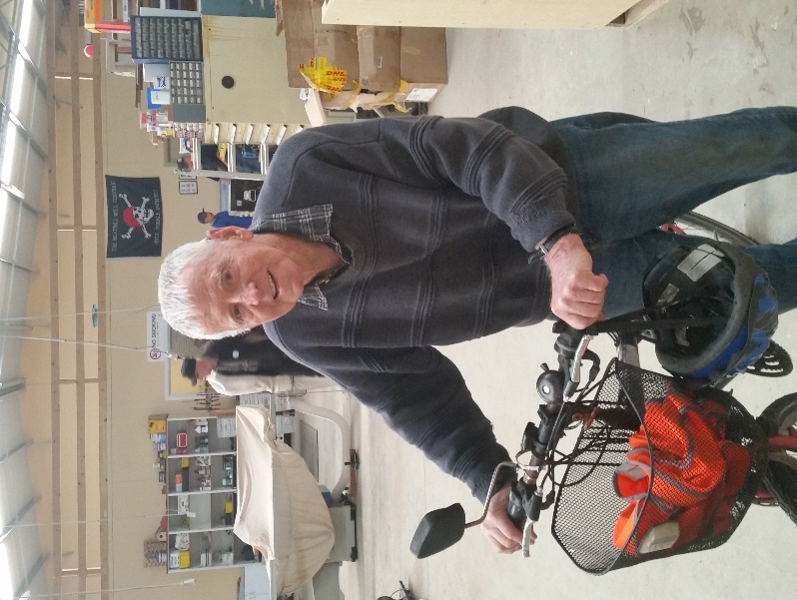  WHERE YOU HAVE WORKED:- Bernard has always worked as a farmer working with both sheep and cattle. In years gone by have done farming classes, learning welding and fitting and turning.  SOMETHING ABOUT YOU OTHER MEMBERS MAY NOT KNOW:- Lost everything in the ASH Wednesday fires including Unfortunately his son. Bernard is a member of the amateur radio club and has an amateur licence. Took up bike riding for exercise which has cured his back pain as well as helped his arthritis.  WHAT YOU WISH TO DO IN THE SHED:- Would like to learn how to do wood turning and get back into metal turning on the metal laythe.  Magic Custard Cake  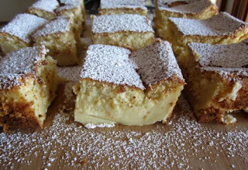  1/2 cup unsalted butter  2 cups milk  4 eggs, separated  4 drops white vinegar  1 1/2 cups powdered sugar  1 tablespoon water  1 cup flour  1 teaspoon vanilla extract  more powdered sugar for the top  Preheat oven to 325° F and lightly butter a 20 cm square baking dish.  Melt the butter and set it aside to cool. Heat the milk to lukewarm and set aside.  In a medium bowl, beat the egg whites and vinegar until stiff peaks form and set aside.  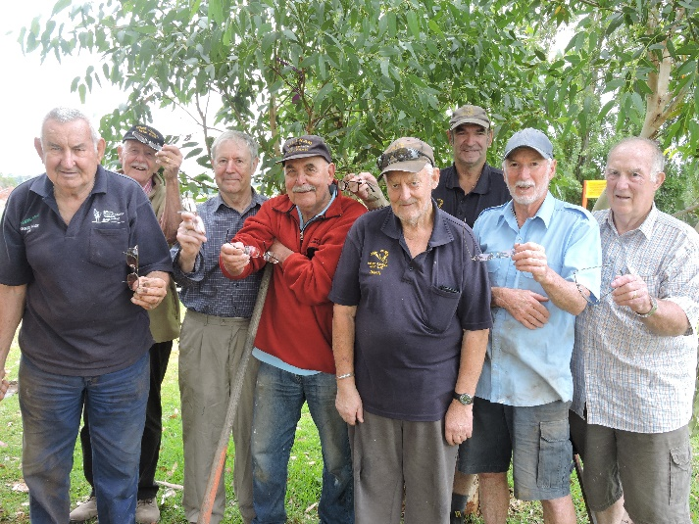  The team ready to install the buddy chair at the local school.  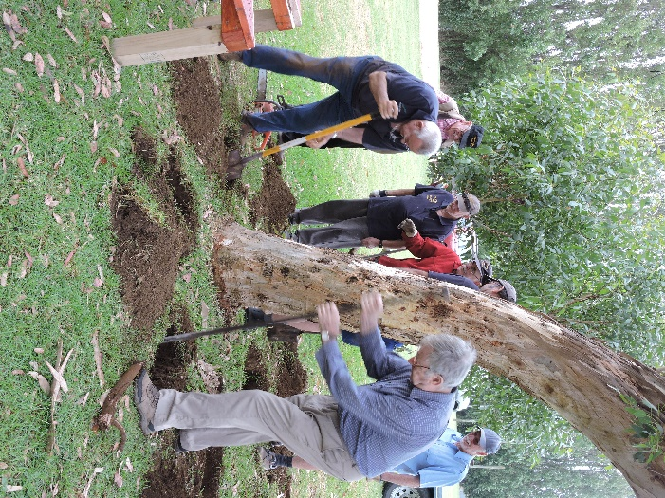  Time to work. With so many holes all managed to do their bit.  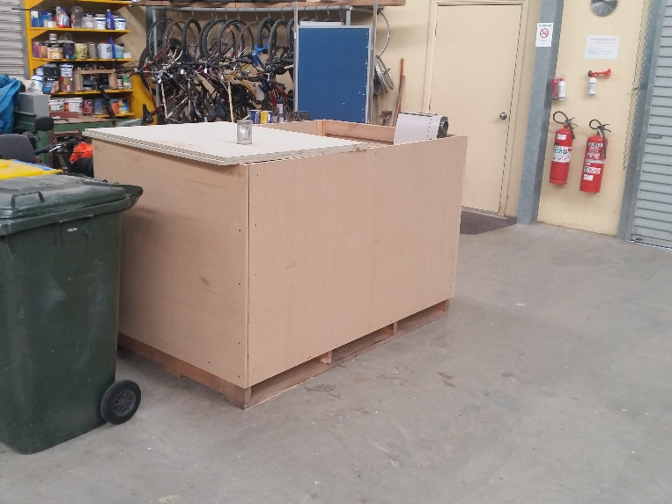  A new box being readied for Ryder Cheshire.  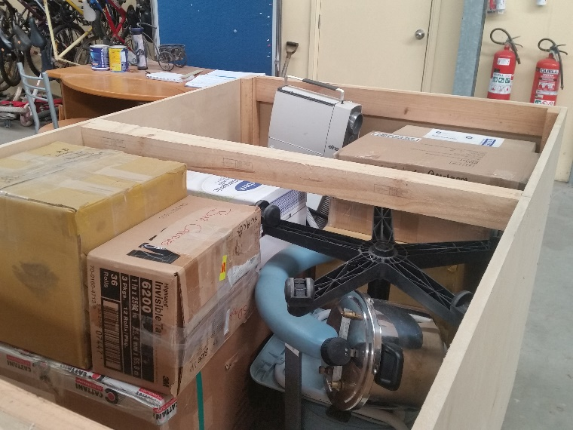  Some of the many items being stacked into the box. | April 1st Saturday Bunnings sausage sizzle. April 7th Friday Race Gates ticket selling Glenburnie May 11th Thursday Race Gates ticket selling Glenburnie May 12th Friday Race Gates ticket selling Glenburnie July 6th 10.30am Thursday SAPOL Road Safety for Seniors (date may change) – session booked District get together at our shed. To be announced: .  REMINDERS  - all borrowings must be authorised by a member of the Management Committee  - and entered in the book by the ‘sign in’ book  Welcome to SAFETY: MENS SHED IS ABOUT MENS HEALTH – physical and mental – check with each other regularly about how our MENTAL HEALTH is and be prepared to take time out to listen.  We will put a sign on the office door to indicate that someone is taking time to share with someone else if there needs to be a private chat.  If the door is shut it is usually an indication that something confidential is happening inside.  When the door is open it is free for all Shedders to come in – even if it ‘looks’ like’ a meeting. It is often groups of fellows who are chatting and you can join in.  It is okay to ask for the office space can be available to have private time even if there are others in there.  JUST FOR A LAUGH: Monthly Jokes  Qld Police Watch  Two Queensland police officers were conducting speeding enforcement on the Cunningham Highway, just west of the Amberley Air force Base in Ipswich.  The officers were using hand held radar devices to check speeding vehicles approaching the crest of a hill. The officers were suddenly surprised when their radar guns began reading 500kms per hour.  The officers attempted to reset the radar guns, but they would not reset and then turn off. Just then a deafening roar over the treetops revealed that the radar had in fact locked onto an RAAF F/A-18F Super Hornet which was engaged in a low flying exercise near the location.  Back at the QLD Police Headquarters the patrol Sergeant fired off a complaint to the RAAF Base Commander.  The reply came back in true RAAF style:  Thank you for your letter. We can now complete the file on this incident.  You may be interested to know that the tactical computer in the hornet had detected the presence of and subsequently locked onto your radar equipment and automatically sent a jamming signal back to it, which is why it shut down. Furthermore, an Air to ground missile aboard the fully armed aircraft had also automatically locked onto your equipment location.  Fortunately, the Senior Pilot flying the Hornet recognized the situation for what it was, quickly responded to the Missile system alert status and was able to override the hostile radar position.  The pilot also suggests, the officer holding the radar gun, should get his dentist to check his back left molar. It appears the filling is loose. Also the snap is broken on his holster.  Thank you for your concern.  Wing Commander Brown, SFO  RAAF, Amberley, Ipswich, Qld.  In a large bowl, beat the egg yolks and sugar until the mixture is pale yellow and falls in a ribbon from the beater. Add in the melted butter and water and beat until fully incorporated, about 2 minutes.  Mix the flour into the egg yolk mixture until fully incorporated. Slowly mix in the milk 1/2 cup at a time by hand with a spatula. Mix in the vanilla.  Fold in 1/3 of the eggs whites until mostly incorporated, and repeat with the remaining 2/3, 1/3 at a time. Mix gently, without deflating the egg yolks, until fully incorporated and there are no more big lumps.  Pour the batter into the prepared pan. Bake 45-60 minutes or until the top is golden. I took mine out at 45 minutes and I think it was a tiny bit overdone, but I’m pretty sure the heating mechanism in there is pretty much uncontrolled. Give the cake a gentle shake, it will still jiggle slightly when it’s done. Allow the cake to cool completely before cutting. You can put it in the fridge to expedite the cooling. Dust with powdered sugar before serving. The cake will last for a few days in the fridge, but let it come to room temperature before serving.  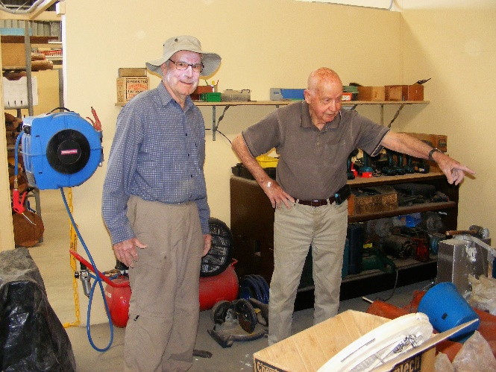  Kelvin organising Graham as to where the clay moulding area will be laid out.  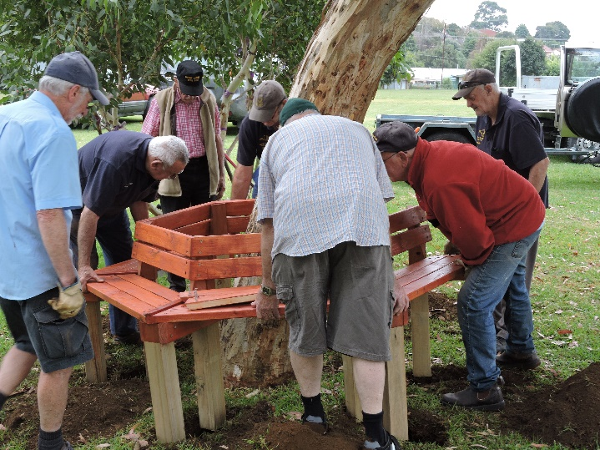  Well as you can see all the holes were put in the right place and project is officially finished. Well done lads.  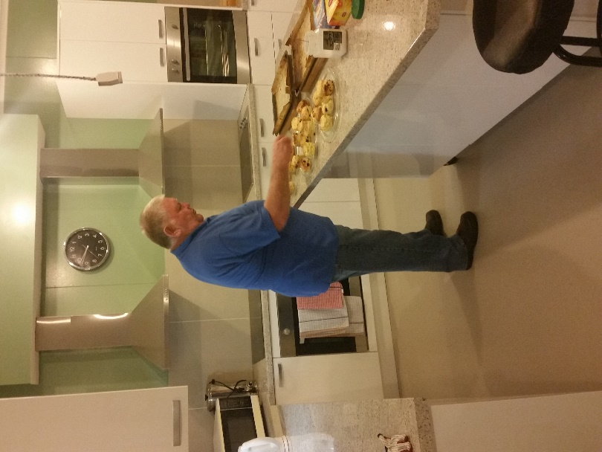  The new apprentice scone maker hard at work doing morning tea. Well done Terry for stepping up.

