EXECUTIVE MEMBERS FOR 2022
PRESIDENT: Ian Bond 0420859540
VICE PRESIDENT: Grant Sullivan
TREASURER: John Plunkett
SECRETARY: Paul Edgeworth 0497386846

PHONE: 0478614027 (prefer Tuesday and Thursday AM.)

WE NOW HAVE A WEB SITE FOR THOSE WHO WISH TO LOOK. THIS WILL BE UPDATED FROM TIME TO TIME WITH NEW PHOTOS, NEWSLETTERS, RADIO REPORTS, CONTACTS AS WELL AS UPCOMING EVENTS AT THE SHED. Go to
www.mgmensshed.com.au

FACEBOOK Mens Shed Mount Gambier
mgmensshed@gmail.com

BIRTHDAYS
Tony P 01/10
Allan V 01/10
John P 02/10
Laurie T 10/10
Peter He 14/10
Bob C 19/10
Bruce A 24/10
Trevor T 24/10

2022 Calendar
12th October Wednesday 6.30 Shedders and partners tea at Park Hotel
13th October Thursday 10.15 Members meeting
15th October Saturday 11.00 EST Heywood Mens Shed Black Dog Institute Scott St, Sound Shell
22nd October Saturday 8.30/12.00 Bunnings BBQ
25th October Tuesday 10.15 Management Meeting
23rd November Wednesday 11am Murray Bridge Shed ‘Spanner in the Works’ 3pm. Invitation clusters meeting details following.
27th November Thursday 11.30 BBQ lunch
2023
7th Feb Tuesday 11.00 Diabetes talk 15/20 min and screening till afternoon.
March /April Bowel talk Mattias Wichmann
World Mental Health Day Make mental health & well-being for all a global priority. The VMSA State-wide Forum and AGM will take place on October 10th to reinforce and celebrate our commitment to positive Mental Health
The overall objective of World Mental Health Day is to raise awareness of mental health issues around the world and to mobilize efforts in support of mental health. The Day provides an opportunity for all of us working on mental health issues to talk about their work, and what more needs to be done to make mental health care a reality for people worldwide. Whilst the pandemic has, and continues to, take its toll on our mental health, the ability to reconnect through World Mental Health Day 2022 will provide us with an opportunity to re-kindle our efforts to protect and improve mental health. Many aspects of mental health have been challenged; and already before the pandemic in 2019 an estimated one in eight people globally were living with a mental disorder. At the same time, the services, skills and funding available for mental health remain in short supply, and fall far below what is needed, especially in low and middle income countries. The COVID-19 pandemic has created a global crisis for mental health, fuelling short- and long-term stresses and undermining the mental health of millions. Estimates put the rise in both anxiety and depressive disorders at more than 25% during the first year of the pandemic. At the same time, mental health services have been severely disrupted and the treatment gap for mental health conditions has widened. Growing social and economic inequalities, protracted conflicts, violence and public health emergencies affect whole populations, threatening progress towards improved well-being; a staggering 84 million people worldwide were forcibly displaced during 2021. We must deepen the value and commitment we give to mental health as individuals, communities and governments and match that value with more commitment, engagement and investment by all stakeholders, across all sectors. We must strengthen mental health care so that the full spectrum of mental health needs is met through a community-based network of accessible, affordable and quality services and supports. Stigma and discrimination continue to be a barrier to social inclusion and access to the right care; importantly, we can all play our part in increasing awareness about which preventive mental health interventions work and World Mental Health Day is an opportunity to do that collectively. We envision a world in which mental health is valued, promoted and protected; where everyone has an equal opportunity to enjoy mental health and to exercise their human rights; and where everyone can access the mental health care they need.

WOODWORM TREATMENT
Given the damage these insects can cause to the timber and furniture in your home or business premises, it’s always a good idea to seek professional assistance to deal with the problem effectively. Woodworm infestations often go hand-in-hand with severe damp, so it pays to do this properly.
The DIY approach rarely gets to the heart of the issue, because as you’ve seen – most of these woodworms are extremely hardy and difficult to completely eradiate unless you really know what you’re doing.
Furniture Damaging Insects Part 1
From their names, wood-damaging insects damage wood by tunneling through it to nest, feed, or live. These destructive insects look small-sized and harmless, but if left untreated, they damage your wooden furniture more than would the forces of nature. There’s always a risk of Infestation irrespective of where you live. It might be caused by climate, an outbreak, or any unknown entryways.
Here’s the good news though; you’ll find a way out of this Infestation!
Below is a guide of the most common wood-damaging insects and how they can be prevented. Read along!
Termites
Termites are the most common wood destroyers. These insects are harmful to timber and can cause a million-dollar loss to your property. Unfortunately, termite damage is usually not covered by most insurance, yet their damages require costly repairs.
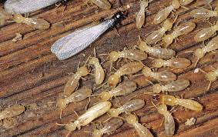
Prevent Termite Infestation
If you’ve discovered that these are the enemies to your furniture, contact a professional exterminator. They’ll help you seal any holes, cracks, and spaces around your windows and doors that could be the termites’ entrance points.

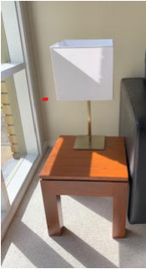
Lamp table made by Dick.

Receipe:-


Ingredients
Cornflake cookies
- 125 gram butter
- 1/3 cup caster sugar
- 1 egg, lightly beaten
- 2/3 cup sultanas
- 1 cup self-rising flour
- 1.5 cup cornflakes, crushed

Method
Cornflake cookies
- Preheat oven to 180°C (160°C fan-forced).
- Beat butter and sugar in small bowl with electric mixer until smooth, add egg, beat until combined.
- Stir in sultanas and sifted flour.
- Roll rounded teaspoons of mixture in Corn Flakes, place about 3cm apart on greased oven trays; flatten slightly.
- Bake in oven about 20 minutes or until lightly browned. Cool on trays.
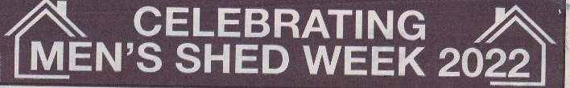
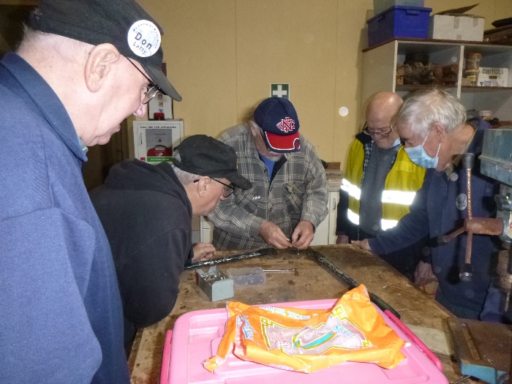
Matt showing Don, Stratty,George and Dick how to sharpen a pair of tree loppers.

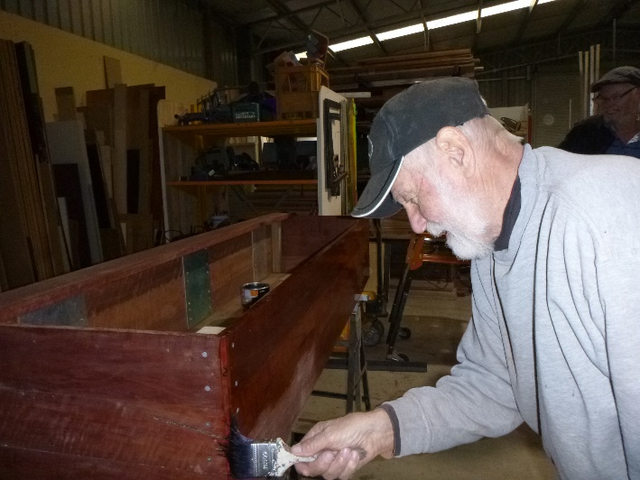
Herman putting the gloss on his coffin.
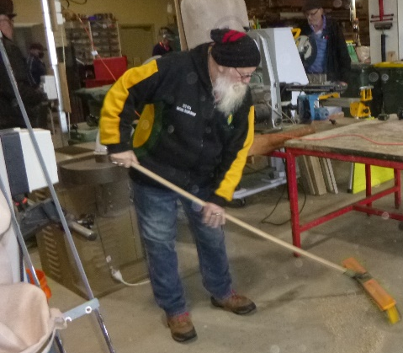
Kevin is only just become a member but shows off his skills of how to use a broom.
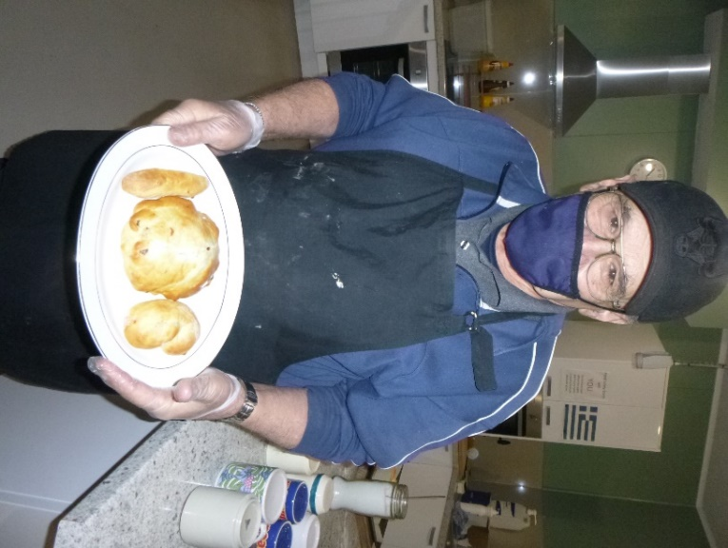
Ben with some special scones for President Ian on his Birthday.
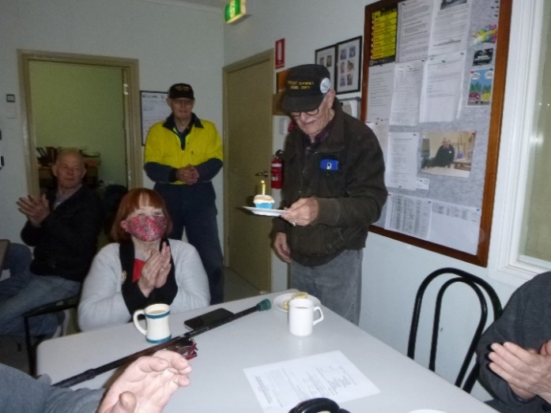
Happy 90th to Ray L.
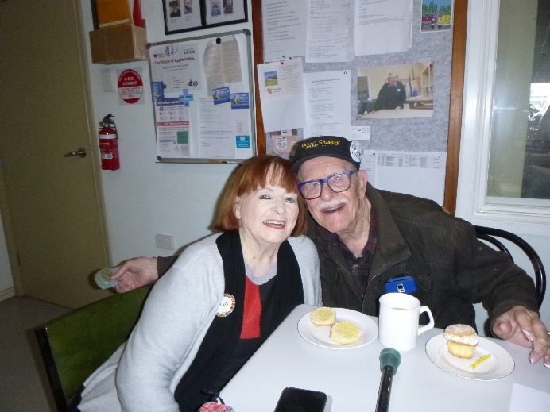
Ray with wife Vicky on his 90th Birthday.
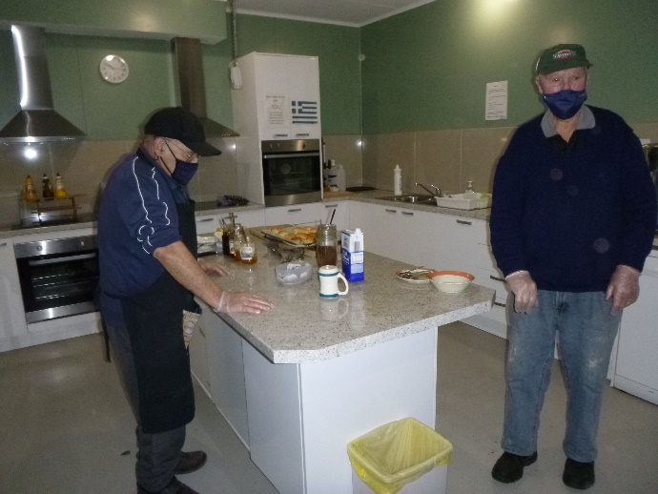
Ben and Allan getting ready for morning tea.
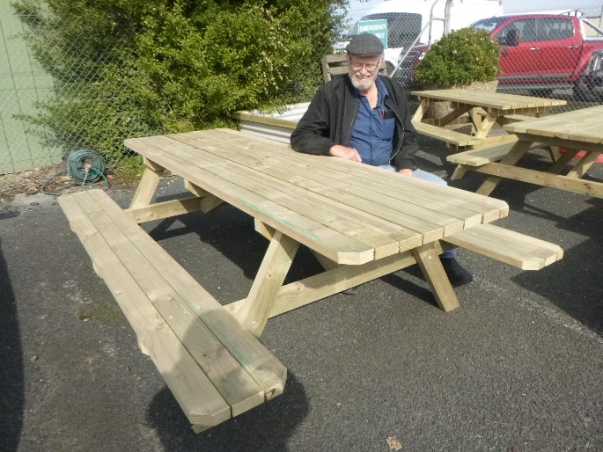
After making another outdoor table Jeff decides it is time to have a rest.
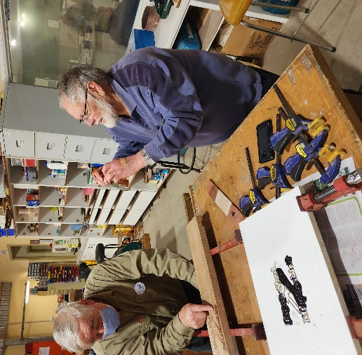
After many years of people asking about our photos this is the moment he finally got caught taking one. Thanks for all your work Paul well done.
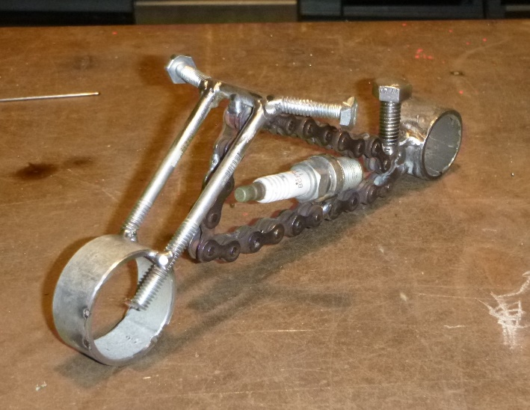
A little fun Harley made by Ian.
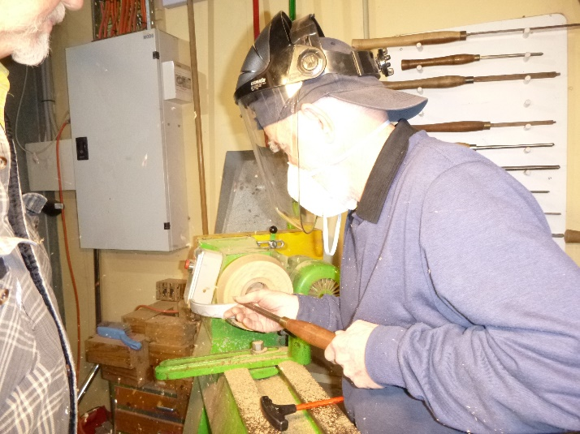
Glen turning up a bowl on the lathe.
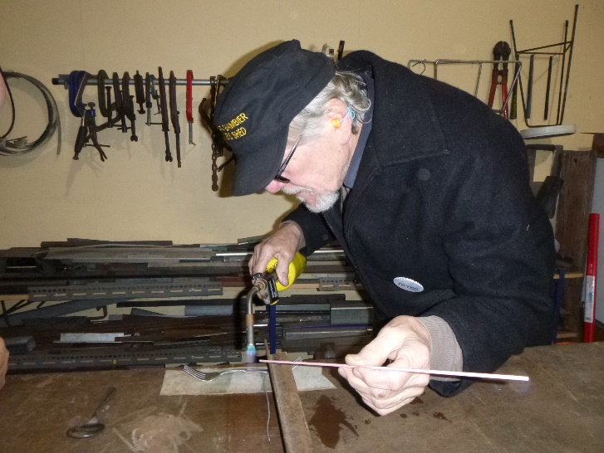
Peter doing a Uri Geller and bending some forks.
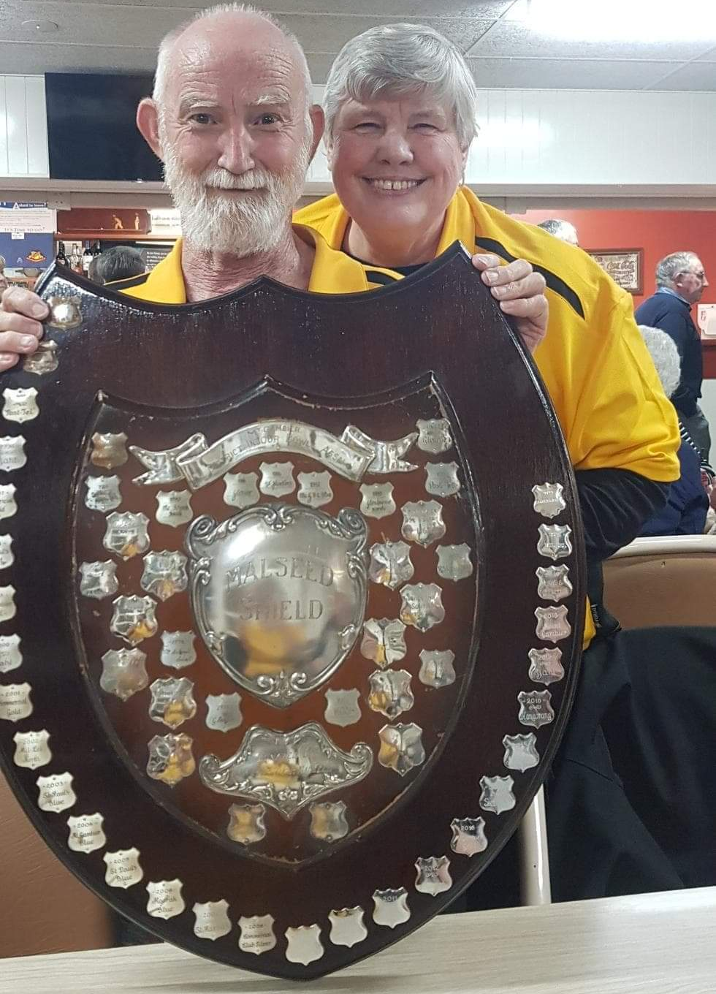
Above and below are the trophies Shed Member Glen andf his wife Cindy with the Bowls sheild and trophy they won for indoor bowls.
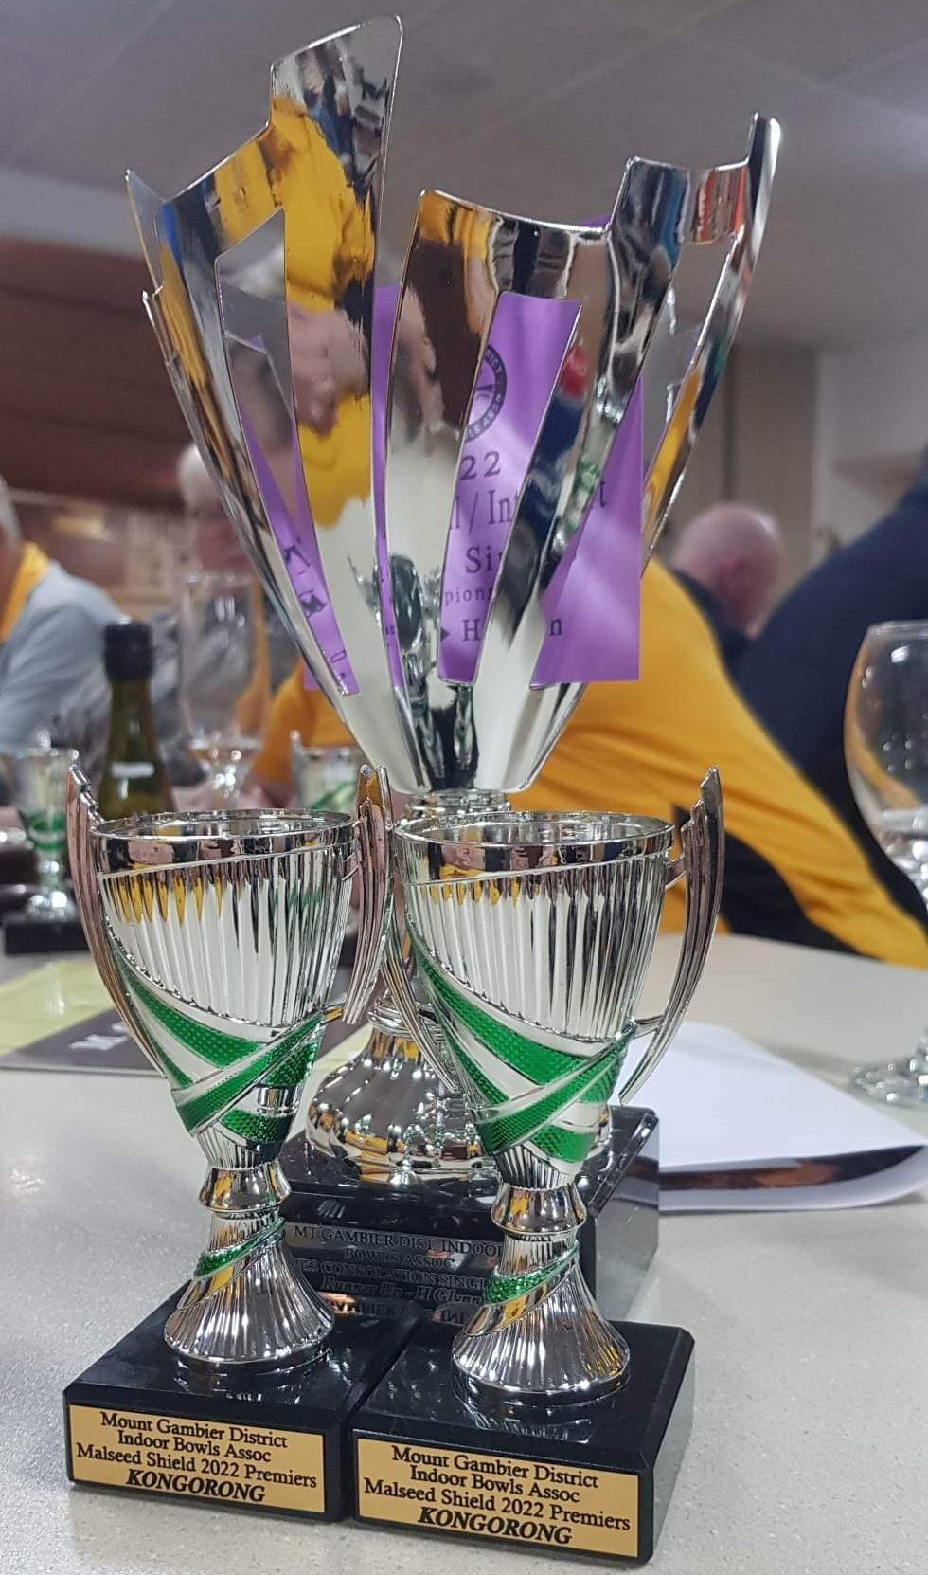
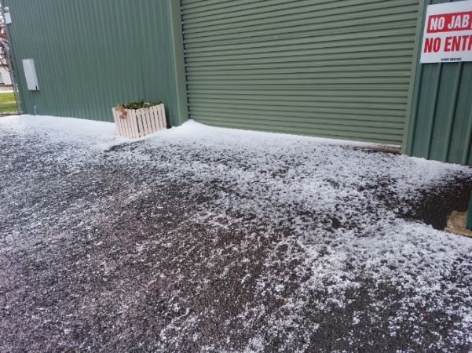
Think we had a hail storm come through.
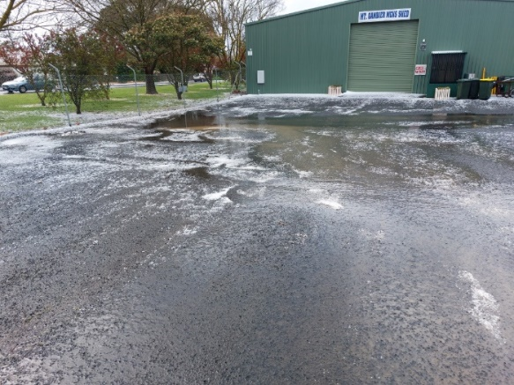
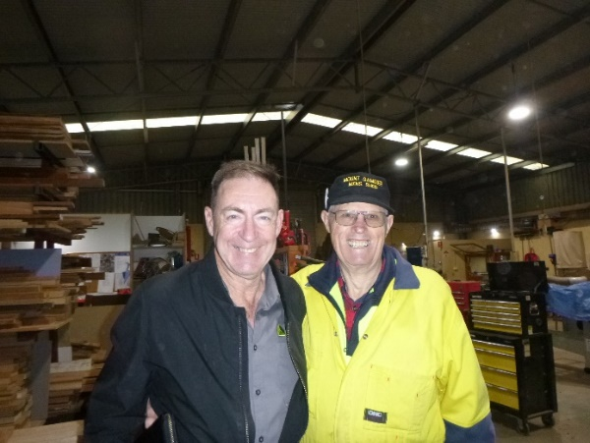
Shed had a visit from Tony Wyld AMSA S.A. Rep with President Ian.
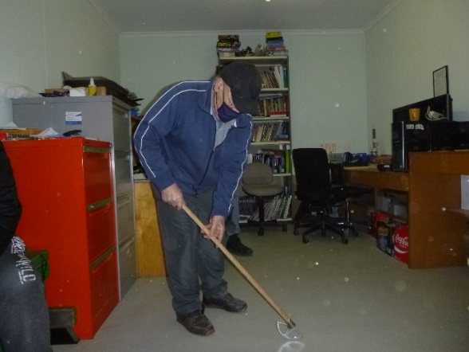
Ben with the Paver weeder made by Trevor.

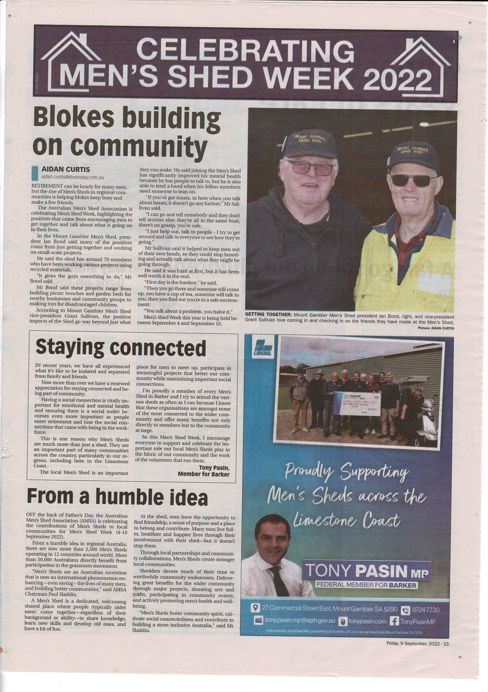

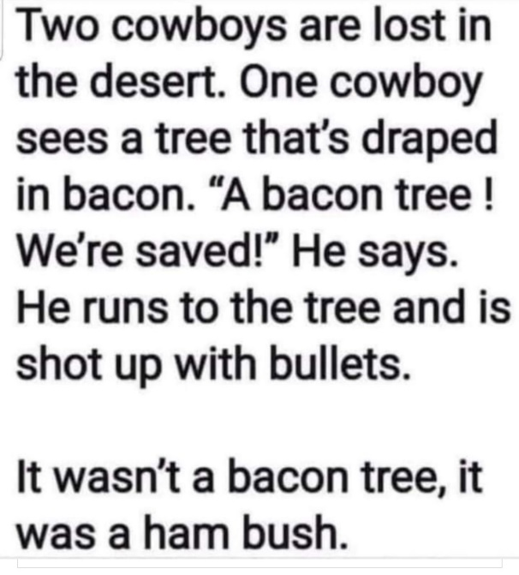

Jennifer, a manager at the Gold Coast
Council, had the task of hiring someone to fill a job opening. After sorting through a stack of resumes she found four people who were equally qualified. Jennifer decided to call the four in and ask them only one question. Their answer would determine which of them would get the job. The day came and as the four sat around the conference room table, Jennifer asked, 'What is the fastest thing you know of? 'The first man replied, 'A THOUGHT.' It just pops into your head. There's no warning. 'That's very good!' replied Jennifer. 'And, now you sir?', she asked the second man. 'Hmmm...Let me see 'A blink! It comes and goes and you don't know that it ever happened. A BLINK is the fastest thing I know of. ''Excellent!' said Jennifer. 'The blink of an eye, that's a very popular cliché for speed. 'She then turned to the third man, who was contemplating his reply. 'Well, out at my dad's property, you step out of the house and on the wall there's a light switch. When you flip that switch, way out across the pasture the light on the barn comes on in less than an instant. 'Yep, TURNING ON A LIGHT is the fastest thing I can think of'. Jennifer was very impressed with the third answer and thought she had found her man. 'It's hard to beat the speed of light,'she said. Turning to Wally, the fourth and final man, Jennifer posed the same question. Old Wally replied, 'After hearing the previous three answers, it's obvious to me that the fastest thing known is DIARRHOEA. ''WHAT !?' said Jennifer, stunned by the response. 'Oh sure', said Wally. 'You see, the other day I wasn't feeling so good, and I ran for the bathroom, but before I could THINK, BLINK, or TURN ON THE LIGHT, I had already shit myself. 'Wally is now working at the Gold Coast Council!









Big supporters of Mount Gambier Mens Shed.

SUPPORT YOUR LOCAL BUSINESSES
THAT SUPPORT YOU.

