EXECUTIVE MEMBERS FOR 2022
PRESIDENT: Ian Bond 0420859540
VICE PRESIDENT: Grant Sullivan
TREASURER: John Plunkett
SECRETARY: Paul Edgeworth 08 8725 6385
PHONE: 0478614027
PHONE: 0478614027
WE NOW HAVE A WEB SITE FOR THOSE WHO WISH TO LOOK. THIS WILL BE UPDATED FROM TIME TO TIME WITH NEW PHOTOS, NEWSLETTERS, RADIO REPORTS, CONTACTS AS WELL AS UPCOMING EVENTS AT THE SHED. Go to
www.mgmensshed.com.au

FACEBOOK Mens Shed Mount Gambier
mgmensshed@gmail.com

BIRTHDAYS
Jim M. 09/05
Wayne E. 23/05

A note from Vice President Grant Sullivan.
Duties of the vice President are as follows: Chair meetings when the President is unavailable. Support the President and fellow committee members. If the secretary is unavailable I take the minutes for meetings. I have taken on the role of membership to lighten the workload of the secretary.
The thing I like about our Shed is how everyone encourages each other and are always ready to lend a hand. Also it is good to see everyone use earmuffs and eye protection when required and always use the equipment in a safe manner.
2022 Calendar
11th May Wednesday 6.30 Tea with partners Jens hotel
12th May Thursday 10.15 Members Meeting
24th May Tuesday 10.15 Management Meeting
26th May Thursday 10.30 EST Health Day at Heywood Mens Shed (6 invited from Mt Gambier)

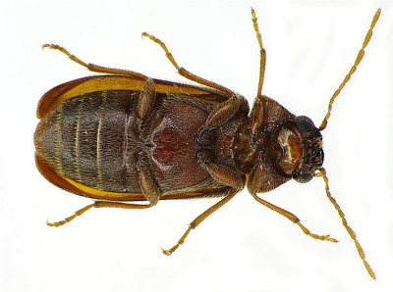
THE COMMON TYPES OF WOODWORM AND WOOD BORING INSECTS pART 8/12
#7. Bark Borer
Latin name: Ernobius Mollis
Appearance: There are many types of bark-borers, but the most common have either dark-brown or light-brown coloring. They can cause major damage to the surface level of timber if left to do their worst.
Preferred timber: The Bark Borer exclusively targets softwoods with bark, and they fly locally to discover other timber sources.
Type of damage: Although the rounded tunnels this beetle creates are kept near the surface of the timber, this insect can still cause significant amounts of damage to all types of softwoods.
Telltale signs: Flight holes are around 2 mm in width, and its frass is rounded in shape and either light or dark colored depending on the wood source.
Next Month - Wood Boring Weevil

Profile:-
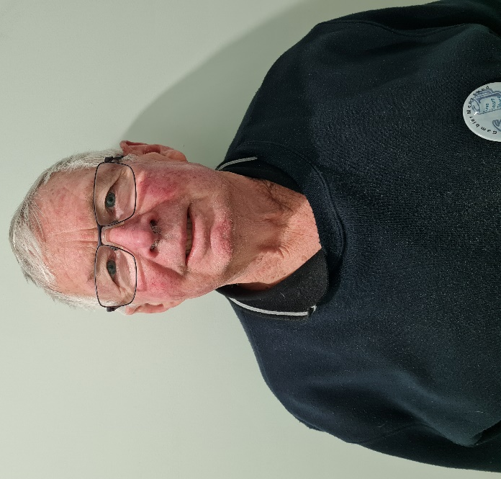
Name: - Garry Vandepeer. Where have you worked:-Most working life as a teacher. Something about you people at the shed don’t know:- Was an Inaugural Member of the shed and is a Lego engineer. What do you want to achieve at the shed:-Easy and simple I want fellowship with all members.

You can’t keep a good man down, our lovable men’s shed stalwart Kelvin seems to be enjoying his time is Strathalbyn. And it looks like he is doing his usual and making new friends. Thanks for the photo Mate you are looking good.
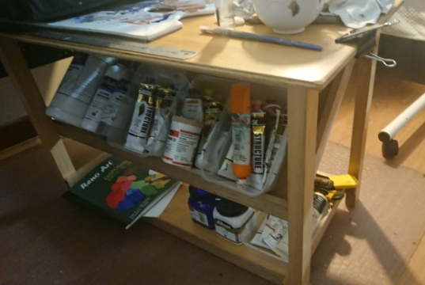
Thinking of Kelvin this is the art desk / trolley that was made by shed members so he could do his painting.
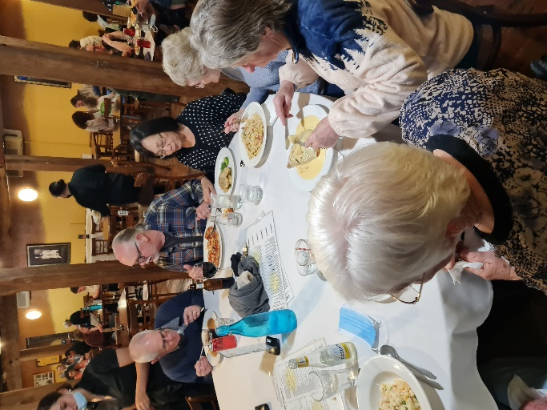
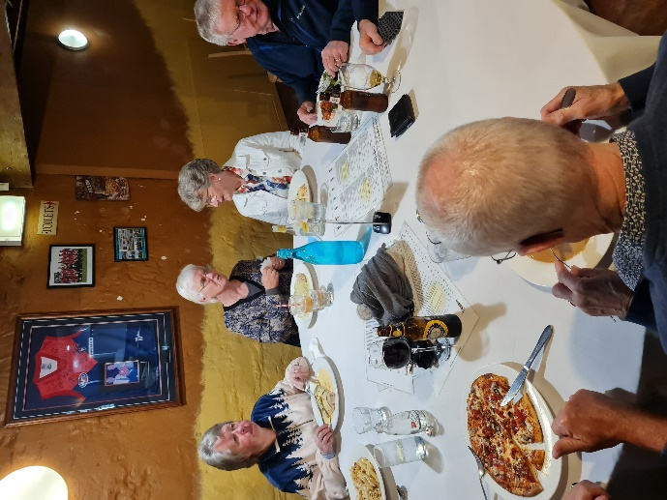
Top 2 photos are tea with wives at Belgiornos.
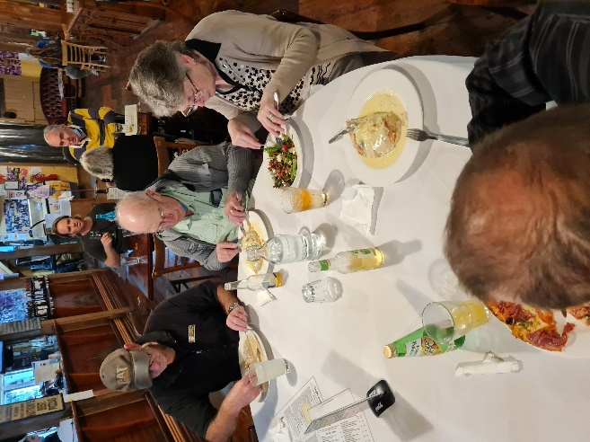
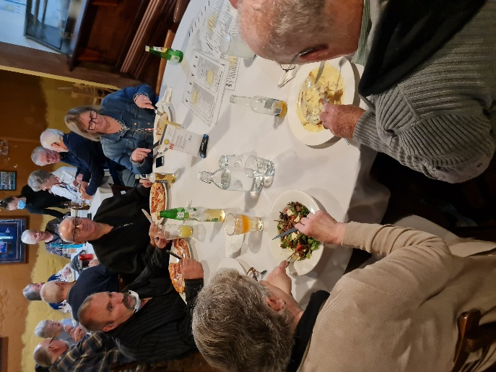
Top 2 photos are tea with wives at Belgiornos.
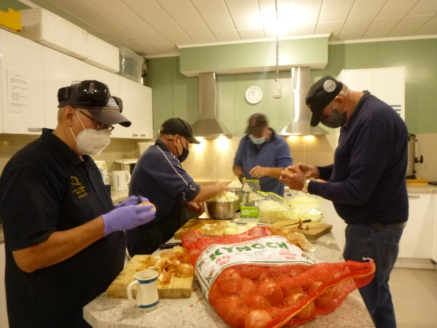
All hands on deck cutting onions Shane, Ben, Gary and Peter.
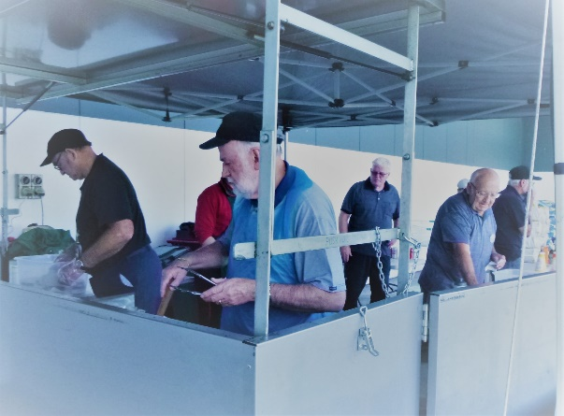
Bunnings Sausage sizzle one of the best we have had so far.

Couple of satisfied customers (with photo permission from Dad)
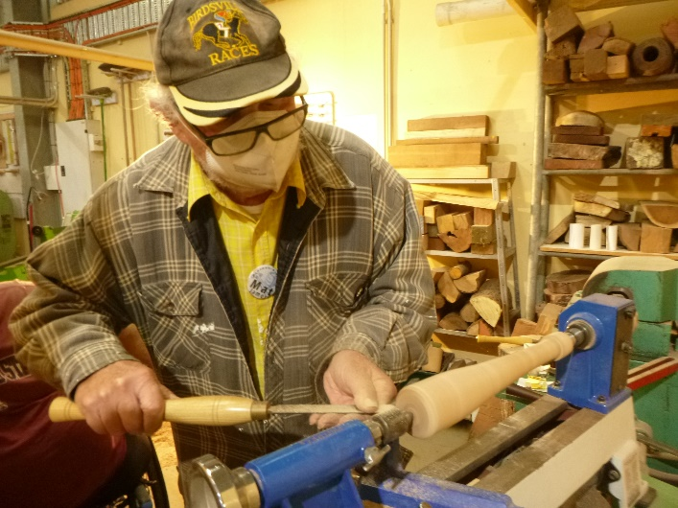
Matt demoing how to make a baseball bat to be used as a trophy.
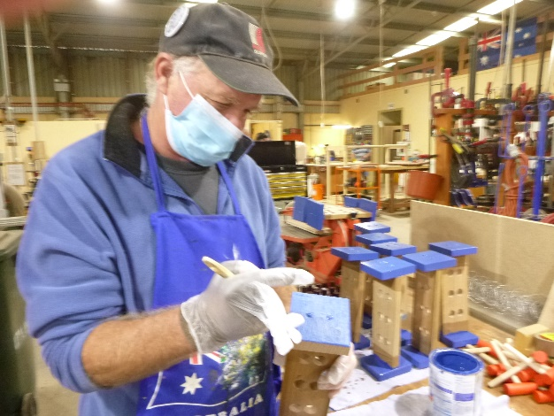
Gary painting a knock through toy

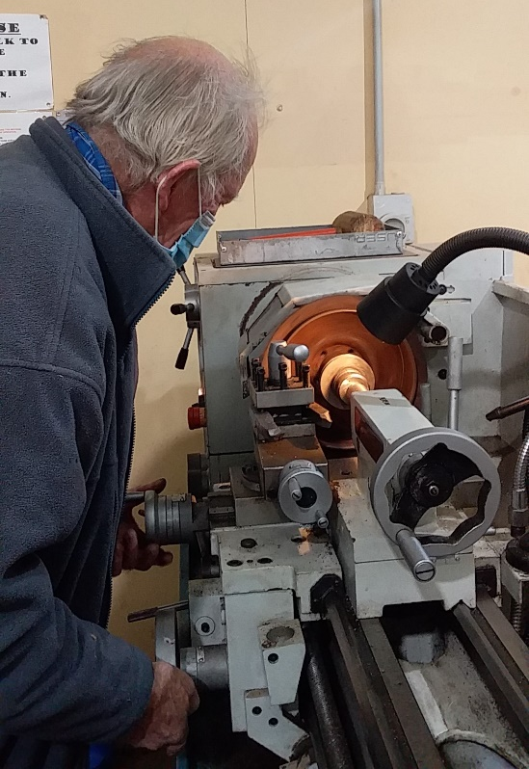
Trevor skimming a break drum.
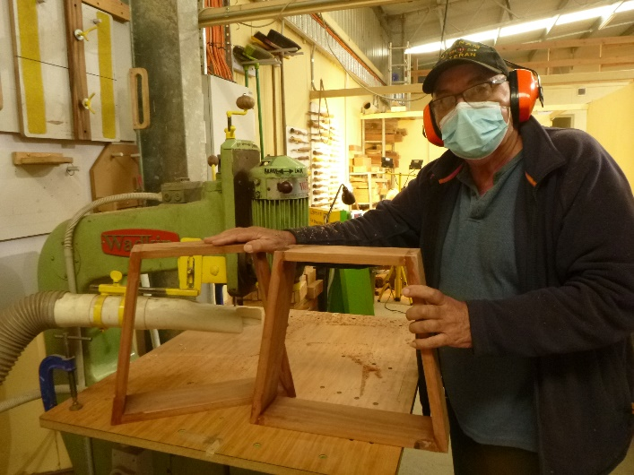
Ansi showing off a couple of retro legs to be used on a small table.
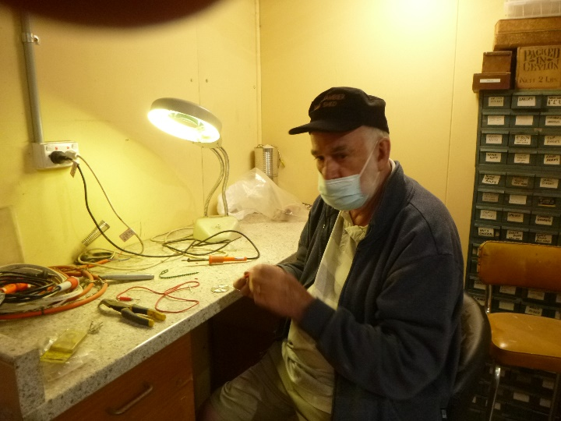
Rob doing some soldering in the electrical area.
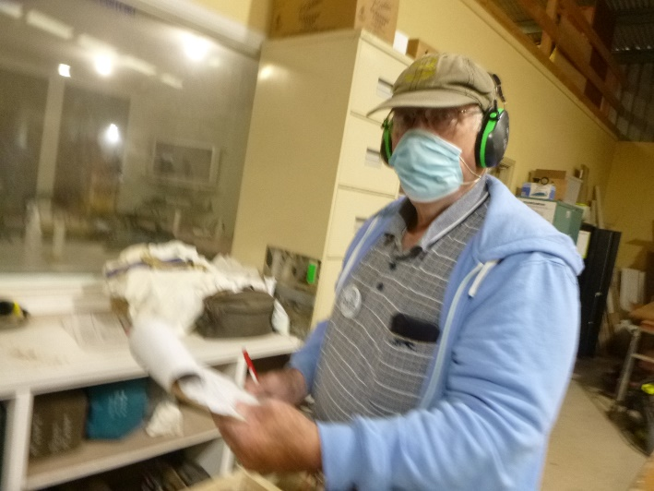
Someone has to keep tabs on the shed stocks and Rod is our man.


FOR SALE:
1 planer/jointer and 1 thicknesser
3 phase, $500 each
Contact: Don Clements 7-9pm 0467333642

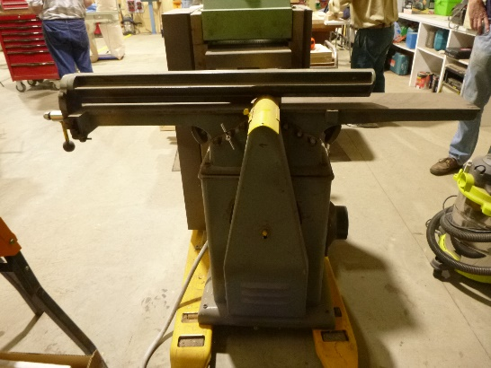
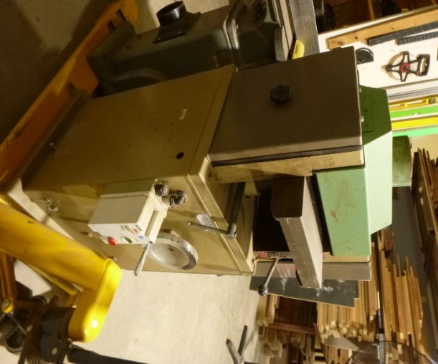

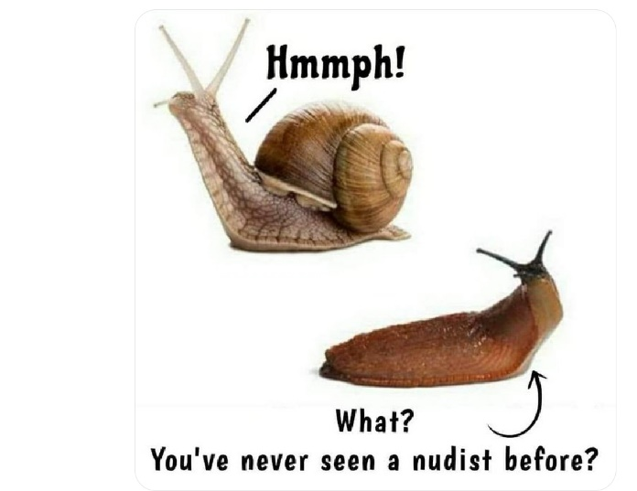



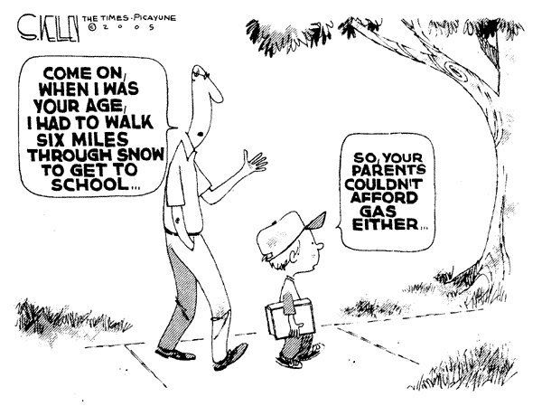


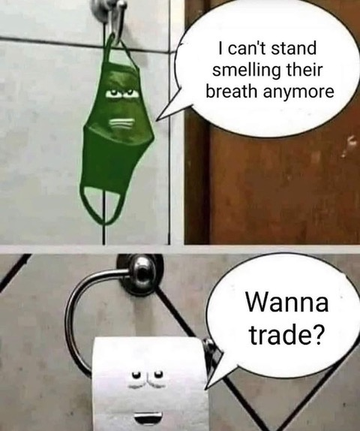










Big supporters of Mount Gambier Mens Shed.

SUPPORT YOUR LOCAL BUSINESSES
THAT SUPPORT YOU.

